BEFORE THE WASHINGTON UTILITIES AND TRANSPORTATION COMMISSION

COMMENTS ON PUGET SOUND ENERGY’S REPORT CONCERNING ITS TEN-YEAR CONSERVATION POTENTIAL AND ITS BIENNIAL CONSERVATION TARGET | DOCKET NO. UE-100177

COMMENTS OF PUBLIC COUNSEL
March 5, 2010
I. INTRODUCTION
- Pursuant to the Commission’s February 2, 2010 Notice of Opportunity to Comment, (Notice) the Public Counsel Section of the Washington State Attorney General’s Office (Public Counsel) respectfully submits these comments in advance of the Commission’s March 11, 2010 Open Meeting. These comments address Puget Sound Energy’s (hereafter PSE or the Company) report concerning its ten-year conservation acquisition potential and its biennial conservation target filed with the Commission in compliance with RCW 19.285.040 and WAC 480-109-010 (hereafter Compliance Report).
- Public Counsel has supported utility conservation programs. These programs deliver an important least-cost resource, and consumers have come to expect that their utility will offer such programs. Public Counsel has been engaged in the review of DSM tariff rider filings and other related conservation filings in part because the cost of such programs is borne by ratepayers. In some cases the costs for these programs has increased substantially in recent years, and in addition, utilities have also sought special ratemaking mechanisms related to their conservation efforts. In this context, it has become increasingly important for the Commission and stakeholders such as Public Counsel to have confidence that utility conservation programs are cost-effective and well-designed.
- Our comments serve to highlight what we identify as key concerns in PSE’s Compliance Report that deserve further review by the Commission, as well as to provide our assessment of the Company’s compliance with regard to the public involvement process in developing the Company’s targets, as well as commentary on how the Company established its ten-year achievable conservation potential and biennial conservation target.
- As discussed below, Public Counsel does not recommend approval at this time but instead recommends that the Commission allow for additional process for further review of this filing, as contemplated by WAC 480-109-010 (4)(b). Additional scrutiny of PSE’s Compliance Report is necessary because PSE has failed to comply with the Commission guidance regarding public involvement in the development of the ten-year potential and biennial target. In addition, PSE’s proposed conservation targets do not appear to comply with statutory requirements that utilities pursue all cost-effective, achievable conservation.
II. TEN-YEAR AND BIENNIAL CONSERVATION TARGETS

- Public Involvement

- WAC 480-109-010(3)(a) states in part that “participation by Commission Staff and the public in the development of the ten-year conservation potential and the two-year conservation target is essential.” The rule also requires that the utility’s report must outline “the extent of public and commission staff participation in the development of these conservation metrics.” PSE’s assertion that its ten-year conservation potential and two-year target filed in the Compliance Report were the result of a public process is, at best, an exceedingly charitable assessment of the utility’s activities. Public Counsel believes PSE has failed to comply with the Commission’s requirement, as discussed below.

PSE did not contemplate the use of the Fifth Plan Calculator in its public process.

- PSE has clearly failed to comply with the Commission requirement for public involvement in the development of the conservation targets. PSE’s implication in its Compliance Report that the CRAG and the IRPAG were aware that the Company had contemplated the use of its calculated share of the Council’s Fifth Plan is extremely misleading. In fact, prior to an email sent by PSE on the evening of Monday, January 25, 2010 (three business days before the filing deadline for the Compliance Report), members of the CRAG and IRPAG were not provided with any information about what the ten-year conservation potential and two -year target might be if they were based the Council’s Fifth Plan, except for when the Company provided those numbers as a means of comparison to the IRP-based filing the Company had long indicated it would make. In its review of documents provided to the CRAG and the IRPAG at
stakeholder meetings, Public Counsel was unable to find a single instance in which potential targets based on the Council’s calculator were provided to either stakeholder group apart from that single comparison described above, in relation to the Company’s IRP-based ten-year potential and biennial target that were to be filed in the Compliance Report.
- But for the limited information provided the week of January 25-29, 2010 the contents of PSE’s Compliance Report were all but unrecognizable to the members of the stakeholder groups who had been involved in PSE’s multi-year development of the Company’s ten-year conservation potential and two-year target. PSE is clearly grasping at straws to now argue that the events of the final week before the filing met the Commission’s public involvement requirement. PSE implies that the bewildering turn of events the week of the compliance report filing was somehow a continuation of its prior is simply not accurate.

The focus of the public process was PSE’s IRP.

- PSE did, in fact, engage in a robust public process. PSE’s engagement of stakeholders and the public in the development of its conservation programs, potential and targets is well recorded through documents provided to the IRPAG and CRAG. However, the focus of that public process was on PSE’s IRP targets—not the Fifth Plan Calculator—and, thus, is not what was ultimately included in the Company’s Compliance Report. The fact that the outcome of the public process is not reflected in the Compliance Report is one reason why its contents are particularly problematic. Ultimately, there was no public process regarding the development of the ten-year potential and biennial target PSE chose to file in its January 29, 2010, Compliance Report.
- PSE discussed the development of the ten-year potential and biennial target at CRAG meetings on September 15, 2009 and October 14, 2009, and an IRPAG meeting on December 15, 2009. The first time PSE provided an estimate of the ten-year potential and biennial target was at the October 14, 2009 CRAG meeting, where PSE gave a PowerPoint presentation detailing a proposed biennial target range of 68.8 aMW-78.2 aMW, based on adjustments made to the 2009 IRP guidance for reduced fuel conversion participation, ramp-up of industrial projects, and other factors. Following that meeting, the Company provided the CRAG and IRPAG with further refinements to its proposed target range, as illustrated in the chart below:
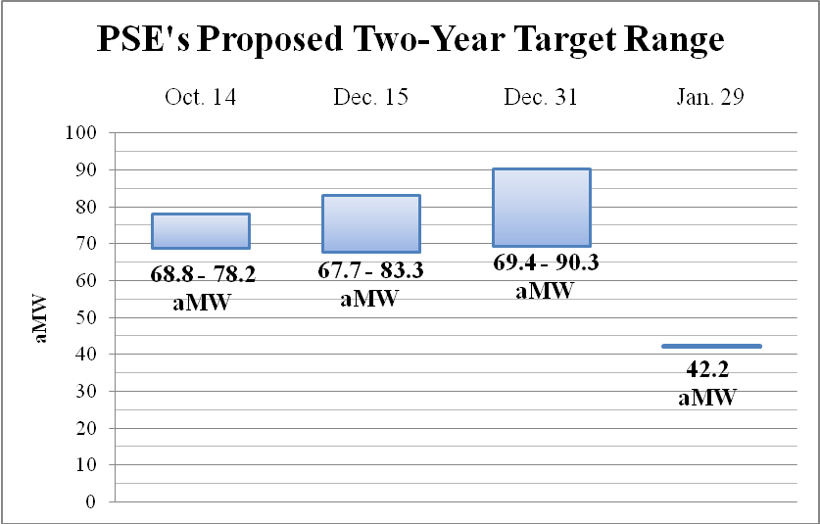
Sources: October 14, 2009 IRP meeting presentation, December 15, 2009 IRPAG meeting presentation; December 31, 2009 email; and January 29, 2010 Compliance Report.

- The obvious exception in this chart is the target eventually filed in the Compliance Report, which, again, was not presented to the CRAG or IRPAG until three working days before the filing deadline, when the Company informed the group via email of its drastic change in plans. Clearly, based on all information provided in the Company’s public process, the anticipated ten- year potential and two- year target were to be based on PSE’s IRP, as stated in PSE’s December 31, 2009 e-mail with PSE’s projected conservation potential assessment.
- Basis for Targets.

- Consistent with the Energy Independence Act, the Commission rules state that in determining its ten-year conservation potential, a utility shall consider conservation resources that are “cost-effective, reliable and feasible.” With respect to the biennial conservation target, the utility “must identify all achievable conservation opportunities,” and the target “must be no lower than a pro-rata share of the utility’s cumulative ten-year achievable conservation potential.” In establishing electric energy efficiency acquisition targets, WAC 480-109-010(1) provides that a utility must derive these from either the utility’s most recent IRP or the utility’s proportionate share of the Northwest Power and Conservation Council’s (hereafter “Council”) current regional power plan targets for the state of Washington.
- As noted above, just days prior to the filing PSE chose to use the Council’s Fifth Plan as the basis for their proposed targets. PSE has not provided information that its proposed ten-year conservation potential meets the statutory requirements of RCW 19.285, nor has the Company provided any relevant information for the Commission to determine whether its proposed biennial target identifies “all achievable conservation opportunities” available to the utility, as required by rule.

PSE’s ten-year potential and biennial target in the Compliance Report.

- As discussed above, PSE elected to use the Council’s Fifth Plan Calculator as the source for establishing the Company’s ten-year conservation potential and biennial conservation target, a peculiar and surprising decision. In the IRP development process, the Company closely analyzed available and feasible cost-effective conservation opportunities, based on PSE’s service territory and avoided cost, something that has not been done for the output of the Fifth Plan Calculator.
- The Company’s use of the Fifth Plan calculator is also questionable because the assumptions included in the Fifth Plan are outdated, as explained to the CRAG and the IRPAG by the Company itself. On December 21, 2009, in an email discussion about PSE’s need to ensure that the then-anticipated IRP projection was consistent with the methodologies utilized by the Council, PSE’s manager for integrated resource planning explained that the methodology between the Fifth and Sixth Plans “had not apparently changed much,” and that the primary changes were related to changes in price, technology, and other factors. These factors have a considerable impact on how much cost-effective conservation is reasonably attainable, not only for the region as a whole but also for PSE, and should be considered in any assessment of conservation potential.

The Fifth Plan is a deficient basis for the Compliance Report requirements.

- Public Counsel does not believe that it would have been acceptable had PSE used the Sixth Plan Calculator, rather than the Fifth Plan, as its ten-year potential and biennial target, because neither the Fifth nor Sixth Plans calculations for PSE were vetted through the public process.
We provide discussion of the Sixth Plan ten-year potential and target calculations in these
- comments for illustrative purposes. Fundamentally, however, neither the Fifth Plan nor Sixth Plan targets for PSE should be considered as compliant with the statutory requirement to achieve all available cost-effective conservation.
- The Sixth Plan was adopted just ten days after PSE filed its Compliance Report, on February 10, 2010. It is surprising that PSE chose not to use the Sixth Plan, despite its imminent approval and the updated information related to achievable conservation in the region that PSE itself recognized is included in the Sixth Plan. The development and pending adoption of the Sixth Plan was well known, as the development of the plan had been in progress for quite awhile, and the Draft Sixth Plan was considered a useful document. For example, the Commission itself took official notice of the Draft Sixth Plan and cited it in the decision regarding the extension of Avista’s decoupling mechanism, issued December 22, 2009. In its decision, the Commission quoted the Draft Sixth Plan and explicitly commented on its relevance, despite the “draft” status of the document.

PSE’s ten-year potential and biennial should have been based on the Company’s IRP.

- For PSE, a utility with a robust public process related to the development of its IRP and sophisticated conservation potential analysis conducted as part of the IRP, it is seemingly intuitive that the ten-year potential and biennial target would be based upon its IRP. The IRP is most certainly a more accurate statement of what the Company projects for conservation achievement, particularly since the analysis is associated with the utility’s long term resource portfolio and customized for local conditions. The Council itself encourages use of IRP conservation goals as more meaningful and appropriate. In the Council’s calculator for both the Fifth and the Sixth Plan, there is a statement included that reads:
“This calculator is intended to provide utilities with an "approximation" of the level of conservation they should target in order to be consistent with the Council's regional goals. The Council does not formally assign individual utility targets in its planning process. Individual utility conservation goals are best established through utility integrated resource planning processes which can better account for local conditions and legal requirements. Nevertheless, the results of this calculator can be used as rough guidance for utility conservation program planning until such time as a utility completes its own integrated resource plan or other similar process.”

- PSE has an up to date IRP, which was recently completed and filed with the Commission in late July, 2009. Furthermore, in December, 2009, the Company made an extensive filing related to its energy efficiency programs, which included detailed information about its programs, as well as a two-year conservation target based on its IRP. Public Counsel strongly believes that PSE should have used its IRP to develop the most accurate ten-year potential and biennial target
- In sum, because PSE based its Compliance Report on the Fifth Plan Calculator, it seems that it not only has failed to provide a ten-year potential estimate and biennial target that is based on the best available information from the Power Council, it also ignored its own internal evaluation and processes. Further, and most importantly, PSE’s ten-year potential and biennial target do not meet the legal requirements set forth in RCW 19.285 and WAC 480-109, requiring the Company to consider all “available conservation that is cost-effective, reliable and feasible” and all “achievable conservation opportunities.” This major flaw with PSE’s Compliance Report will be discussed further in the next section, which describes the Company’s recent planning and budget projections regarding future conservation acquisition, previous achievement levels, and compares those with the Sixth Plan Calculator outcomes.
- Comparison of Ten-Year Potential Estimates and Biennial Targets, Actual Conservation Achievements, and Budgeted Targets.
- This section addresses two topics. First, the substantial variation between PSE’s IRP target and PSE’s estimated target based on the Council’s Fifth and Sixth Plans is discussed. Second, as a “reality check,” PSE’s proposed biennial target is compared to the Company’s recent electric conservation performance, and to PSE’s recent projections of its conservation budgets and savings for 2010-2011 included in its December, 2009, Energy Efficiency Services filing with the Commission. The data provided below shows startling differences between PSE’s proposed targets and the Company’s recent and projected conservation performance.

Ten-Year Potential Estimates and Biennial Targets: Fifth Plan, Sixth Plan and IRP.

- PSE’s proposed cumulative ten-year conservation potential is 213.7 aMW and biennial target is 42.2 aMW, based on the Council’s Fifth Plan Calculator. However, as mentioned, on December 31, 2009, PSE provided the Commission and the stakeholder groups with an IRP-based ten-year conservation potential estimate of 427.9 aMW, and biennial target range of 69.4 aMW to 90.3 aMW. The Compliance Report reflects a reduction of 214.2 aMW (roughly 50 percent) for the ten-year potential and a reduction of between 27.2 aMW and 48.1 aMW for the range of the two-year target (a 39 percent reduction from the bottom of the range and a 53 percent reduction from the top of the range) from the Company’s previous IRP-based estimates.
- Even if PSE had used the Council’s Sixth Plan Calculator as the basis for its Compliance Report, which Public Counsel still does not believe would have been appropriate, the ten-year potential and biennial target would be considerably higher. PSE’s ten-year potential based on the Sixth Plan is 412.5 aMW and the 2010-2011 biennial conservation target is 59.9 aMW. Because PSE is depending on the outdated assumptions of the Fifth plan, its ten-year potential estimate is 198.8 aMW (48 percent) lower and two-year target is 17.64 aMW (29.4 percent) below even what would have been required if the Company had relied upon the Sixth Plan. The following charts illustrate the dramatic difference between these various scenarios.
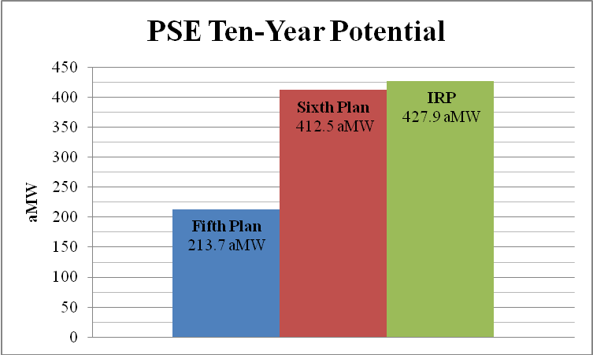
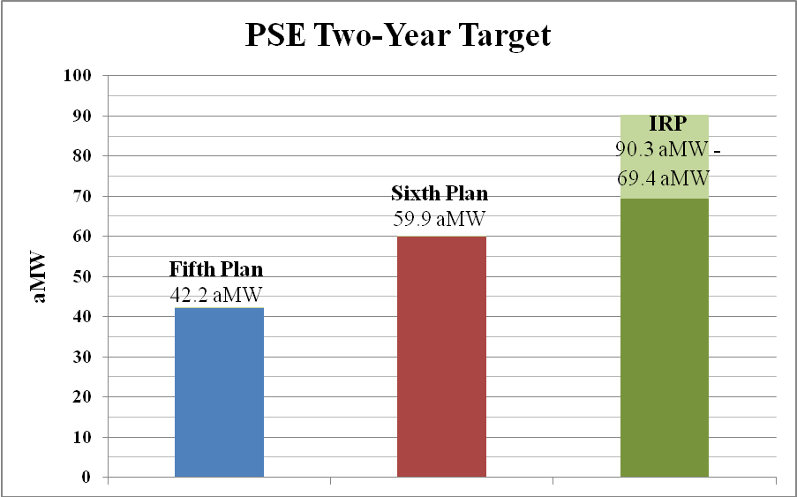
Sources: Projected conservation potential assessment, Docket No. UE-091986; Fifth Plan Calculator and Sixth Plan Calculator available at http://www.nwcouncil.org/energy/powerplan/6/supplycurves/I937/default.htm.

Comparison of PSE’s Proposed Biennial Target to Recent Performance and Budgeted Targets.

- It is worthwhile to note that in terms of the cost-effective conservation that PSE is capable of achieving, PSE filed its EES Annual Report filed on February 16, 2010. That report indicated that the Company achieved 66.4 aMW of savings over the prior two year period (2008-2009), with 35.1 aMW saved in 2009 alone. Additional historic budget information for PSE’s EES programs are included in the table below, as well as the projected budget and target for the 2010-2011 biennium.
PSE’s Historic and Proposed Budgets and Savings
 | 2004-2005  (actual) | 2006-2007  (actual) | 2008-2009  (actual) | 2010-2011 (proposed)
Budget | $50.4M | $65.1M | $122.8M | $166.8M
 |  |  |  | EES Tariff Filing | Compliance Report
Savings | 39.34 aMW | 44.4 aMW | 66.4 aMW | 71.0 aMW | 42.2 aMW
Cost per aMW | $1.28M | $1.47M | $1.85M | $2.35M | $3.95M
Sources: 2005 EES Annual Report, 2007 EES Annual Report, 2009 EES Annual Report, and 2010-2011 EES tariff filing, Docket No. UE-091859.
- As this table illustrates, PSE’s budget for its electric conservation programs has increased significantly over the past six years and is expected to ramp up further over the next two. The savings associated with these programs have also increased over the same time period, and based on the information in the EES tariff filing, are expected to increase (71.0 aMW). However, the biennial target included in the Compliance Report (42.2 aMW) would represent a substantial reduction over historical savings. PSE’s December, 2009, EES filing outlined the Company’s intent to collect roughly $100 million more for its electric conservation programs than it did in 2006-2007. And yet, its proposed biennial target in the Compliance Report is 2.2 aMW lower than what was achieved in that same period. This highlights the fundamentally flawed nature of PSE’s proposed target.
- Additionally, using PSE’s data shown in the table above, it appears that, at the budgeted amounts, the cost per aMW for the biennial target for 2010-2011 would be more than double what it was in 2008-2009, and nearly 70 percent higher than the per aMW cost related to the EES tariff filing target of 71.0 aMW. This calls into question whether the conservation savings associated with the Compliance Report target could actually be considered cost-effective, as is required by the RCW and WAC. However, PSE provided no information related to the cost-effectiveness of its programs or the biennial target in its Compliance Report. Thus, at this time, there is simply not enough information to make a determination on this issue.

QUALIFYING CONSERVATION MEASURES INCLUDED IN MEETING CONSERVATION TARGETS

- Two years from now, PSE and the other electric utilities will be filing reports regarding their compliance with their biennial targets, pursuant to WAC 480-109-050(4). At some point, no later than the review of compliance with the biennial targets, the Commission will have to determine which measures, and their associated savings, are properly included as qualifying toward the target.
- Qualifying Measures.
- PSE’s Compliance Report does not address the issue of which measures should be considered as qualifying measures, for I-937 compliance.
- Savings Estimates.
- Historically, the Commission has not explicitly approved the savings estimates employed by the electric or natural gas utilities to document and measure conservation performance. These savings estimates form the building blocks of the utility’s calculation of its conservation achievement over a given period, and are therefore a critical piece of the puzzle in determining the performance of the utility in its conservation achievement. Public Counsel’s understanding, however, is that these savings estimates are not reported to the Commission. While the utilities have non-binding advisory groups regarding conservation – such as PSE’s CRAG – Public Counsel’s experience is that in general there has been little time devoted to discussion of these savings estimates at the utility conservation advisory group meetings.
- Consequently, the Commission, Staff, Public Counsel, and other stakeholders have not had the opportunity to develop a clear understanding of the basis and underlying assumptions of the specific savings estimates employed by the utilities. While the Council’s Regional Technical Forum (RTF) provides guidance to utilities on such matters, the investor owned utilities are not required to comply with the RTF’s guidance. Neither Avista, PSE, nor Pacificorp have demonstrated or addressed whether they employ electric DSM savings estimates that are consistent with the guidance and recommendations of the RTF. In addition, in the event a utility makes changes to its savings estimates, there does not appear to be any requirement that the utility inform the Commission and/or its conservation advisory group of any such changes.

OTHER RECOMMENDATIONS and concerns

- Overall Public Counsel Recommendation.

- At this time, Public Counsel believes it is premature to take a position regarding approval of PSE’s proposed ten-year conservation potential and biennial target, due to the outstanding questions and issues addressed in these comments. We recommend that at a minimum, the Commission should reserve its decision until after an additional round of written and oral comments. This is appropriate for several reasons. First, this would allow all parties sufficient time to review all written comments, as well as any oral comments on March 11, 2010, and to prepare a response and final recommendation. Second, since this represents the Company’s initial compliance filing pursuant to RCW 19.285.040, we believe the Commission and interested parties will benefit from additional review and further opportunities for comment on this new and significant area. After this further round of comment and recommendations, the Commission can then determine whether to approve a filing, or whether review is needed for individual companies.
- If the Commission determines that additional process is necessary, for PSE or any of the electric utilities, Public Counsel recommends the Commission invoke the discovery rule, in order to facilitate information exchange among interested parties.
- Effect of Commission Approval of Conservation Targets
- Public Counsel recommends that the Commission provide clear guidance in this docket regarding the specific scope of the Commission’s “approval” of a utility’s conservation targets. It would be helpful to parties to have understand the scope as they prepare further comments and recommendations. For example, in the event the Commission approves PSE’s ten-year conservation potential and biennial target, either with or without conditions, does that approval apply to:
- The specific megawatt hours identified as the biennial target and ten-year potential;
- The 3-page Compliance Report filed January 29, 2010, and all statements made therein; or,
- The Compliance Report filed January 29, 2010 and all attachments to the filing, including all statements made therein.
- Public Counsel recommends that any approval be limited narrowly to item (a) only, that is, to the numerical MWh target. The Commission should not prejudge the prudence of any of the underlying energy efficiency activities at this time. That issue should be reserved for proceedings where prudence issues for DSM programs are currently determined. The Energy Independence Act also specifically provides that the Commission may examine the cost- effectiveness of utility conservation programs. The approval of these targets should not preclude the Commission from reviewing that issue at a later time. Public Counsel further notes that the WAC provisions implementing the Energy Independence Act permit prudence to be raised in the event a utility seeks to recover in rates penalty amounts incurred for failure to meet the target.
- Need for Generic Proceeding Regarding Utility Conservation Programs and I-937 Requirements.
- Public Counsel recommends the Commission consider a rulemaking proceeding, or other appropriate process, to address at least two topics: the savings estimates used to calculate conservation acquisition, and the development of consistent DSM reporting requirements for all utilities.
- As discussed above, Public Counsel believes it is important for the Commission to have a clear understanding of the savings estimates used by the electric utilities in measuring their conservation achievement. The Commission and stakeholders should have confidence that the savings estimates used by the utilities contribute to an accurate and reliable calculation of conservation savings acquisition. Therefore, we recommend these issues also be considered as part of a rulemaking or other process to allow for a thorough review of the savings estimates used by the electric utilities to comply with the requirements of RCW 19.285 and WAC 480-109, and to consider what if any procedures or requirements should be put in place regarding the basis and development of those savings estimates, consideration of any changes to those estimates, and related issues.
- In addition, consistent reporting requirements would greatly assist the Commission and interested stakeholders in reviewing utility projections, performance levels, expenditures, and cost-effectiveness results. Such a process could address reporting of the following information, for example:
- Projected budget, participation, and savings levels by program;
- Actual expenditures, participation, and savings levels by program;
- Cost-effectiveness methodology and analysis;
- Total savings achieved compared with targets;
- Incentives provided, by program and/or measure;
- Savings estimates, by program and/or measure;
- Narrative explanation of savings estimates, and workpapers;
- Evaluation, Measurement, and Verification (EM&V) of Savings;
- NEEA expenditures and savings calculations
- The frequency of utility reporting on these matters should also be addressed. It may be most helpful for utilities to report on some or all of these issues every six months. Currently, for example, both PSE and Pacificorp file semi-annual and annual reports regarding their DSM programs.
If the Commission agrees that such a rulemaking or other proceeding is warranted to address these and possibly other related matters, it should consider employing the assistance of a Facilitator, an individual with expertise on this technical subject matter who would help facilitate the proceeding. This individual might also develop preliminary recommendation to the Commission. Commission Staff and interested parties would be provided an opportunity to provide written comments regarding the recommendations of the Facilitator. The importance and the complexity of the issues surrounding I-937 implementation warrant consideration of devoting resources to a special approach of this type.

- CONCLUSION
- Public Counsel appreciates the opportunity to comment on PSE’s Compliance Report. We recognize that this first compliance period and filing which establishes PSE’s ten-year conservation potential and biennial target for the 2010-2011 period is a learning process for all parties. We look forward to working with the Company, the Commission and stakeholders, in future proceedings and compliance periods to address these issues.

WAC 480-109-010(3)(a).
The multi-year public process PSE touts in Section 6 of its filing produced a ten-year potential estimate and two-year target that were later drastically changed at the eleventh hour with little notice and yielded approximately seven pages of documents—including cover page—that were filed with the Commission as the Compliance Report.
Compliance Report, p. 2. The Company states: PSE notified interested public parties via email on December 31, 2009 of the projection of a ten-year potential. In that email PSE shared a projection of a ten year potential based on the most recent IRP and the Conservation Council’s [then] current (Fifth) plan targets.
In an email sent December 31, 2009, that also served as the projected conservation potential assessment provided to Commission Staff and filed under Docket No. UE-091986, Andrew Hemstreet of PSE stated, By contrast, PSE’s share of the Power Council’s Fifth regional plan would be a cumulative ten year potential of 219.4 aMW (2009-2018, the latest period in the Council’s published calculator) and a 2010-2011 “target” of 42.7 aMW. (Emphasis added.)
Review of presentations from September 15, 2009 and October 14, 2009 CRAG meetings and December 15, 2009 IRPAG meeting; December 31, 2009 projected conservation potential assessment e-mail to CRAG and IRPAG.
Compliance Report, p. 3, the Company states the ten-year potential and two-year target were developed “over the period of several years.”
Both Staff and Public Counsel expressed their considerable surprise to PSE, as well as the CRAG and IRPAG, at the drastic change of position made by the company at the late date in the process.
For example, on p. 2 of the Compliance Report, PSE states that the Conservation Target Calculator was updated on the Council’s website “as a result of this public involvement process.” This is clearly a disingenuous attempt to bolster the all but non-existent public process associated with the ten-year potential and biennial target in the Compliance Report. The fact that PSE was dependent upon the calculator, as downloaded from the Council website, speaks to the unusual nature of the amended ten-year potential and biennial target and the apparent haste with which the change was made.
October 14, 2009 CRAG meeting presentation, p. 12. Also, on p. 7 of the same presentation, the Company provided an estimate of 71 aMW for their two-year target associated with their Energy Efficiency Services portfolio for 2010-2011, which is similarly based on IRP guidance.
On January 27, 2010, PSE held a meeting to discuss this entirely new ten-year potential estimate and biennial target, but due to the short notice provided in advance of the meeting, many stakeholders, including Public Counsel and Staff, were not able to participate.
PSE’s December 31, 2010 e-mail to the CRAG and IRPAG, filed in Docket No. UE-091986.
WAC 480-108-010 (1)(a).
Id. at (2)(a).
Id. at (2)(b).
WAC 480-109-040(2)(a).
December 21, 2009 e-mail sent by Phillip Popoff of PSE to PSE IRPAG.
In making this assessment, the Company referenced Chapter 4 of the Sixth Plan, which states: “Concern has also been expressed about the fact that utilities will need to produce their first I-937 conservation plans at the precise moment the Council is making the transition from the Fifth to the Sixth Regional Power Plan. On this issue we should point out that the Council’s methodology is essentially the same in the Sixth and Fifth power plans and is clearly described in Chapter 4 of this draft. The conservation targets are higher in the Sixth Plan because of changes in prices, technology, and other factors, not because of a change in methodology.”
December 21, 2009 e-mail sent by Phillip Popoff of PSE to PSE’s IRPAG.
Docket Nos. UE-090134, UG-090135 and UG-060518 (consolidated), Order No. 10, ¶ 239
Id. The Commission’s Order No. 10, ¶ 239, states: Though it remains in draft form at this time and relates to the electric sector, the Sixth Power Plan being developed by the Northwest Power and Conservation Council offers these observations concerning the importance of conservation in our region: In each of its power plans, the Council has found substantial amounts of conservation to be cheaper and more sustainable than many forms of additional electric-generating capability. In this Sixth Power Plan, because of higher costs of alternative generation sources, rapidly developing technology, and heightened concerns about global climate change, conservation holds an even larger potential for the region. The Plan finds enough conservation to be available and cost-effective to meet the load growth of the region for the next 20 years. Although the final report may deviate slightly from the draft, these words clearly express the fundamental point that achieving significant conservation will remain a critically important goal for utilities in this region, including Washington, into the indefinite future.” (citations omitted).
See Fifth Plan Calculator and Sixth Plan Calculator (emphasis added). Available at http://www.nwcouncil.org/energy/powerplan/6/supplycurves/I937/default.htm
Docket No. UE-080949. Filed July 30, 2009.
Docket No. UE-091859.
For example, PSE’s IRP, the EES tariff filing and its related Staff investigation, and the EES Annual Report all provide considerable information that discredit the Compliance Report ten-year potential and biennial target.
RCW 19.285.040(1)
WAC 480-109.010(2)(a)
Compliance Report, p. 1.
PSE’s December 31, 2010 e-mail to the CRAG and IRPAG that also served as the projected conservation potential assessment provided to Commission Staff and filed under Docket No. UE-091986.
Sixth Plan Calculator, Option #2, see n. 21 for website link.
EES 2009 Annual Report, filed February 16, 2010, Docket No. UE-970686.
Historic information derived from Annual Reports filed under Docket No. UE-970686, source of projected 2010-2011 budget and target is PSE’s conservation tariff filing, Docket No. UE-091859.
2010-2011 EES Tariff Filing, Docket No. UE-091859, Appendix B.
The Council’s Fifth Calculator suggests that an appropriate budget for PSE’s target, as based on assumptions included in that calculator, would be $88.8M—roughly half of what PSE will collect from ratepayers. PSE can clearly achieve greater conservation under its current budget. See Fifth Plan Calculator, Budget Estimator, Option 2 available at http://www.nwcouncil.org/energy/powerplan/6/supplycurves/I937/default.htm.
Public Counsel performed this of Cost per aMW calculation by dividing the budget amounts by the Actual and Proposed Savings.
RCW 19.285.040(1) and WAC 480-109-101(1)(a).
RCW 19.285.040(1)(d).
WAC 480-109-105(4).
For example, PSE’s semi-annual and annual Energy Efficiency Services reports are filed in Docket. No. UE- 970686.
In conjunction with other Qwest state commissions, the Commission utilized a Facilitator in the review of Qwest’s proposed multi-state Qwest Performance Assurance Plan (QPAP) as part of Qwest’s 271 proceeding. The Facilitator provided a recommended QPAP to the participating state commissions, and the WUTC provided an opportunity for interested stakeholders to submit comments regarding the Special Master’s recommendations, and the Commission ultimately modified certain components of the QPAP. UT-003022 & UT-003040, Thirtieth Supplemental Order Addressing Qwest's Performance Assurance Plan. In the one of the telecommunications Generic Cost and Pricing dockets, the Commission retained a special advisor to assist the Commission.

