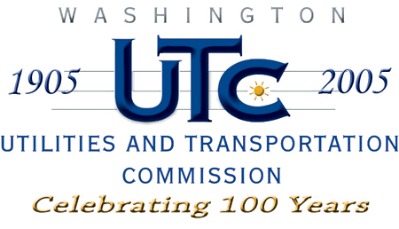

Memorandum
July 1, 2009

To: TR-081796 - File

From: Kathy Hunter, Deputy Assistant Director Transportation Safety

Subject: TR-081796 WSDOT Grade Crossing Protective Fund (GCPF) Project at SR-290 (Milepost 8.59)

On December 23, 2008, the Washington Utilities and Transportation Commission (Commission) awarded a GCPF grant totaling $12,120 for a project related to vehicle and pedestrian safety at a crossing located on SR-290 in Spokane Valley. The USDOT number assigned to the crossing is 066250W. Total project costs are estimated at $12,120 which includes BNSF Railway providing the equipment and labor to remove the tracks at no cost to WSDOT or UTC.

On June 30, 2009, the applicant, WSDOT submitted a request for reimbursement in the amount of $24,070.00. The additional cost is attributed to increase in paving depth and using a paving contractor instead of WSDOT staff. The Commission will reimburse the awarded amount of $12,120 and WSDOT will pay the additional amount. Commission staff received photos of the track removal and repaving of the roadway as part of the reimbursement package thus the project is completed according to the specifications outlined in the order approving the grant.

Please close this docket.

