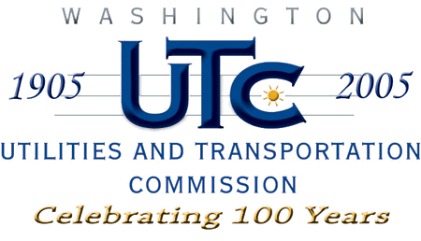

Memorandum
July 21, 2008

To: TR-080478 - File

From: Kathy Hunter, Transportation Safety Compliance Manager

Subject: TR-080478 Palouse River and Coulee City Railroad
Grade Crossing Protective Fund (GCPF) Project at South Park Ave.

On April 8, 2008, the Washington Utilities and Transportation Commission (Commission) awarded a GCPF grant totaling $20,000 for upgrades to a crossing located at South Park Avenue in the city of St. John. Total project costs are estimated $44,203.17, with WSDOT paying the amount over $20,000. The USDOT number assigned to this crossing is 089294C.

On July 21, 2008, the applicant, Palouse River and Coulee City Railroad submitted a request for reimbursement in the amount of $20,000 pursuant to commission order. On
June 12, 2008, commission staff conducted a site visit and verified that the project is completed according to the specifications outlined in the order approving the grant.

Please close this docket.

