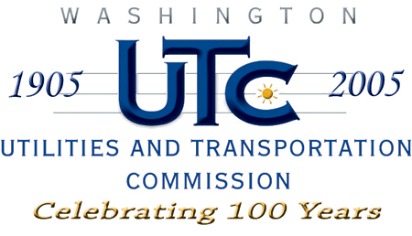

Memorandum
April 21, 2008

To: TR-080115 - File

From: Kathy Hunter, Transportation Safety Compliance Manager

Subject: TR-080115 Washington and Idaho Railway
Grade Crossing Protective Fund (GCPF) Project at Main Street

On January 24, 2008, the Washington Utilities and Transportation Commission (Commission) awarded a GCPF grant totaling $4,378.84 for upgrades to a crossing located at Main Street in the city of Palouse in Whitman County. The USDOT number assigned to this crossing is 066182X.

On April 11, 2008, the applicant, Washington and Idaho Railway submitted a request for reimbursement in the amount of $4,099.00 pursuant to commission order. On
April 15, 2008, commission staff conducted a site visit and verified that the project is completed according to the specifications outlined in the order approving the grant.

Please close this docket.

