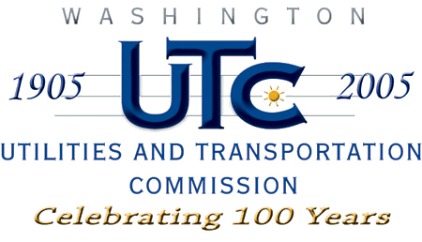

Memorandum
April 21, 2008

To: TR-072166 - File

From: Kathy Hunter, Transportation Safety Compliance Manager

Subject: TR-072166 Washington State Department of Transportation (WSDOT)
Grade Crossing Protective Fund (GCPF) Project at SR-241

On November 21, 2007, the Washington Utilities and Transportation Commission (Commission) awarded a GCPF grant totaling $20,000.00 for upgrades to a crossing located at SR-241 in Yakima County. The USDOT number assigned to this crossing is 104534G.

On April 11, 2008, the applicant, WSDOT submitted a request for reimbursement in the amount of $20,000.00 pursuant to commission order. On April 8, 2008, commission staff conducted a site visit and verified that the project is completed according to the specifications outlined in the order approving the grant.

Please close this docket.

