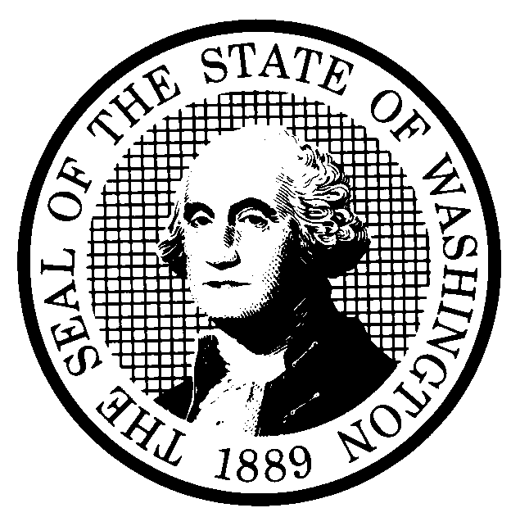 | PROPOSED RULE MAKING |  |  |  |  | CR-102 (June 2004)  (Implements RCW 34.05.320)  Do NOT use for expedited rule making
Agency: Washington Utilities and Transportation Commission
Preproposal Statement of Inquiry was filed as WSR 06-15-123 ; or  Expedited Rule Making--Proposed notice was filed as WSR ; or  Proposal is exempt under RCW 34.05.310(4). |  |  |  |  |  |  | Original Notice  Supplemental Notice to WSR  Continuance of WSR
Title of rule and other identifying information: (Describe Subject) Chapter 480-75 WAC Hazardous Liquid, Gas, Oil and Petroleum Pipeline Companies -- Safety.

WAC 480-75-270 Damage Prevention: Identifies hazardous liquid operators’ obligation to adhere to the provisions of RCW 19.122 as applicable.
WAC 480-75-300 Leak Detection: Clarifies conditions that require leak protection.
WAC 480-75-450 Construction Specifications: Removes an exemption from the longitudinal seam orientation requirement.
WAC 480-75-630 Incident Reporting: Adds another type of reportable incident and modifies others.
WAC 480-75-650 Annual Reports: Amends who receives annual reports and the date they are due.

Docket PL-061026
Hearing location(s):  WUTC Hearing Room 206  2nd Floor, Chandler Plaza Building  1300 S. Evergreen Park Drive S.W.  Olympia, WA 98504-7250 |  |  |  | Submit written comments to:  Name: Washington Utilities and Transportation Commission  Address: 1300 S. Evergreen Park Drive S.W., P.O. Box 47250  Olympia, WA 98504-7250  e-mail records@wutc.wa.gov  fax (360)586-1150 by (date) January 10, 2007
Date: February 7, 2007 Time: 1:30 p.m. |  |  |  | Assistance for persons with disabilities: Contact  Mary DeYoung by February 5, 2007  TTY (800) 416-5289 or (360) 664-1133
Date of intended adoption: February 7, 2007
(Note: This is NOT the effective date)
Purpose of the proposal and its anticipated effects, including any changes in existing rules:

Since the commission has adopted rules in Chapter 480-75, Hazardous Liquid, Gas, Oil and Petroleum Pipeline Companies – Safety, stakeholders and agency staff have identified a variety of issues, and changes in the federal rules that suggest that the commission should review certain rules relating to safety operation of hazardous liquid pipelines. This rulemaking proposes changes to WAC 480-75-300, WAC 480-75-450, WAC 480-75-630, and WAC 480-75-650 and to add a new rule ensuring that pipeline operators comply with Damage Prevention requirements in Chapter 19.122 RCW.

Reasons supporting proposal:

The proposed changes will provide clarity in some areas of the rules, eliminate requirements that are no longer necessary and provide compliance with federal rules.
Statutory authority for adoption: RCW 80.01.040, RCW 81.01.010 and RCW 81.88.060 |  |  |  | Statute being implemented: N/A
Is rule necessary because of a:  Federal Law?  Federal Court Decision?  State Court Decision?  If yes, CITATION: |  | Yes  Yes  Yes | No  No  No |  | CODE REVISER USE ONLY  Filed with the Code Reviser’s Office  December 6, 2006, 10:04 a.m.  WSR 06-24-128
DATE
December 6, 2006
NAME (type or print)
Carole J. Washburn
SIGNATURE

TITLE
Executive Secretary

(COMPLETE REVERSE SIDE)
Agency comments or recommendations, if any, as to statutory language, implementation, enforcement, and fiscal matters:
None.
Name of proponent: (person or organization) Washington Utilities and Transportation Commission |  |  | Private  Public  Governmental
Name of agency personnel responsible for:
 | Name | Office Location | Phone
Drafting............... Ilyne Lawson |  | WUTC - 1300 S. Evergreen Park Dr. S.W., Olympia, WA 98504 | (360) 664-1302
Implementation.... Carole J. Washburn |  | WUTC - 1300 S. Evergreen Park Dr. S.W., Olympia, WA 98504 | (360) 664-1174
Enforcement........Carole J. Washburn |  | WUTC - 1300 S. Evergreen Park Dr. S.W., Olympia, WA 98504 | (360) 664-1174
Has a small business economic impact statement been prepared under chapter 19.85 RCW?
Yes. Attach copy of small business economic impact statement.

A copy of the statement may be obtained by contacting:
Name:
Address:

phone ( )
fax ( )
e-mail
No. Explain why no statement was prepared.

The proposed rules will not result in or impose an increase in costs. Because there will not be any increase in costs resulting from the proposed rule changes, an SBEIS is not required under RCW 19.85.030(1).

Is a cost-benefit analysis required under RCW 34.05.328?

Yes A preliminary cost-benefit analysis may be obtained by contacting:
Name:
Address:

phone ( )
fax ( )
e-mail

No: Please explain: The Commission is not an agency to which RCW 34.05.328 applies. The proposed rule is not a significant legislative rule as referenced in RCW 34.05.328(5).

