 |  |  |  |  |  |  |  | Commission Docket No.
 |  |  |  |  |  |  |  | Agenda Date Assigned
BEFORE THE WASHINGTON UTILITIES AND TRANSPORTATION COMMISSION

LESS THAN STATUTORY NOTICE AND WAIVER OF CUSTOMER NOTICE RULES REQUESTED BY:
(Utility Name)  Qwest Corporation |  |  |  |  |  |  |  |  |  |  |  |  |  | (Utility UBI Number)  6012957939
(Utility d/b/a if different than registered name)
Utility proposes to change |  |  | Qwest Access Services Tariff |  |  |  |  |  |  |  |  |  |  | Number |  | WN U-44
 | (tariff title, price list title, etc.)
Present provisions are:
Proposed changes are:
Adding rate element to Qwest’s Access Service Tariff, WN U -44, Section 6.8.1
Indicate below, or attach, an explanation of the reason the company requests permission to file the proposed provisions with less than statutory notice and to provide notification to customers on less than required notice.
This new tariff rate element was inadvertently left out of the original filing, Advice 3510T, Docket UT-042173. Qwest’s seeks less than statutory approval to begin implementing this new charge effective 1/27/05.

Kirk Nelson |  |  |  | is authorized to issue and file tariffs on behalf of |  |  |  |  |  |  |  |  |  |  | Qwest Communications Corporation
(Name and title of issuing agent) |  |  |  |  |  |  |  |  |  |  |  |  |  |  | (Name of Utility)
Signature and Title of Company Officer
I request these provisions become effective on |  |  |  |  | January 27, 2005
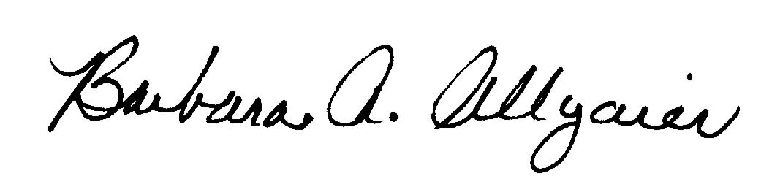 |  |  |  |  |  |  |  |  |  | (Date) 1/18/05
 |  |  |  |  |  |  |  |  |  | Director Legal Issues
(Signature of Authorized Agent) |  |  |  |  |  |  |  |  |  | (Title)
Barbara Allgaier
(Print Name)
(303) 896-0529 |  |  |  |  |  | (303) 896-9994 |  |  |  |  |  |  | Barbara.Allgaier@qwest.com
(Telephone Number) |  |  |  |  |  | (Fax Number) |  |  |  |  |  |  | (E-Mail Address)
1801 California, Room 4700 |  |  |  |  |  | Denver |  |  |  |  |  |  | Colorado |  |  |  | 80202
(Mailing Address) |  |  |  |  |  | (City) |  |  |  |  |  |  | (State) |  |  |  | (Zip Code)
WASHINGTON UTILITIES AND TRANSPORTATION COMMISSION

O R D E R
The Commissioners, having determined this order is consistent with the public interest, directed the Secretary to enter this order granting the provisions requested above.
DATED and signed at Olympia, Washington, this |  |  |  |  |  |  |  |  | Day of
 |  |  |  |  |  |  |  |  |  | (Month and Year)
 |  |  |  |  |  |  |  |  |  | Secretary
Util LSN Form 02/24/04

