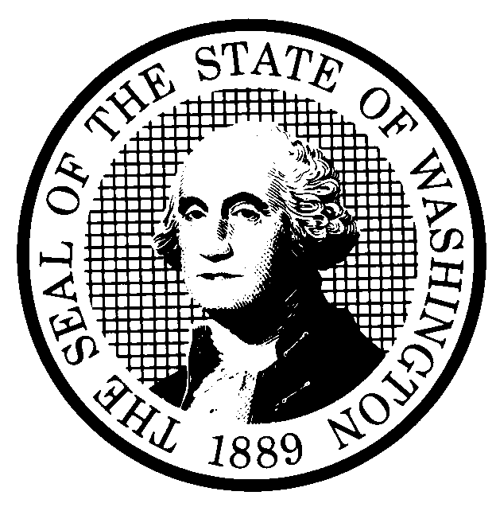 | PREPROPOSAL STATEMENT OF INQUIRY  (RCW 34.05.310) |  |  | CR-101 (7/22/01)  Do NOT use for expedited rule making
Agency: WASHINGTON UTILITIES AND TRANSPORTATION COMMISSION

Subject of possible rule making:

This rulemaking would consider developing a new chapter applicable to the economic regulation of Hazardous Liquid Pipeline Companies regulated as common carriers by the Commission, including, but not limited to, financial reporting requirements.

Docket No. TO-030288
- Statutes authorizing the agency to adopt rules on this subject:
RCW 80.01.040 and RCW 80.04.160, RCW 81.01.010 and RCW 81.88.030
- Reasons why rules on this subject may be needed and what they might accomplish:
There is currently no chapter of rules that addresses economic regulation of hazardous liquid pipeline companies. Such rules would facilitate the Commission in carrying out its statutory powers and duties, and to respond promptly to rapidly changing regulatory, operational, economic, and consumer issues. To that end, Staff proposes that the Commission explore this topic, which is expected to result in consideration of rules that (among other potential subjects):
Require financial transaction reports twenty days prior to the transfer of cash, credit, or pecuniary interest when certain thresholds have been exceeded.
Require an annual subsidiary transaction report summarizing all transactions that occurred between the company and its subsidiaries during the preceding year.
Require an annual affiliated interest transaction report.
Clarify accounting system requirements.
Set out retention and preservation of records requirements.
Establish consumer rules.

- Identify other federal and state agencies that regulate this subject and the process coordinating the rule with these agencies:

(d) Process for developing new rule (check all that apply):
Negotiated rule making
Pilot rule making
X Agency study
X Other (describe)
The Commission will ask for initial written comments, and will provide the opportunity for participation in workshop-style sessions as well as opportunities for additional comments.
(e) How interested parties can participate in the decision to adopt the new rule and formulation of the proposed rule before publication:
Interested persons may contact the Secretary, Washington Utilities and Transportation Commission, P.O. Box 47250, 1300 S. Evergreen Park Drive, S.W., Olympia, Washington, 98504-7250; Telephone (360) 664-1174; Facsimile (360) 586-1150.
Interested persons may file written comments on the CR-101 by Wednesday, April 9, 2003. For specific information regarding opportunities for written comment and to ensure receipt of further information concerning this rulemaking, please see the attachment to this form.

A stakeholder workshop will be held Thursday, April 10, 2003, in Room 206 at the Commission’s headquarters, beginning at 9:30 a.m. until 4:30 p.m. |  |  | CODE REVISER USE ONLY
SIGNATURE |  |  | Filed with the Code Reviser's Office  March 13, 2003, 9:30 a.m.  WSR# 03-07-034
TITLE  SECRETARY |  | DATE  MARCH 13, 2003

WASHINGTON UTILITIES AND TRANSPORTATION COMMISSION
CR-101 - ATTACHMENT
DOCKET NO. TO-030288

(e) Interested persons may contact the Secretary, Washington Utilities and Transportation Commission, P. O. Box 47250, Olympia, Washington, 98504-7250, 360-664-1174 (Fax: 360-586-1150).

WRITTEN COMMENTS AND STAKEHOLDER WORKSHOP

Written comments may be submitted to the Commission at the address given above and should be filed with the Commission no later than Wednesday, April 9, 2003, for consideration at the April 10, 2003, stakeholder workshop.
Electronic copies. The Commission requests that comments be provided in electronic format to enhance public access, for ease of providing comments, to reduce the need for paper copies, and to facilitate quotations from the comments. Comments may be submitted by electronic mail to the Commission’s Records Center at records@wutc.wa.gov. Please include:

- The docket number of this proceeding (TO-030288)
- The commenting party’s name
- The title and date of the comment or comments

An alternative method for submitting comments may be by mailing/delivering an electronic copy on a 3 ½ inch, IBM-formatted, high-density disk, in .pdf Adobe Acrobat format or in Word 97 or later. Include all of the information requested above. The Commission will post on the Commission’s web site all comments that are provided in electronic format. The web site is located at http://www.wutc.wa.gov/030288. If you are unable to file your comments electronically or to submit them on a disk, the Commission will always accept a paper document.

Opportunity for further comment is anticipated. Information about the schedule and other aspects of the rulemaking, including comments, will be posted on the Commission’s web site as it becomes available. If you wish to receive further information on this rulemaking you may (1) call the Commission’s Records Center at 360-664-1234, (2) e-mail the Commission at <records@wutc.wa.gov>, or (3) mail written comments to the address above to the attention of Carole J. Washburn, Secretary. When contacting the Commission, please refer to Docket No. TO-030288 to ensure that you are placed on the appropriate service list. Questions may be addressed to Kim Dobyns (360) 664-1242 or e-mail at kdobyns@wutc.wa.gov.

TO CONTINUE RECEIVING NOTICES AND INFORMATION ABOUT THIS RULEMAKING -- The Commission wants to ensure its mailings are sent to persons who are interested in the topic and want to receive that information. ANY PERSON WHO COMMENTS will continue to receive notices and information. If you do not submit comments but wish to remain on the mailing list for this rulemaking, please advise the Records Center by any one of the following methods: (1) send a note with your name, address (or a copy of your mailing label), and telephone and fax numbers referencing Docket No. TO-030288, and the words "Please keep me on the mailing list"; or (2) E-mail your name, address, telephone and fax numbers, referencing Docket No. TO-030288, and the words "Please keep me on the mailing list" to <records@wutc.wa.gov>. Please note that all information in the mailings will be accessible through the Commission's Internet web site at <http://www.wutc.wa.gov/030288>. THOSE PARTIES WHO DO NOT RESPOND MAY NOT RECEIVE FURTHER MAILINGS OR INFORMATION ON THE RULEMAKING.
NOTICE

