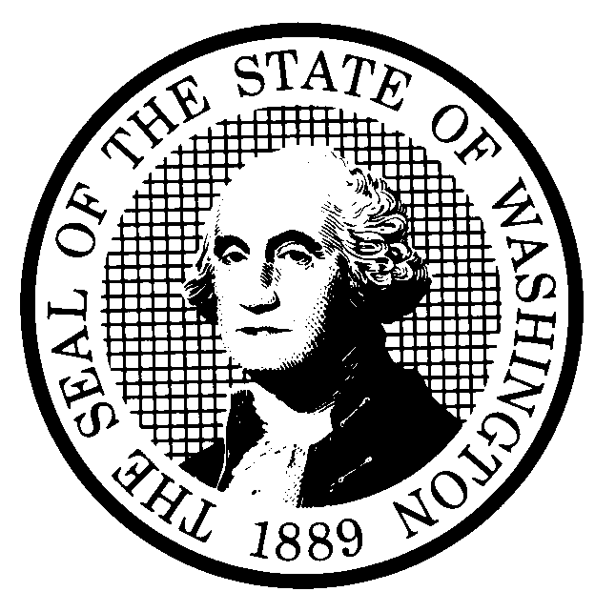 | PREPROPOSAL STATEMENT OF INQUIRY  (RCW 34.05.310) |  |  | CR-101 (7/22/01)  Do NOT use for expedited rule making
Agency: WASHINGTON UTILITIES AND TRANSPORTATION COMMISSION

Subject of possible rule making: This rulemaking would consider establishing rules relating to reporting of transactions between regulated utility and transportation companies and their subsidiaries to the Commission. Industries that may be affected include Household Goods Carriers, Commercial Ferries, Auto Transportation Companies, Solid Waste and Collection Companies, Petroleum Pipeline Companies, Gas Companies, Low Level Radioactive Waste, Electric Companies, Water Companies, Telecommunications Companies. Rules that may be affected include WAC Chapters 480-15 Household Goods Carriers, 480-51 Commercial Ferries, 480-70 Solid Waste, 480-75 Petroleum Pipeline Companies, 480-90 Gas Operations, 480-92 Low Level Radioactive Waste, 480-100 Electric Operations, 480-110 Water Companies, 480-120 Telecommunications Operations, 480-140 Budgets, and 480-146 Securities and Affiliated Interests. Docket No. A-021178

- Statutes authorizing the agency to adopt rules on this subject:
RCW 80.01.040 and RCW 80.04.160
- Reasons why rules on this subject may be needed and what they might accomplish:
The regulated transportation and utility business environments have undergone a number of significant developments that include corporate and industry restructuring, competition, bankruptcy, financial rating downgrades, volatile commodity supply and demand, volatile pricing, and concern with the accuracy of corporate financial statements and reports. In this new environment, transactions between regulated companies and their affiliates and subsidiaries may significantly impact ratepayers. Transactions with affiliated interests are covered by existing law, but there are no rules covering some types of subsidiaries. Establishing reporting requirements regarding transactions between regulated companies and their subsidiaries would provide the Commission with more timely identification and disclosure of intercompany transactions that pose difficult regulatory issues. Establishing rules applicable to regulated companies may include, but not be limited to, the following:
1. Require regulated companies to prefile the following transactions with subsidiaries:
- Management or service contracts (to be defined).
- Maintenance, operation and construction contracts.
- Construction, maintenance, or use of a telecommunications line or service contracts.
- Issuance of evidence of ownership or indebtedness or creation of liens on regulated company property.
- Require regulated companies to file periodic reports detailing transactions that have already occurred with subsidiaries.
- Require regulated companies to immediately post-file significant transactions/arrangements with subsidiaries.
- Identify other federal and state agencies that regulate this subject and the process coordinating the rule with these agencies: FERC, FCC, SEC

(d) Process for developing new rule (check all that apply):
Negotiated rule making
Pilot rule making
X Agency study
X Other (describe)
The Commission will ask for initial written comments, and will provide the opportunity for additional comments.
(e) How interested parties can participate in the decision to adopt the new rule and formulation of the proposed rule before publication:
Interested persons may contact the Secretary, Washington Utilities and Transportation Commission, P.O. Box 47250, 1300 S. Evergreen Park Drive, S.W., Olympia, Washington, 98504-7250; Telephone (360) 664-1174; Facsimile (360) 586-1150.
Interested persons may file written comments on the CR-101 by October 30, 2002. For specific information regarding opportunities for written comment and to ensure receipt of further information concerning this rulemaking, please see the attachment to this form.

A stakeholder workshop will be held Tuesday, November 5, 2002, in Room 206 at the Commission’s headquarters, beginning at 9:30 a.m. until 4:30 p.m. |  |  | CODE REVISER USE ONLY
 |  |  | Filed with the Code Reviser’s Office
NAME (TYPE OR PRINT)  CAROLE J. WASHBURN |  |  | October 2, 2002 at 9:24 a.m.  WSR# 02-20-105
SIGNATURE
TITLE  SECRETARY |  | DATE  OCT. 2, 2002

WASHINGTON UTILITIES AND TRANSPORTATION COMMISSION
CR-101 - ATTACHMENT
DOCKET NO. A-021178

(e) Interested persons may contact the Secretary, Washington Utilities and Transportation Commission, P. O. Box 47250, Olympia, Washington, 98504-7250, 360-664-1174 (Fax: 360-586-1150).

WRITTEN COMMENTS AND STAKEHOLDER WORKSHOP
Written comments may be submitted to the Commission at the address given above and should be filed with the Commission no later than Wednesday, October 30, 2002, for consideration at the November 5, 2002, stakeholder workshop.
Electronic copies. The Commission requests that comments be provided in electronic format to enhance public access, for ease of providing comments, to reduce the need for paper copies, and to facilitate quotations from the comments. Comments may be submitted by electronic mail to the Commission’s Records Center at records@wutc.wa.gov. Please include:

- The docket number of this proceeding (A-021178)
- The commenting party’s name
- The title and date of the comment or comments

An alternative method for submitting comments may be by mailing/delivering an electronic copy on a 3 ½ inch, IBM-formatted, high-density disk, in .pdf Adobe Acrobat format or in Word 97 or later. Include all of the information requested above. The Commission will post on the Commission’s web site all comments that are provided in electronic format. The web site is located at http://www.wutc.wa.gov/021178. If you are unable to file your comments electronically or to submit them on a disk, the Commission will always accept a paper document.

Opportunity for further comment is anticipated. Information about the schedule and other aspects of the rulemaking, including comments, will be posted on the Commission’s web site as it becomes available. If you wish to receive further information on this rulemaking you may (1) call the Commission’s Records Center at 360-664-1234, (2) e-mail the Commission at <records@wutc.wa.gov>, or (3) mail written comments to the address above to the attention of Carole J. Washburn, Secretary. When contacting the Commission, please refer to Docket No. A-021178 to ensure that you are placed on the appropriate service list. Questions may be addressed to Fred Ottavelli (360) 664-1297 or e-mail at <fottavel@wutc.wa.gov>or Sharyn Bate (360) 664-1295 or e-mail at <sbate@wutc.wa.gov>.

TO CONTINUE RECEIVING NOTICES AND INFORMATION ABOUT THIS RULEMAKING -- The Commission wants to ensure its mailings are sent to persons who are interested in the topic and want to receive that information. ANY PERSON WHO COMMENTS will continue to receive notices and information. If you do not submit comments but wish to remain on the mailing list for this rulemaking, please advise the Records Center by any one of the following methods: (1) send a note with your name, address (or a copy of your mailing label), and telephone and fax numbers referencing Docket No. A-021178, and the words "Please keep me on the mailing list"; or (2) E-mail your name, address, telephone and fax numbers, referencing Docket No. A-021178, and the words "Please keep me on the mailing list" to <records@wutc.wa.gov>. Please note that all information in the mailings will be accessible through the Commission's Internet web site at <http://www.wutc.wa.gov/021178>. THOSE PARTIES WHO DO NOT RESPOND MAY NOT RECEIVE FURTHER MAILINGS OR INFORMATION ON THE RULEMAKING.
NOTICE

