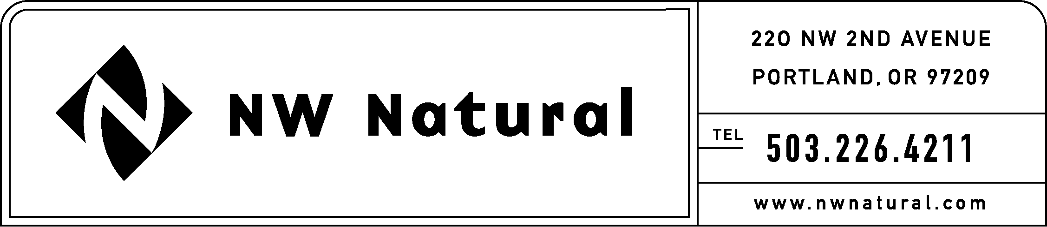
RATES AND REGULATORY AFFAIRS
ONITA R. KING
Telephone: (503) 226-4211 X 3586
Facsimile: (503) 721-2532
Email: ork@nwnatural.com

May 17, 2002

Secretary
Washington Utilities & TraTransportation Commission
P.O. Box 47250
Olympia, Washington 98504-7250

Re: Docket Number A-020405
WAC 480-90-113 and 480-90-118

NW Natural appreciates the opportunity to comment in the above-referenced matter.

We would like to suggest using the 1-year Treasury Constant Maturity as a possible replacement for the 52-week Treasury bill rate to compute the interest rate payment on customer deposits. The Federal Reserve describes the Treasury Constant Maturity series as follows:

“Yields on Treasury securities at “constant maturity” are interpolated by the U.S. Treasury from the daily yield curve. This curve, which relates to the yield on a security to its time to maturity is based on the closing market bid yields on actively traded Treasury securities in the over-the-counter market. These market yields are calculated from composites of quotations obtained by the Federal Reserve Bank of New York. The constant maturity yield values are read from the yield curve at fixed maturities, currently, 1, 3 and 6 months and 1,2,3,5,7, 10 and 20 years. This method provides a yield for a 10-year-maturity, for example, even if no outstanding security has exactly 10 years remaining to maturity.” Federal Reserve Statistical Release. H.15 Selected Interest Rates (Daily), May 8, 2002.

A copy of the above-referenced Statistical Release, together with a graph depicting the 1-year constant maturity rates between May 9, 2001 and May 8, 2002, are attached to these comments.

Thank you again for the opportunity to comment in this proceeding. We look forward to working with staff in this matter.

Sincerely,

Onita R. King
Tariff Consultant

Attachments

