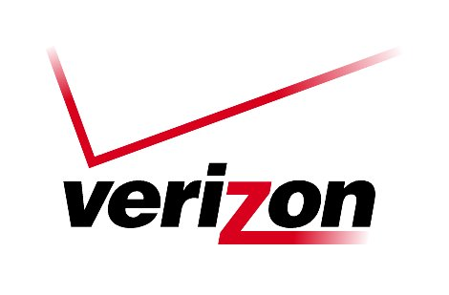 Verizon Northwest Inc.

1800 – 41st Street, WA0105RA
P. O. Box 1003
Everett, WA 98206-1003
Fax: 425-261-5262

July 2, 2007

Advice No. 3252

Ms. Carole J. Washburn, Executive Secretary
Washington Utilities and Transportation Commission
1300 S. Evergreen Park Drive, S. W.
Olympia, Washington 98504-7250

Dear Ms. Washburn:

Verizon Northwest Inc. (“Verizon NW”) submits for filing Advice No. 3252, which provides changes to the General and Local Exchange Tariff, WN U-17, Section 5, related to the residential Late Payment Charge. Specifically, the purpose of this filing is to remove the December 31, 2007 expiration of the effectiveness of the residential Late Payment Charge from the tariff. As the commission noted in paragraph 3 of Order No. 17 in Docket No. UT-040788 (referring back to Order No. 15 in the same docket), Verizon NW may re-file the residential Late Payment Charge tariff provision or file a modified tariff for continued operation of the residential Late Payment Charge at any time after July 1, 2007. Verizon NW does so with this filing by making three deletions to provisions within the tariff that describe expiration of the residential Late Payment Charge on December 31, 2007.

Recognizing that the commission will likely prefer to review Verizon NW’s final report on implementation of the residential Late Payment Charge, which is due to be filed on August 15, 2007, before removing the expiration provisions, the enclosed tariff deletions are effective on September 13, 2007. Additionally, in order to facilitate commission review of the report to be delivered on August 15, 2007, Verizon NW encloses a preliminary report with this Advice Letter (“Preliminary Report”). The Preliminary Report includes data through May 31, 2007, as well as a narrative explaining the results. Thus, the only new information to be provided in the August report (which, per paragraph 30 of Order No. 15 in Docket No. UT-040788, is to address the first six months of 2007) will be data from June 2007. The data in the Preliminary Report continues the significant trend shown in previous reports of declining revenues from the Late Payment Charge, as well as reductions in the numbers and percentage of customers assessed the charge (including reductions among customers eligible for the Washington Telephone Assistance Program). That trend, as well as the absence of any impact by residential Late Payment Charge on the number of disconnections, should assuage the commission’s stated reasons for reviewing the impact of implementation of the residential Late Payment Charge (see paragraph 28 of Order No. 15 in Docket No. UT-040788).

Ms. Carole J. Washburn
Page 2
Verizon Northwest Inc.

Verizon NW considers material submitted under confidential cover protected under the protective order issued in Docket No. UT-040788. The confidential material in the attached is marked “Confidential per Protective Order in WUTC Docket No. UT-040788.” Verizon NW, for commercial reasons, may be harmed if this information is not kept confidential.

Please contact Lin Fogg at (425) 261-6380 with questions.

Very truly yours,
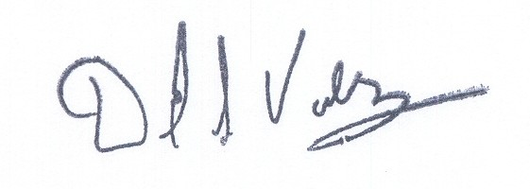

David S. Valdez
Senior Vice President - West
Public Affairs, Policy and Communications

DSV:LF:lf
Attachments
(WAIGLU-17-0250)

Carole J. Washburn, Executive Secretary
Verizon Northwest Inc.
Advice No. 3252

Attachment A

General and Local Exchange Tariff, WN U-17

Section 2

5th Revised Sheet 20

Section 5

2nd Revised Sheet 5.1

5th Revised Sheet 6

VERIZON NORTHWEST INC.
EVERETT, WASHINGTON

N O T I C E

Verizon Northwest Inc. filed Advice No. 3252 on July 2, 2007 with the Washington Utilities and Transportation Commission at Olympia to become part of the General and Local Exchange Tariff, WN U-17, Section 2, Rules and Regulations and Section 5, Service Charges.

The purpose of this filing is to remove the December 31, 2007 expiration of the effectiveness of the residential Late Payment Charge from the tariff. As the commission noted in paragraph 3 of Order No. 17 in Docket No. UT-040788 (referring back to Order No. 15 in the same docket), Verizon NW may re-file the residential Late Payment Charge tariff provision or file a modified tariff for continued operation of the residential Late Payment Charge at any time after July 1, 2007. Verizon NW does so with this filing by making three deletions to provisions within the tariff that describe expiration of the residential Late Payment Charge on December 31, 2007.

The company requests an effective date of September 13, 2007 for this tariff filing.

A copy of this tariff is available for public inspection at the following Verizon Plus store locations:

189 Cascade Mall Drive 1402 SE Everett Mall Way
Burlington Everett
Burlington Verizon Plus Everett Verizon Plus

511 Valley Mall Parkway 18700 33rd Ave. West, Suite D
East Wenatchee Lynnwood
East Wenatchee Verizon Plus Alderwood Verizon Plus

Posted at __________________________
__________________________
by __________________________

Post in above store

