BEFORE THE WASHINGTON UTILITIES AND TRANSPORTATION COMMISSION

DOCKET NO. UE-11________
DOCKET NO. UG-11________

DIRECT TESTIMONY OF
MARK T. THIES
REPRESENTING AVISTA CORPORATION

I. INTRODUCTION
Q. Please state your name, business address, and present position with Avista Corp.
A. My name is Mark Thies. My business address is 1411 East Mission Avenue, Spokane, Washington. I am employed by Avista Corporation as Senior Vice President and Chief Financial Officer.

Q. Would you please describe your education and business experience?
A. I received a Bachelor of Arts degree with majors in Accounting and Business Administration from Saint Ambrose College in Davenport, Iowa, and became a Certified Public Accountant in 1987. I have extensive experience in finance, risk management, accounting and administration within the utility sector, primarily in the Midwest.
I joined Avista in September of 2008 as Senior Vice President and Chief Financial Officer (CFO). Prior to joining Avista, I was Executive Vice President and CFO for Black Hills Corporation, a diversified energy company, providing regulated electric and natural gas service to areas of South Dakota, Wyoming and Montana. I joined Black Hills Corporation in 1997 upon leaving InterCoast Energy Company in Des Moines, Iowa, where I was the manager of accounting. Previous to that I was a senior auditor for Arthur Anderson & Co. in Chicago, Illinois.
Q. What is the scope of your testimony in this proceeding?
A. I will provide a financial overview of the Company and will explain the overall rate of return proposed by the Company in this filing for its electric and natural gas operations. The proposed rate of return is derived from Avista’s total cost of debt including long-term and short-term debt, and common equity, weighted in proportion to the proposed capital structure.
I will address the proposed capital structure, as well as the proposed cost of total debt and equity in this filing. Dr. Avera, on behalf of the Company, will provide additional testimony related to the appropriate return on equity for Avista, based on the specific circumstances of the Company, together with the current state of the financial markets.
In brief, I will provide information that shows:
- Avista’s plans call for significant capital expenditure requirements for the utility over the next two years to assure reliability in serving our customers and meeting customer growth. Capital expenditures of approximately $482 million are planned for 2011-2012 for customer growth, investment in generation upgrades and transmission and distribution facilities, as well as necessary maintenance and replacements of our natural gas utility systems. Capital expenditures of approximately $1.2 billion are planned for the five-year period ending December 31, 2015. Avista needs adequate cash flow from operations to fund these requirements, together with access to capital from external sources under reasonable terms.

- Avista’s corporate credit rating from Standard & Poor’s (S&P) is currently BBB and Baa2 from Moody’s Investors Service (Moody’s). Avista must operate at a level that will support a solid investment grade corporate credit rating, meaning “BBB” or “BBB+”, in order to access capital markets at reasonable rates, which will decrease long-term borrowing costs to customers. In March 2011, S&P upgraded Avista’s Corporate Credit Rating to BBB from BBB- and Moody’s upgraded Avista’s Issuer Rating to Baa2 from Baa3. A supportive regulatory environment is an important consideration by the rating agencies when reviewing Avista. Maintaining solid credit metrics and credit ratings will also help support a stock price necessary to issue equity under reasonable terms to fund capital requirements.

- The Company is proposing an overall rate of return of 8.23%, including a 48.04% equity ratio and a 10.90% return on equity. Our proforma cost of debt is 5.76%.

The Company’s initiatives to carefully manage its operating costs and capital expenditures are an important part of our performance, but are not sufficient without revenues from the general rate request for our electric and natural gas businesses in these cases. Sufficient cash flows from operations can only be achieved with the support of regulators in allowing the timely recovery of costs and the ability to earn a reasonable return on investment.
A table of contents for my testimony is as follows:
Description Page
I. Introduction 1
II. Financial Overview 3
III. Credit Ratings 12
IV. Cash Flow 21
V. Capital Structure 27
VI. Cost of Debt 27
VII. Cost of Common Equity 28

Q. Are you sponsoring any exhibits with your direct testimony?
A. Yes. I am sponsoring Exhibit No.___ (MTT-2) pages 1 through 5, which were prepared under my direction. Avista’s credit ratings by S&P and Moody’s are summarized on page 1, and Avista’s actual capital structure at December 31, 2010 and pro forma capital structure at December 31, 2011 are included on page 2, with supporting information on pages 3 through 5 of the Exhibit.
II. FINANCIAL OVERVIEW
Q. Please provide an overview of Avista's financial situation.
A. The Company has made solid progress in improving its financial health in recent years, as demonstrated by improved financial ratios and recent credit rating upgrades. The Company has been able to improve and balance its debt and equity ratios by paying down debt, issuing additional common stock, and through additional retained earnings.
Avista’s goal is to operate at a level that will support a solid corporate credit rating of BBB / BBB+. Operating at this rating level will help reduce long-term costs to customers, reduce collateral requirements, and allow us to maintain access to more counterparties for acquisition of natural gas and electricity. We expect that a continued focus on the regulated utility, conservative financing strategies (including the issuance of common stock) and a supportive regulatory environment will contribute to operating at this rating level.
We are operating the business efficiently to keep costs as low as practicable for our customers, while at the same time ensuring that our energy service is reliable, and customers are satisfied. An efficient, well-run business is not only important to our customers, but also to investors. Additionally, the Company is working through regulatory processes to recover our costs in a timely manner so that earned returns are closer to those allowed by regulators in each of the states we serve. This is one of the key determinants from the rating agencies’ standpoint when they are reviewing our overall credit ratings.
Q. What additional steps has the Company taken to improve its financial health?
A. We are working to assure there are adequate funds for operations, capital expenditures and debt maturities. In February 2011, Avista entered into a four-year committed line of credit in the amount of $400 million. This committed line of credit replaced the $320 million and $75 million committed line of credit agreements that had an expiration date of April 2011. In December 2010 Avista elected to terminate the Receivables Purchase Agreement prior to its March 2011 expiration based on the Company’s forecasted liquidity needs, the fact that S&P was not recognizing the Program as a liquidity source, as well as the increases in costs associated with establishing a new multi-year program.
We obtain a portion of our capital requirements through issuing common equity. In 2010, we issued over $46.2 million of equity primarily through Avista’s Periodic Offering Program (POP).
We have reduced our overall cost of debt to 5.61% at December 31, 2010, from approximately 6.5% in 2008, due primarily to issuing the following debt:
- September 2009:
  - $250 million of secured debt at a coupon of 5.125% due in 2022,
- December 2010:
  - $52 million of secured debt at a coupon of 3.89% due in 2020
  - $35 million of secured debt at a coupon of 5.55% due in 2040
  - $50 million of secured debt at a coupon of 1.68% due in 2013
The total net proceeds from the sale of the $35 million and $52 million secured debt were used to redeem $45 million of secured debt at a coupon of 6.125% due in December 2013, and $30 million of secured debt at a coupon of 7.25%, due in September 2013. Both were redeemed at par plus a total make-whole redemption premium of $10.7 million. We did this in order to take advantage of historically low interest rates and to reduce interest rate risk for the future. The $50 million of secured debt was issued to take advantage of historically low interest rates and the expected increase in short-term borrowing costs under the new line of credit agreement. The coupon rate on the $50 million issuance was less than the estimated borrowing rate on the new line of credit.
We are anticipating the cost of debt to rise to 5.76% in 2011, from 5.61% in 2010. This increase is mainly due to the increased cost of short term debt and the remarketing of the Pollution Control Revenue Bonds, which are currently owned by the Company and were purchased with borrowings under the credit facility. The increase in the cost of short term debt is due to the increase in fees and margins related to the line of credit that was executed in February 2011, which replaced the $320 million credit facility. More specifically, the Eurodollar Margin (the spread paid over LIBOR) on the new $400 million line of credit, based on our current credit rating, is 1.30% and the facility fee is 0.20% as compared to 0.30% and 0.10%, respectively under the prior $320 million line of credit.
The Company recently entered into two forward-starting interest rate swaps for a total of $50 million as a hedge on a portion of the interest payments on the long-term debt we are planning to issue in 2012. The Company is continuing to analyze the possibility of entering into additional transactions in order to lock in the interest rate on forecasted debt issuances at a time when Treasury rates continue to be attractive.
Q. In addition to having credit ratings that will allow Avista to attract debt capital under reasonable terms, is it also necessary to attract capital from equity investors?
A. It is absolutely essential. Avista has two primary sources of external capital – debt and equity investors. As of December 31, 2010, Avista had approximately $2.36 billion of debt and equity. Approximately half of that investment is funded by debt holders, and the other half is funded by equity investors and retained earnings. There tends to be a lot of emphasis on maintaining credit metrics and credit ratings that will provide access to debt capital under reasonable terms, however, access to equity capital is equally important. In fact, equity investors also focus on cash flows, capital structure and liquidity, as do debt investors.
Additional equity capital generally comes in two forms: retained earnings and new equity issuances. Retained earnings represent the annual earnings (return on equity) of the Company that is not paid out to investors in dividends. The retained earnings are reinvested by the Company in utility plant, and other capital requirements, to serve customers, which avoids the need to issue new debt or new equity. Occasionally, it’s necessary to issue common equity in order to maintain a balanced debt and equity capital structure, which allows Avista access to both debt and equity markets under reasonable terms, on a sustainable basis. Because of the large capital requirements at Avista, it is imperative that Avista have ready-access to both the debt and equity markets at reasonable costs. It is worth repeating that our capital requirements for the next five years are sizable at approximately $1.2 billion, as compared to our current rate base of $2.1 billion.
Q. Are the debt and equity capital markets a competitive market?
A. Yes. Our ability to attract new capital, especially equity capital, under reasonable terms is dependent on our ability to offer a risk/reward opportunity that is better than the equity investors’ other alternatives. We are competing with not only other utilities, but businesses in other sectors of the economy. Demand for the stock supports the stock price, which provides the opportunity to issue additional stock under reasonable terms to fund capital investment requirements.
To the extent that the equity investor holds a diversified portfolio of companies that includes utilities and other energy companies, we would be competing with those companies to attract those equity dollars.
Q. What is Avista doing to attract equity investment?
A. Avista is carrying a capital structure that provides the opportunity to have financial metrics that offer a risk/reward proposition that is competitive and/or attractive for equity holders.
We have steadily increased our dividend for common shareholders over the past several years, to work toward a dividend payout ratio that is comparable to other utilities in the industry. This is an essential element in providing a competitive risk/reward opportunity for equity investors.
We are employing tracking mechanisms such as the Energy Recovery Mechanism (ERM) and Purchased Gas Adjustment (PGA), approved by the Washington Utilities and Transportation Commission (the Commission), to balance the risk of owning and operating the business in a manner that places us in a position to offer a risk/reward opportunity that is competitive with not only other utilities, but with businesses in other sectors of the economy.
We are seeking this rate increase to provide timely recovery of costs and earned returns closer to those allowed by the Commission. Utility equity holders look for investments that provide a competitive dividend payout and the opportunity for appreciation in stock price through earnings growth. If we are not able to achieve a reasonable actual earned return on our equity investment, our earnings growth will be limited. This limitation could affect the appreciation in our stock price. If appreciation is not realized it would reduce the overall total return to investors. A reduction in total return would make it difficult to attract equity dollars that are absolutely necessary to support this business going forward.
Dr. Avera provides additional testimony related to the appropriate return on equity for Avista that would allow the Company access to equity capital under reasonable terms, and on a sustainable basis.
Q. Has regulatory lag reduced the actual return earned by the Company?
A. Yes. Although we have received rate increases in recent years, we are continuing to experience increases in costs, and increased capital investment requirements that are not reflected in retail rates. As an example, our most recent rate case in Washington included recovery of only a portion of the new capital investment in 2010, and none for 2011. What that means is we are not recovering the costs associated with significant new capital investment that is already in place providing service to customers.
Mr. DeFelice explains in his testimony how the Retail Revenue Credit in the ERM credits back to customers the revenues from new customer growth that would otherwise cover a portion of new capital investment and increases in O&M costs. Because these new retail revenues are credited back to customers through the mechanics of the ERM, unless the new capital investment and O&M is proformed into retail rates in the general rate case, Avista will not receive recovery of these costs.
As we process this rate filing, it is imperative that we work toward a more timely recovery of the costs to provide service to customers, and a meaningful opportunity to earn a return closer to the allowed return, so that we can have access to debt and equity capital under reasonable terms.
Q. What has been Avista’s actual earned return on equity for its Washington utility operations for the last five years?
A. In each of the last five years our actual earned ROE has been below the ROE authorized by the Commission, and in the more recent years, well below the authorized level. Illustration No.1 shows the actual earned ROE for the combined electric and natural gas utility operations in the state of Washington for 2006 through 2010.
Illustration No. 1
The ROE currently authorized by the Commission for Avista is 10.2%. The recent returns in the table above are well below the 10.2% (Avista’s actual earned returns in other regulatory jurisdictions are closer to the authorized returns.).
If we cannot achieve actual, earned returns closer to the return allowed by the Commission, it will be very difficult for us to compete for the equity investment that we need going forward to upgrade and replace the essential utility infrastructure necessary to provide reliable service to customers. Equity investors will simply take their money somewhere else.
In addition, these low earned returns are inconsistent with the standards set forth by the U.S. Supreme Court in the Bluefield and Hope cases. The Court held that a utility’s allowed ROE should be sufficient to: 1) fairly compensate the utility’s investors, 2) enable the utility to offer a return adequate to attract new capital on reasonable terms, and 3) maintain the utility’s financial integrity. Furthermore, as Dr. Avera explains in his testimony, “The Supreme Court has reaffirmed that the end result test must be applied to the actual returns that investors expect if they put their money at risk to finance utilities.” (emphasis added) (Exhibit No. ___(WEA-1T), at P.17, ll. 14-16)
For these, and other, reasons it is imperative that the retail rates authorized by the Commission at the conclusion of this proceeding provide the opportunity for Avista to actually earn a return on equity more closely in line with that authorized by the Commission. This can only be accomplished by including appropriate adjustments to revenues, expenses, and capital investment in establishing retail rates in this case. Company witness Ms. Andrews summarizes these adjustments in her testimony.

III. CREDIT RATINGS
Q. How important are credit ratings for Avista?
A. Utilities need ready access to capital markets in all types of economic environments. The nature of our business with long-term capital projects, our obligation to serve, and the potential for high volatility in fuel and purchased power markets, necessitates the need to have the ability to go to the financial markets under reasonable terms on a regular basis. In order to have this ability, investors need to understand the risks related to any of their investments. In order to help investors assess the creditworthiness of Avista, Nationally Recognized Statistical Rating Organizations (rating agencies) developed their own standardized ratings scale, otherwise known as credit ratings. These credit ratings indicate the financial strength of a company. These rating agencies assign ratings to most of our bond issues so that investors can determine the credit worthiness of an issue without having to do the financial analysis on their own.
Q. Please explain the credit ratings for Avista’s debt securities.
A. Two of the most widely recognized rating agencies are S&P and Moody’s. These rating agencies assign a credit rating to companies and their securities so investors can more easily understand the risks associated with investing in their debt and preferred stock. Credit ratings have a direct impact on the cost of debt to customers to finance utility infrastructure, and can have a direct correlation with the coupon rate the Company must pay in order to attract investors. Avista’s credit ratings are summarized on page 1 of Exhibit No.___ (MTT-2).
As I mentioned before, Avista Corp.’s Corporate Credit Rating was upgraded to BBB/Baa2 from BBB-/Baa3 in March 2011, by S&P and Moody’s. As a direct result of these upgrades:
- An additional $46 million in unsecured credit from trading counterparties was immediately recognized.
- A letter of credit in the amount $4 million was returned to the Company effective upon receiving the upgrade, an approximate annual savings of $68,000.
- The applicable rates in the Company’s line of credit decreased as follows:
  - The Facility Fees were reduced to 0.20% from 0.25%, an approximate savings of $200,000 annually.
  - The Eurodollar Margin Spread was reduced to 1.30% from 1.50%, an approximate savings of over $100,000 for 2011.
- An investment banker indicated that in the current public market for 10-year debt the Company’s coupon rate could be 10 basis points lower.
The savings realized by these upgrades will directly benefit customers by reducing the overall cost of debt and other fees.
As shown in Illustration No. 2, Avista’s BBB corporate credit rating from S&P places us among the average U.S. Regulated Electric Utilities. As I noted earlier, I believe it’s important that we operate at a BBB/BBB+ Corporate Credit Rating. S&P has put Avista on “Stable” outlook.
Illustration No. 2:
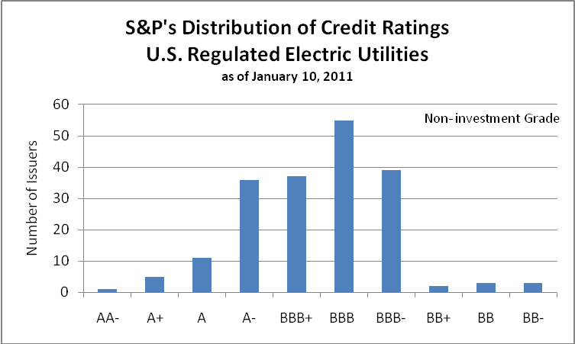
Avista
Investment Grade
Q. Please explain the implications of the credit ratings in terms of the Company’s ability to access financial markets.
A. Credit ratings impact investor demand and expected return. More specifically, when the Company issues debt, the credit rating is one factor that helps determine the interest rate at which the debt will be issued. The credit rating also determines the type of investor who will be interested in purchasing the debt. For each type of investment a potential investor could make, the investor looks at the quality of that investment in terms of the risk they are taking and the priority they would have in the event that the organization experiences severe financial stress. Investment risks include the likelihood that a company will not meet all of its debt obligations in terms of timeliness and amounts owed for principal and interest. Secured debt receives the highest ratings and priority for repayment and, hence, has the lowest relative risk. In challenging credit markets, where investors are less likely to buy corporate bonds (as opposed to U.S. Government bonds), a higher credit rating will attract more investors, and a lower credit rating could reduce or eliminate the number of potential investors. Thus, lower credit ratings may result in a company having more difficulty accessing financial markets and/or incur significantly higher financing costs.
Q. What credit rating does Avista Corporation believe is appropriate?
A. The move to investment grade for Avista Corp was a significant step in improving the Company’s ability to access capital at a reasonable cost. As Avista experienced, it took approximately six years for the Company to regain its investment grade rating from S&P after it was downgraded during the energy crisis. The difference between investment grade and non-investment grade is not only a matter of debt pricing, but also the ability to access markets. To avoid adverse circumstances, Avista should operate at a level that will support a solid corporate investment grade credit rating, meaning operating at a “BBB” or “BBB+” corporate credit rating using S&P’s rating scale. As shown in Illustration 2 above, BBB/BBB+, is the average rating of U.S. regulated electric utilities. The Company’s goal is to maintain a credit rating of at least the utility average. A further upgrade to BBB+ would further strengthen the Company by lowering debt pricing and attracting additional investors.
A solid investment grade credit rating also allows the Company to post less collateral with counterparties than would otherwise be required with a lower credit rating, which we experienced first-hand with the recent upgrade.
Financially healthy utilities have lower financing costs which, in turn, benefit customers. In addition, financially healthy utilities are better able to invest in the needed infrastructure over time to serve their customers, and to withstand the challenges and risks facing the industry.
Q. What financial metrics are used by the rating agencies to establish credit ratings?
A. S&P’s financial ratio benchmarks used to rate companies such as Avista are set forth in Illustration No. 3 below.
Illustration No. 3:

Standard & Poor's Financial Risk Indicative Ratios
 | FFO/Debt (%) | FFO/Interest (x) | Debt/Capital (%)
Minimal | Greater than 60 | (a) | Less than 25
Modest | 45 - 60 | (a) | 25 - 35
Intermediate | 30 - 45 | (a) | 35 - 45
Significant | 20 - 30 | (a) | 45 - 60
Aggressive | 12 - 20 | (a) | 50 - 60
Highly leveraged | Less than 12 | (a) | Greater than 60
12 Months Ended 12/31/10 Ratios:
Avista Adjusted ^{(b)} | 18.23% | 4.02x | 53.96%
^{(a)} Not available, however, S&P has indicated that it is a benchmark ratio used for the Utility industry.
^{(b)} Calculated as of 12/31/10 based on last known S&P methodology

The ratios above are utilized to determine the financial risk profile. Currently, Avista is in the “Aggressive” category. The financial risk category along with the business risk profile (Avista is in the Excellent category) is then utilized in Illustration No. 4 below to determine a company’s rating. S&P currently has Avista’s corporate credit rating as a BBB, based upon an “Aggressive” financial risk profile and “Excellent” business risk profile.
Illustration No. 4:

Standard & Poor's Business and Financial Risk Profile Matrix
 |  | Financial Risk Profile
Business Risk Profile |  | Minimal | Modest | Intermediate | Significant | Aggressive | Highly Leveraged
Excellent |  | AAA | AA | A | A- | BBB | -
Strong |  | AAA | A | A- | BBB | BB | BB-
Satisfactory |  | A- | BBB+ | BBB | BB+ | BB- | B+
Fair |  | - | BBB- | BB+ | BB | BB- | B
Weak |  | - | - | BB | BB- | B+ | B-
Vulnerable |  | - | - | - | B+ | B | CCC+

Moody’s uses a similar methodology to analyze and determine utility credit ratings.
Q. Please describe how S&P’s Financial Risk ratios are calculated and what they mean?
A. The first ratio, “Funds from operations/total debt (%)”, calculates the amount of cash flow from operations as a percent of total debt. The ratio indicates the company’s ability to fund debt obligations. The second ratio, “Funds from operations/interest coverage (x)”, calculates the amount of cash from operations that is available to cover interest requirements. This ratio indicates how well a company’s earnings can cover interest payments on its debt. The third ratio, “Total debt/total capital (%)”, is the amount of debt in our total capital structure. The ratio is an indication of the extent to which the company is using debt to finance its operations. S&P looks at many other financial ratios; however, these are the three most important ratios they use when analyzing our financial profile.
Q. Do rating agencies make adjustments to the financial ratios that are calculated directly from the financial statements of the Company?
A. Yes. Rating agencies make adjustments to debt to factor in off-balance sheet commitments (e.g., purchased power agreements and the unfunded status of pension and other post-retirement benefits) that negatively impact the ratios. For example, in 2010 S&P made adjustments to Avista’s debt totaling approximately $81 million primarily related to the purchased power, post-retirement benefits, and non-recourse debt. The adjusted financial ratios for Avista are included in Illustration No. 3 above.
Q. What other risks are Avista and the utility sector facing that may impact credit ratings?
A. Avista’s credit ratings are impacted by risks that could negatively affect the Company’s cash flows. These risks include, but are not limited to, the level and volatility of wholesale electric market prices and natural gas prices for fuel costs, liquidity in the wholesale market (fewer counterparties and tighter credit restrictions), recoverability of natural gas and power costs, streamflow and weather conditions, changes in legislative and governmental regulations, rising construction and raw material costs, customers’ ability to timely pay their bills, and access to capital markets at a reasonable cost.
Credit ratings for the utility sector are also adversely impacted by large capital expenditures for new generation, transmission and distribution facilities, and environmental compliance. The utility sector is in a cycle of significant capital spending, which will likely be funded by significant issuances of debt and equity. This increases the competition for financial capital.
The increased capital spending needs and resulting increased debt and equity issuances make regulation supporting the full and timely recovery of prudently incurred costs even more critical to the utility sector than in previous years.
Q. How important is the regulatory environment in which a Company operates?
A. The regulatory environment in which a company operates is a major qualitative factor in determining a company’s creditworthiness. Moody’s stated the following regarding Avista’s regulatory environment in March 2011’s credit opinion:
Avista's ratings could be negatively impacted if the level of regulatory support wanes, if the contribution of its unregulated business were to increase disproportionately to those of its regulated operations, or if CFO pre-WC to debt and CFO pre-WC interest coverage were to fall below 15% and 3.5x, respectively, for a sustainable period.

S&P stated the following:
Regulation is the most critical aspect that underlies regulated integrated utilities’ creditworthiness. Regulatory decisions can profoundly affect financial performance. Our assessment of the regulatory environments in which a utility operates is guided by certain principles, most prominently consistency and predictability, as well as efficiency and timeliness. For a regulatory process to be considered supportive of credit quality, it must limit uncertainty in the recovery of a utility’s investment. They must also eliminate, or at least greatly reduce, the issue of rate-case lag, especially when a utility engages in a sizable capital expenditure program. (emphasis added)
Due to the major capital expenditures planned by Avista, a supportive regulatory environment will be critical to Avista’s financial health.

IV. CASH FLOW
Q. What are the Company’s sources to fund capital requirements?
A. The Company utilizes cash flow from operations, long-term debt and common stock issuances to fund its capital expenditures. Additionally, on an interim basis, the Company utilizes its credit facility to fund capital needs until longer-term financing can be obtained.
Q. What are the Company’s near-term capital requirements?
A. As a combination electric and natural gas utility, over the next few years, capital will be required for investment in generation upgrades, expansion and replacement of transmission and distribution facilities, customer growth as well as necessary upgrade and replacements of our natural gas systems.
The amount of capital expenditures planned for 2011-2012 is approximately $482 million and over a five year period ending December 31, 2015 approximately $1.2 billion. For 2011, alone, these costs equate to a total of approximately $250 million, including AFUDC. Total company rate base as of December 31, 2010, was $2.1 billion; therefore, these planned capital additions represent substantial new investments given the relative size of the Company.
Major capital expenditures are a normal part of utility operations. Customers are added to the service area, roads are relocated and require existing facilities to be moved, and facilities continue to wear out and need replacement. These and other requirements create the need for significant capital expenditures each year.
Q. What are the Company’s long-term capital requirements related to new energy resources?
A. Avista’s Integrated Resource Plan has identified the potential need for the Company to finance significant expenditures for electric generating facilities. The preferred strategy outlined in our 2009 Integrated Resource Plan included total expenditures of $1.25 billion by 2020, including investment in wind resources and combined-cycle combustion turbines (to meet customer load) as well as upgrades at hydroelectric stations.
Q. What are the Company’s near-term plans related to its debt?
A. In 2011 the Company plans on remarketing $83.7 million of Pollution Control Revenue Bonds. The proceeds of the planned remarketing of the $83.7 million Pollution Control Revenue Bonds in 2011 will be used to repay funds borrowed under our credit facility. Illustration No. 5 below shows the amount of debt maturities for Avista each year including the maturity dates of the forecasted remarketing of the Pollution Control Revenue Bonds (labeled as (a) and (b) on the chart):
Illustration No. 5:
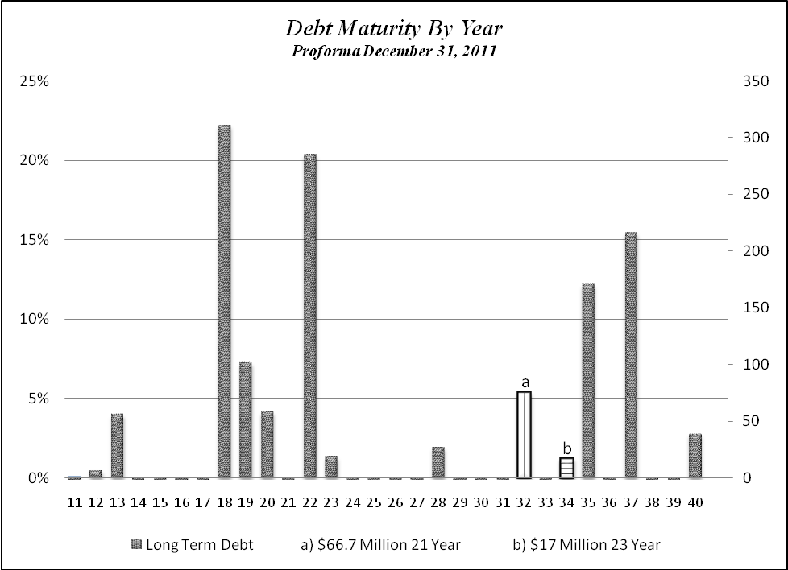
Q. What is the status of the Company’s line of credit agreements secured by first mortgage bonds and its accounts receivable program?
A. In February 2011, Avista entered into a four-year committed line of credit in the amount of $400 million with an expiration date of February 2015. This committed line of credit replaced the $320 million and $75 million committed line of credit agreements that had an expiration date of April 2011. The new committed line of credit is secured by $400 million of non-transferable First Mortgage Bonds of the Company.
The facility has been sized to allow the Company to maintain adequate liquidity to cover daily cash needs, manage counterparty collateral requirements, and avoid issuing securities in unfavorable markets. We believe our current agreement provides us adequate liquidity and flexibility to face volatile financial markets and volatile energy commodity prices.
This line of credit is our primary source of immediate cash for borrowing to meet daily cash management needs and supports the issuance of letters of credit and cash for collateral needs. This credit facility is required to manage daily cash flow since the timing of cash receipts versus cash disbursements is never totally balanced.
In December 2010, the Company terminated the Accounts Receivables program. We elected to terminate the Receivables Purchase Agreement prior to its March 2011 expiration date based primarily on the Company’s forecasted liquidity needs, the fact that S&P was not recognizing the Program as a liquidity source, as well as the increase in costs associated with establishing a new multi-year program.
Q. Is there pending legislation that may impact the Company’s collateral requirements?
A. Yes. The Dodd-Frank Wall Street Reform and Consumer Protection Act (Dodd-Frank Act) was signed into law on July 21, 2010. The Dodd-Frank Act establishes regulatory jurisdiction by the Commodity Futures Trading Commission (CFTC) and the Securities and Exchange Commission (SEC) for certain swaps (which include a variety of derivative instruments) and the users of such swaps, that otherwise would have been exempted under the Commodity Exchange Dodd-Frank Act, federal securities laws and federal banking laws.
A variety of rules must be adopted by federal agencies (including the CFTC, SEC and the FERC) to implement the Dodd-Frank Act. These rules, which will be developed and implemented over timeframes as defined in the Dodd-Frank Act, could have a significant impact on Avista Corp. that was not clearly defined in the Act itself.
Under the Dodd-Frank Act, “Swap Dealers” and “Major Swap Participants” will be required to post collateral to meet minimum capital requirements as well as minimum initial and variation margin requirements, the purpose of which is to ensure the safety and soundness of the capital markets by addressing concerns brought about by the global financial crisis of 2007 and 2008. Swap Dealers and/or Major Swap Participants are persons who serve as dealers in swaps or who maintain a substantial position in swaps, for reasons other than mitigating commercial risk.
The Dodd-Frank Act also requires a broad category of swaps to be cleared and traded on registered exchanges or special derivatives exchanges. Such clearing requirements would result in a significant change from our current practice of bilateral transactions and negotiated credit terms. An exemption to such clearing requirements is outlined in the Dodd-Frank Act for end users that are not Major Swap Participants or Swap Dealers and enter into hedges to mitigate commercial risk. We expect to qualify under the end user exemption; however, concern remains that counterparties that are Swap Dealers or Major Swap Participants will pass along the increased cost and margin requirements through higher prices and reductions in unsecured credit limits.
We continue to monitor developments and cannot predict the impact the Dodd-Frank Act may ultimately have on our operations.
Q. What are Avista’s plans regarding common equity and why is this important?
A. Avista continuously monitors the common equity ratio of its capital structure, and assesses the need to issue additional common equity. In 2010, we issued $46.2 million, including $43.2 million under the Periodic Offering Program (POP). As of December 31, 2010, we had 1.0 million shares available to be issued under the POP. We expect to issue up to $25 million of common stock in 2011 in order to maintain our capital structure at an appropriate level for our business.. It is important to the rating agencies for Avista to maintain a balanced debt/equity ratio in order to minimize the risk of default on required debt interest payments.
Dr. Avera notes that electric utilities are facing, among other things, rising cost structures, the need to finance significant capital investment plans, and uncertainties over accommodating future environmental mandates. A more conservative financial profile, in the form of a higher common equity ratio, is consistent with the increasing uncertainties and the need to maintain continuous access to capital that is required to fund operations and necessary system investment.
In his testimony Dr. Avera concludes that the 48.04 percent common equity ratio is reasonable based on the following:
• Avista’s requested capitalization is consistent with the Company’s need to maintain its credit standing and financial flexibility as it seeks to raise additional capital to fund significant system investments and meet the requirements of its service territory;

• Avista’s proposed common equity ratio is entirely consistent with the range of capitalizations maintained by the proxy group of utilities, and falls below the 49.3 percent and 51.5 percent average common equity ratios for the proxy utilities, based on year-end 2010 data and near-term expectations, respectively; and,

• The requested capitalization reflects the importance of an adequate equity layer to accommodate Avista’s operating risks and the pressures of funding significant capital investments. This is reinforced by the need to consider the impact of uncertain capital markets conditions, as well as off-balance sheet commitments such as purchased power agreements, which carry with them some level of imputed debt. ((Exhibit No. ___ (WEA-1T), P. 6, ll. 11-25).

V. CAPITAL STRUCTURE
Q. Please explain the capital structure proposed by Avista in this case.
A. Avista’s current capital structure consists of a blend of total debt, including long-term and short-term debt, and common equity necessary to support the assets and operating capital of the Company. The proportionate shares of Avista Corp.’s pro forma capital structure are 48.04% common equity, and 51.96% total debt as shown on page 2 of Exhibit No.___ (MTT-2), additional details related to these adjustments are located on pages 3 through 5 of Exhibit No.___ (MTT-2).

VI. COST OF DEBT
Q. How have you determined the cost of debt?
A. Cost of total debt in the Company’s proposed capital structure includes long-term debt and the forecasted monthly average of short-term debt (for the period December 31, 2010 through December 31, 2011). As shown on page 2 of Exhibit No.___ (MTT-2), the actual weighted average cost of total debt outstanding on December 31, 2010 was 5.61%. The size and mix of debt changes over time based upon the actual financing completed. We have made certain pro forma adjustments to update the debt cost through December 31, 2011 to 5.76%, which is a reduction from the 5.92% currently allowed in rates. Pro forma adjustments to total debt reflect the issuance of new debt and the forecasted monthly average of short-term debt for the pro forma period.
We are anticipating the cost of debt to rise to 5.76% in 2011, from 5.61% in 2010. This increase is mainly due to the increased cost of short term debt and the remarketing of the Pollution Control Revenue Bonds, which are currently owned by the Company and were purchased with borrowings under the credit facility. The increase in the cost of short term debt is due to the increase in fees and margins related to the line of credit that was executed in February 2011, which replaced the $320 million credit facility. More specifically, the Eurodollar Margin (the spread paid over LIBOR) on the new $400 million line of credit, based on our current credit rating, is 1.30% and the facility fee is 0.20% as compared to 0.30% and 0.10%, respectively under the prior $320 million line of credit.

VII. COST OF COMMON EQUITY
Q. What rate of return on common equity is the Company proposing in this proceeding?
A. The Company is proposing a 10.90% return on common equity (ROE), which falls essentially at the midpoint of Dr. Avera’s recommended range of required return on equity. Dr. Avera testifies to analyses related to the cost of common equity with an ROE range of 10.3% to 11.3% and 10.45% to 11.45% (after accounting for the impact of common equity flotation costs). In his testimony Dr. Avera states that:
My conclusion that a 10.90 percent ROE for Avista is a reasonable estimate of investors’ required return is also reinforced by the greater uncertainties associated with Avista’s relatively small size, the economic reality that Avista’s actual returns have fallen consistently short of the allowed ROE, and the fact that current cost of capital estimates are likely to understate investors’ requirements at the time the outcome of this proceeding becomes effective and beyond. (Exhibit No.___(WEA-1T), at P.5, ll. 18-24)

With regard to the Weighted Cost of Equity (ROE x equity layer) authorized by other state commissions across the country, the following graph shows the weighted cost of equity (WCOE) authorized by state commissions for the most recent rate cases of the Utility Proxy Group in Dr. Avera’s testimony. The Illustration below shows that the majority of WCOEs are at 5.0% or above.
Illustration No. 6:
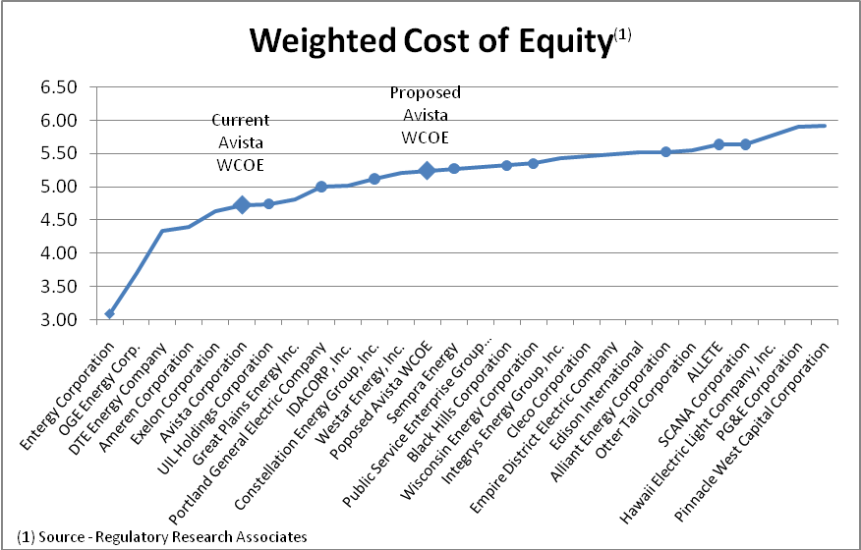

The dots on the graph reflect authorized WCOEs within the last six-months, which highlights the fact that recent commission orders are continuing to provide supportive equity components (ROEs and equity layers) that are essential to attract the equity investment necessary to fund the infrastructure required by utilities to provide reliable service to customers.
The diamonds on the graph reflect Avista’s currently authorized WCOE of 4.74% (10.2% ROE x 46.5% equity layer), and Avista’s proposed WCOE of 5.24% (10.9% ROE x 48.04% equity layer).
I believe this weighted cost of equity would allow Avista to successfully compete for equity capital from investors
Q. Please summarize the proposed capital structure and the cost components for debt and common equity.
A. As also shown on page 2 of Exhibit No.___ (MTT-2), the following illustration shows the capital structure and cost components proposed by the Company.
Illustration No. 7:
AVISTA CORPORATION
Proforma Cost of Capital
December 31, 2011
 |  |  |  | Percent of
 |  | Amount |  | Total Capital |  | Cost |  | Component
 | Total Debt | $ 1,304,517,375 |  | 51.96% |  | 5.76% |  | 2.99%
 | Common Equity | 1,205,989,116 |  | 48.04% |  | 10.90% |  | 5.24%
 | Total | $ 2,510,506,491 |  | 100.00% |  |  |  | 8.23%
Q. Does that conclude your pre-filed direct testimony?

A. Yes.

2011 Noxon facility upgrade project to be completed in May 2011 is the only exception.
Bluefield Water Works & Improvement Co. v. Pub. Serv. Comm'n, 262 U.S. 679 (1923).
Fed. Power Comm'n v. Hope Natural Gas Co., 320 U.S. 591 (1944).
As Dr. Avera notes in his testimony. “(w)hile the ratings agencies were faulted during the financial crisis for failing to adequately assess the risk associated with structured finance products, investors continue to regard corporate credit ratings as a reliable guide to investment risks.” Exhibit No.___(WEA-3) P. 6
Moody’s Investor Service, Moody’s Investor Services, Rating Action: Moody's upgrades Avista's ratings to Baa2, Stable, March 2011
Standard and Poors, Key Credit Factors: Business and Financial Risks in the Investor-owned Utilities Industry, March 2010.

