Cristalina
Water Company

January 10, 2010

VIA EMAIL (records@utc.wa.gov)
Utilities & Transportation Commission
ATTN: Records Center
1300 South Evergreen Park Drive SW
Olympia, Washington 98504

RE: Cristalina LLC
Dockets UW-090516 & UW-090839

Dear Sir or Madame:

Attached please find December water use data which is being filed to meet compliance requirements in the above referenced dockets. The well-head readings are included under #1015.

If you have any questions or concerns, please feel free to contact our office. Thank you very much.

Sincerely,
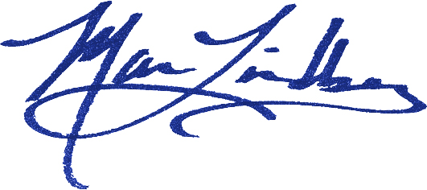
Maria Lindberg
Owner

ML:tc
Attachment

Cristalina Water LLC, PO Box 2626, Bellingham WA 98227

