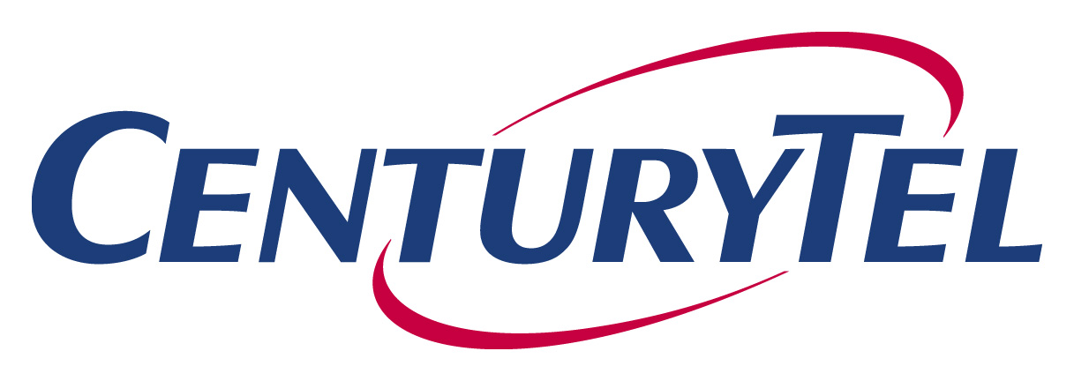

July 26, 2006

VIA E-FILING AND OVERNIGHT MAIL

Ms. Carole J. Washburn
Washington Utilities and Transportation Commission
1300 S. Evergreen Park Dr. SW
Olympia, WA 98504-7250

Re: Docket No. UT-063038 – Qwest Complaint re: VNXX

Dear Ms. Washburn:

CenturyTel hereby waives any objection to possible ex parte communications resulting from the participation of Mr. Williamson, member of Commission Staff, in the arbitration proceedings between Level 3 and Qwest, Docket No. UT-063006, which may be similar to those issues presented in the above noted Docket, in which Mr. Williamson is likely to appear as a Staff witness.

Very truly yours,

Calvin K. Simshaw
Assoc. General Counsel-Regulatory

CKS/rp

cc: ALJ Rendahl
Service List

