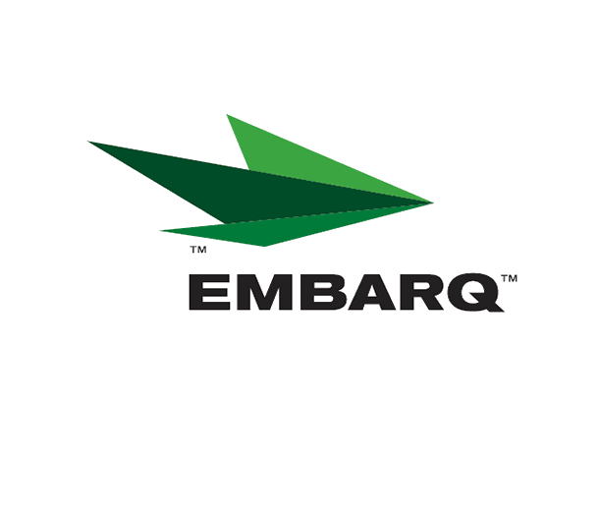


March 24, 2008

Ms. Carole J. Washburn, Secretary
Washington Utilities & Transportation Commission
P. O. Box 47250
Olympia, Washington 98504-7250

Re: Washington Quality of Service Report

Dear Ms. Washburn:

Attached is United Telephone Company of the Northwest d.b.a. EMBARQ “Service Quality Reports” for the month of February 2008.

The trouble reports per 100 access lines objective was met for the month of February in all exchanges.

Should you have any questions, please contact me at (541) 387-9289 or by e-mail at Becky.Sandercock@embarq.com.

Sincerely,

Becky Sandercock
Regulatory and External Affairs Docket Manager

Enclosures: Installation/Repair Appointments
Service Activation in 5 Days
Trouble Per 100/Access Lines
Switching – Dial Tone Speed in 3 Seconds
Final Trunk Blockage (EAS and Toll)
Out of Service Trouble Cleared in 48 Hours
Not Out of Service Trouble Cleared in 72 Hours

