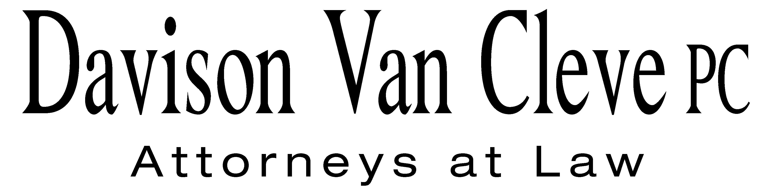
TEL (503) 241-7242 ● FAX (503) 241-8160 ● tcp@dvclaw.com
Suite 400
333 SW Taylor
Portland, OR 97204

January 8, 2015

Via E-Mail and Federal Express

Mr. Steven V. King
Executive Director and Secretary
Washington Utilities & Transportation Commission
1300 S. Evergreen Pk. Dr. S.W.
P. O. Box 47250
Olympia, WA 98504-7250

Re: Motion to Amend Procedural Schedule
Docket Nos. UE-121697/UG-121705 and UE-130137/UG-130138

Dear Mr. King:

Pursuant to communications with the Administrative Law Judge in the above-captioned proceedings, the Industrial Customers of Northwest Utilities (“ICNU”) respectfully moves for the hearing in these dockets to be rescheduled from February 2, 2015 to February 13, 2015. ICNU has communicated with the other parties to this proceeding that are likely to participate in the hearing and understands that they are available on the proposed date.

In addition, the parties have agreed to establish a discovery cut-off date of January 13, 2015 by the close of business. They have also agreed to a deadline for submission of cross-examination exhibits of February 9, 2015, and a deadline for the presentation of witnesses of February 10, 2015. Accordingly, ICNU further moves for these dates to be adopted as part of the procedural schedule in this case.

Thank you for your assistance. If you have any questions, please do not hesitate to contact me.

Sincerely,

/s/ Tyler C. Pepple
Tyler C. Pepple

cc: Service List

