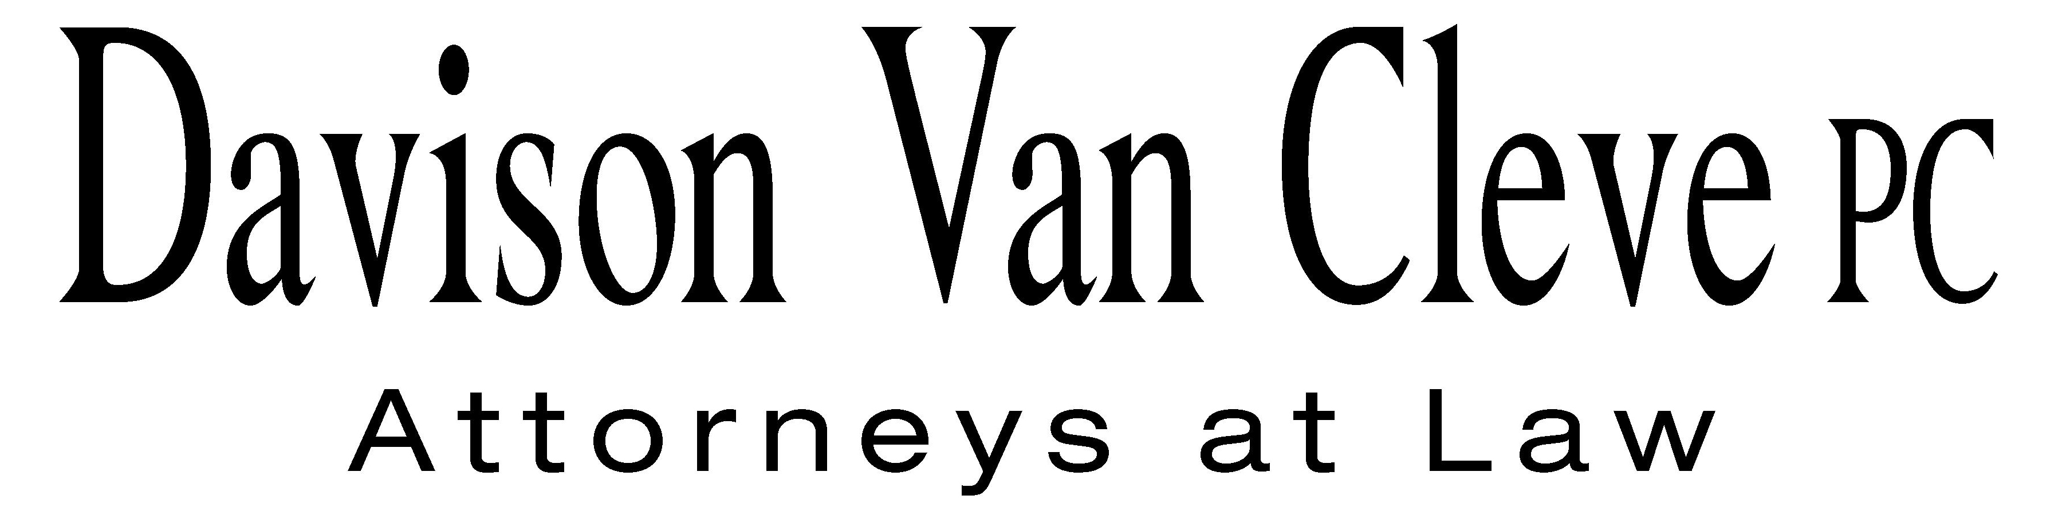
TEL (503) 241-7242 ● FAX (503) 241-8160 ● mail@dvclaw.com
Suite 400
333 SW Taylor
Portland, OR 97204

May 20, 2010

Via Email and Federal Express

Carole J. Washburn
Secretary
Washington Utilities and Transportation Commission
PO Box 47250
1300 S Evergreen Park Drive SW
Olympia, WA 98504-7250

Re: In the matter of the PacifiCorp’s general rate increase.
Docket No. UE-100749

Dear Ms. Washburn:

Enclosed please find an original and twelve (12) copies of the Petition to Intervene of the Industrial Customers of Northwest Utilities.

Additionally, please find an original and twelve (12) copies of the Notice of Appearance of Melinda J. Davison and Irion A. Sanger on behalf of the Industrial Customers of Northwest Utilities.

Thank you for your assistance.

Sincerely yours,

/s/ Martin H. Patail
Martin H. Patail
Enclosures

cc: Service List

CERTIFICATE OF SERVICE

I hereby certify that I have this day served the foregoing documents upon all parties of record in this proceeding by mailing a copy thereof in a sealed, first-class postage prepaid envelope to each individual’s last-known address, as listed below.
DATED this 20th day of May, 2010.
Davison Van Cleve, P.C.

/s/ Martin H. Patail
Martin H. Patail

ANDREA KELLY  VICE PRESIDENT, REGULATION  PACIFICORP  825 NE MULTNOMAH, SUITE 800  PORTLAND OR 97232 | CATHIE ALLEN  PACIFIC POWER  REGULATORY AFFAIRS  825 NE MULTNOMAH STREET STE 2000  PORTLAND OR 97232  cathie.allen@pacificorp.com
KATHERINE MCDOWELL  MCDOWELL & RACKNER P.C.  520 SW 6TH AVENUE STE 830  PORTLAND OR 97204  katherine@mcd-law.com | MICHELLE R MISHOE  LEGAL COUNSEL  PACIFICORP  825 NE MULTNOMAH STE 1800  PORTLAND OR 97232  michele.mishoe@pacificorp.com
DON TROTTER  ASSISTANT ATTORNEY GENERAL  WUTC  ATTORNEY GENERAL SECTION  STATE MAIL STOP 40128  dtrotter@utc.wa.gov | SIMON FFITCH  OFFICE OF THE ATTORNEY GENERAL  PUBLIC COUNSEL  800 FIFTH AVENUE STE 2000  SEATTLE WA 98104-3188  simonf@atg.wa.gov

