BEFORE THE WASHINGTON UTILITIES AND
TRANSPORTATION COMMISSION

In the Matter of the Joint Application of  QWEST COMMUNICATIONS INTERNATIONAL INC. AND CENTURYTEL, INC.  For Approval of Indirect Transfer of Control of Qwest Corporation, Qwest Communications Company LLC, and Qwest LD Corp. | Docket No. UT-100820  JOINT MOTION TO  AMEND THE SCHEDULE

MOTION TO AMEND SCHEDULE
The Joint CLECs and the Joint Applicants respectfully submit this joint motion to amend the procedural schedule to permit CLEC Intervenors an opportunity to file, on November 1, 2010, supplemental responsive testimony relating to the Hart-Scott-Rodino Act documents (“HSR Documents”) produced by the Joint Applicants to the Intervenors on or about October 12, 2010, and to permit Joint Applicants to file rebuttal testimony relating to the HSR Documents on November 15, 2010. In support of this motion, Joint CLECs and Joint Applicants state as follows:
BACKGROUND
On September 20, 2010, Joint CLECs filed a motion to compel responses to Integra’s First Set of Information Requests, Request No. 143, and Commission Staff Request Nos. 13 and 133, which sought the production by Joint Applicants of the HSR Documents. Subsequently, Joint Applicants agreed to supplement their previous discovery responses to produce all of the HSR documents not previously produced. That production was made to Intervenors on or about October 12, 2010.
Pursuant to the procedural schedule in this docket, Staff, Public Counsel and Intervenor Responsive Testimony and Exhibits were due September 27, 2010, prior to October 12, 2010 receipt of the HSR Document production. Thus, CLEC Intervenors have not had an opportunity to address these HSR documents in pre-filed testimony.

PROPOSED AMENDMENT TO THE PROCEDURAL SCHEDULE
The procedural schedule calls for the filing of Staff, Public Counsel and Intervenor Cross-Answering Testimony and Exhibits on Monday, November 1, 2010. As a matter of convenience for the parties and the Commission, Joint CLECs and Joint Applicants have agreed that November 1, 2010 would be an appropriate date to allow CLEC Intervenors to also file supplemental responsive testimony and exhibits relating to the HSR Documents. Joint CLECs and Joint Applicants have also agreed that Joint Applicants should be afforded an opportunity to file rebuttal testimony and exhibits relating to the HSR documents on November 15, 2010. This additional testimony filing date is early enough that no other modifications to the procedural schedule would be necessary. Accordingly, Joint CLECs and Joint Applicants move the Commission for an Order modifying the procedural schedule to allow:
1) CLEC Intervenors to file supplemental testimony and exhibits relating to the HSR Documents on November 1, 2010; and 2) Joint Applicants to file rebuttal testimony and exhibits relating to the HSR Documents on November 15, 2010.
No parties to the proceeding will be prejudiced by the proposed modification to the procedural schedule.
CONCLUSION
For the foregoing reasons, the Joint CLECs and the Joint Applicants respectfully requests that the procedural schedule be modified as set forth above.

DATED this ______ day of October, 2010.

DAVIS WRIGHT TREMAINE LLP

By:
MARK TRINCHERO, OSB #883221
Email: marktrinchero@dwt.com
Telephone: (503) 241-2300
Facsimile: (503) 778-5299
Of Attorneys for Joint CLECs Telecom
CENTURYLINK QWEST
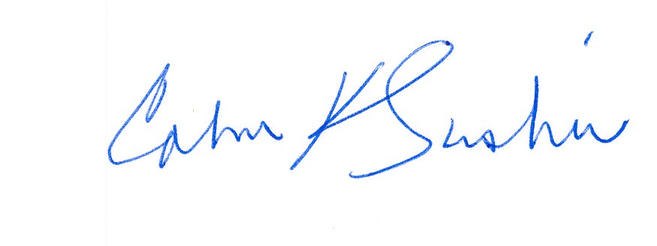
Calvin K. Simshaw Lisa A. Anderl (WSBA # 13236)
CenturyLink Qwest Law Department
805 Broadway 1600 – 7th Ave., room 1506
Vancouver, WA 98660 Seattle, WA 98191
calvin.simshaw@centurylink.com lisa.anderl@qwest.com

Joint CLECs: Integra Telecom of Washington, Inc., Electric Lightwave, Inc., Advanced TelCom, Inc., United Communications, Inc. d/b/a Unicom (collectively, “Integra”), tw telecom of Washington, LLC, XO Communications Services, Inc., Pac-West Telecomm, Inc., McLeodUSA Telecommunications Services, Inc., d/b/a PAETEC Business Services, Covad Communications Company, and Charter Fiberlink WA-CCVII, LLC.
Joint Applicants: Qwest Communications International, Inc. (“Qwest”) and CenturyTel, Inc. (“CenturyLink”).
Staff and Public Counsel were provided the full set of HSR documents in July 2010.

