
David S. Valdez
Vice President
Public Policy & External Affairs
WA0101RA
1800 41st Street
P.O. Box 1003
Everett, WA 98201
Phone 425 261-5691
Fax 425 261-5262
October 6, 2005

Ms. Carole Washburn, Executive Secretary
Washington Utilities and
Transportation Commission
1300 S. Evergreen Park Drive S.W.
Olympia, Washington 98504-7250

Dear Ms. Washburn:

Subject: Verizon Communications Inc. and MCI, Inc. Reply Testimony – Docket No. UT-050814

Pursuant to Paragraph 14 of Order No. 01 dated June 23, 2005 in the above referenced docket, please find enclosed for filing an original and nine (9) copies of the rebuttal testimony of 1) Dr. Carl R. Danner; 2) Dr. William E. Taylor; 3) Michael A. Beach; 4) Julie A. Canny; and 5) Stephen E. Smith.

Some of the testimony and exhibits are designated confidential pursuant to WAC 480-07-160, and the Protective Order in this matter. Therefore, these documents are being provided on canary yellow paper in a separate, sealed envelope. Some of the testimony and exhibits are designated highly confidential pursuant to WAC 480-07-160, and the Protective Order in this matter. Therefore, these documents are being provided on light blue paper in a separate, sealed envelope.

If you have any questions please call me at (425) 261-5691.

Very truly yours,

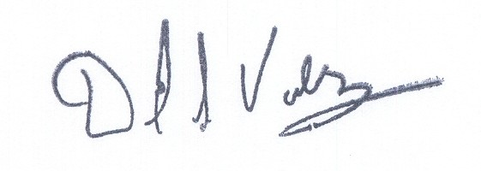

David S. Valdez

DSV:kad
Enclosures

c: Service List

