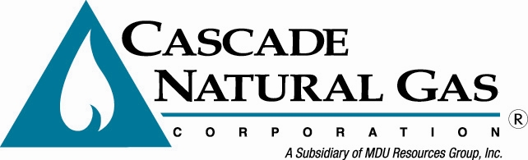

Washington Customer Notice
Cascade Natural Gas files to Increase Prices

September 2016 - Cascade Natural Gas Corporation filed its annual Conservation Program Adjustment with the Washington Utilities and Transportation Commission (UTC) to reflect a slight increase in annual conservation program costs. The request will increase residential customers’ natural gas bills by
0.37 percent, or about $0.17 more per month.

At the same time, Cascade will update its annual adjustment for the pipeline replacement cost recovery mechanism. By itself, the effect of this filing on the average residential customer would be a 0.92 percent increase, or about $0.50 more per month. For the average commercial customer it would be a 0.74 percent increase, or about $1.80 more per month.

These two filing are expected to become effective November 1, 2016.

You may contact the UTC at 1-888-333-9882, by fax at 360-586-1150 or website www.utc.wa.gov. Consumers can file comments on the homepage by clicking on the Submit a Comment link at the top of the page. Comments can also be mailed to: UTC, 1300 S. Evergreen Park Drive S.W., P.O. Box 47250, Olympia, WA 98504-7250; or by e-mail at: comments@utc.wa.gov.

Cascade Natural Gas is a natural gas distribution company serving approximately 272,000 residential, commercial, industrial and transportation customers in 96 communities in Washington and Oregon. Cascade is a subsidiary of MDU Resources Group, Inc., a multidimensional natural resources enterprise traded on the New York Stock Exchange as “MDU.” For more information about MDU Resources, visit the company’s website at www.mdu.com. For more information about Cascade, visit www.cngc.com or call 1-888-522-1130.

