June 29, 2016

VIA ELECTRONIC FILING SYSTEM

Mr. Steven V. King
Washington Utilities & Transportation Commission
1300 S. Evergreen Park Drive SW
Olympia, WA 98504-7250

RE: 2016 ETC Certification – Eligible Telecommunications Carrier’s Annual Report on High Cost Fund Support Pursuant to WAC 480-123-060, 070, and 080 and Affidavit Pursuant to WAC 480-123-060 and 070.

Pend Oreille Telephone Company electronically submits its redacted ETC Annual Report and Affidavits pursuant to WAC 480-123-060, 070, and 080. Please be advised that a native version of some of the files is not available.

Please feel free to contact me with any questions regarding this particular matter.

Sincerely,
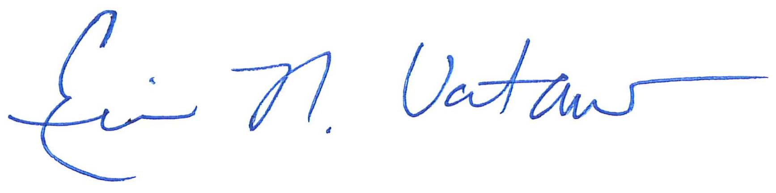
Eric N. Votaw, Senior Manager for
Moss Adams LLP
Enclosures

Cc: Susan Case – Pend Orielle Telephone Company

