WN U-74 |  |  | Fifth Revision of Sheet No. 37.2
 |  |  | Canceling Fourth Revision of Sheet No. 37.2
PACIFIC POWER & LIGHT COMPANY
 |  |  |  |  |  |  |  |  |  |  | FOR COMMISSION’S RECEIPT STAMP
 | SCHEDULE 37  COGENERATION AND SMALL POWER PRODUCTION  (Continued)  - The Company will purchase the entire output from the Seller’s facility, or if the Seller wishes to reduce his net delivery and billing from the Company, the Company will purchase the net output from the Seller’s facility. The metering configuration to measure such purchases will be specified in the Power Purchase Agreement and/or Interconnection Agreement.  - The Avoided Cost rates are fixed for five years. However, these rates are recalculated every year and applicable to any seller that enters into power purchase agreement with PacifiCorp in that year.  GENERAL RULES AND PROVISIONS:  Service under this schedule is subject to the General Rules and Provisions contained in this tariff.  AVOIDED COST RATES:  No capacity payment is made in 2011 because the Company is capacity surplus during the winter peak 2011. |  |  |  |  |  |  |  |  |  |  |  | (C)  (C)
   | Deliveries | Capacity | Energy
   | During | Payment | Payment
   | Calendar Year | $/kW - Month | $/MWH
   | 2010 | $1.81 | 45.70
   | 2011 | $0.00 | 50.02
   | 2012 | $1.88 | 50.62
   | 2013 | $1.92 | 51.02
   | 2014 | $1.95 | 51.79
Issued |  |  |  |  | February 10, 2010 |  | Effective |  |  | February 26, 2010
Issued by |  |  |  | PACIFIC POWER & LIGHT COMPANY
By |  | 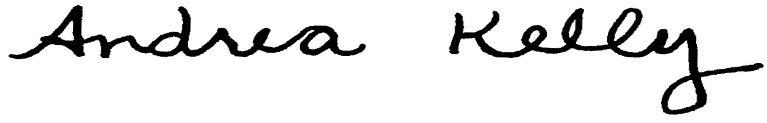  Andrea L. Kelly |  |  |  |  |  | Title | VP, Regulation
 |  | TF2 37-2.REV |  |  |  | Advice No. |  |  |  |  |  | 09-06
Form F

