7/31/2026
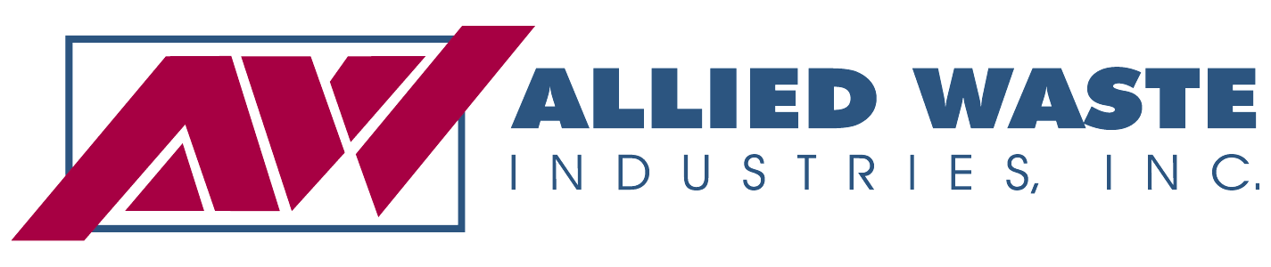
Dear Valued Commercial Customer,

This letter is to notify you of proposed rate increases for our commercial services within the areas of King County, if approved by the Washington Utilities and Transportation Commission (UTC).

The proposed rate increase is needed because the Company has incurred increased costs, primarily labor and fuel costs. If approved, the proposed rates will become effective August 1, 2008.
Pickup Current Rate Proposed Rates
Commercial Service Frequency Per Pick Up Monthly Rent Per Pick Up Monthly Rent
90 Gal Can Weekly weekly 6.41 1.50 8.67 1.50
1 yard container weekly 12.06 7.00 16.63 10.15
1.5 yard container weekly 17.29 8.50 23.68 11.45
2 yard container weekly 22.22 9.50 30.61 12.38
3 yard container weekly 33.39 12.00 45.65 14.70
4 yard container weekly 43.85 13.75 59.85 17.02
6 yard container weekly 69.67 20.00 95.32 22.44
8 yard container weekly 92.00 23.50 125.42 26.31

Roll Off Service
30 yard container on call 118.00 97.33 145.10 94.05
Delivery 85.00 85.00

The proposed rate increases for our commercial, roll off and multi family services range from 0% to 54.0% and not all services are listed above.

If you have questions about the proposed rate increase you may contact the company at (206)-652-8832 or by email at kentmeridianseatacdisposal@awin.com.

The commission has the authority to set final rates that may vary from the company’s request, depending on the results of its investigation. To comment on this filing, be added to the commission’s mailing list, or ask questions about the ratemaking process, please use the contact information below. You may also comment in person at the commission’s open meeting at 1300 S. Evergreen Park Dr. SW in Olympia at 9:30 a.m. on June 12, 2008, or by using the “Public Comment” feature at the commission’s web site, at http://www.utc.wa.gov/comment. The commission is scheduled to make a decision at its open meeting on June 26.

If you are unable to attend the open meeting in person, you can participate or listen by telephone. Call 360-664-1234 for instructions the day before the open meeting.

You may also comment by using the “Public Comment” feature at the commission’s web site, at http://www.utc.wa.gov or you may continue to provide your comments in the following manner:

Mail: Post Office Box 47250, Olympia, WA 98504-7250
E-mail: comments@utc.wa.gov
Telephone: 1-800-562-6150

We look forward to continued service to you.

Allied Waste Services

