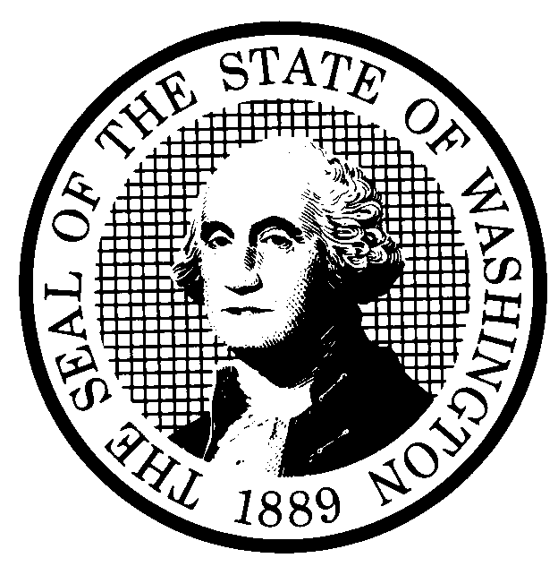 | PREPROPOSAL STATEMENT OF INQUIRY  (RCW 34.05.310) |  |  | CR-101 (710/97)  Do NOT use for expedited repeal or adoption
Agency: Washington Utilities and Transportation Commission

Subject of possible rule making:
Examine the need to reorganize, revise, repeal, and adopt rules governing the conduct of business before the Commission, including rules governing formal proceedings, such as the rules presently codified in Chapter 480-09 WAC – Procedure.

Docket No. A-010648
(a) Statutes authorizing the agency to adopt rules on this subject:

RCW 80.01.040(4) and RCW 34.05.020
(b) Reasons why rules on this subject may be needed and what they might accomplish:
It is important that there be clearly stated methods and opportunities to interact with the Commission in adjudications, rulemakings, and in the conduct of other business. The Commission’s experience since it last revised rules governing the conduct of business before the Commission demonstrate the need to inquire into existing procedures and consider whether new or amended rules are required. New or amended rules may be needed to improve the handling of confidential documents, discovery in adjudicative proceedings, and other processes routinely undertaken in the conduct of Commission business.
(c) Identify other federal and state agencies that regulate this subject and the process coordinating the rule with these agencies: N/A
(d) Process for developing new rule (check all that apply):
Negotiated rule making
Pilot rule making
x Agency study
x Other (describe) The Commission will schedule one or more workshops with representatives of affected constituencies in a manner designed to develop consensus among affected interests regarding any rule proposal. The first workshop is scheduled for June 22, 2001, at 1:30 p.m., at the Commission’s office in Olympia, Washington. The Commission will ask for initial written comments by July 13, 2001, and will provide the opportunity for additional comments.
(e) How interested parties can participate in the decision to adopt the new rule and formulation of the proposed rule before publication:
(List names, addresses, telephone, fax numbers of persons to contact; describe meetings, other exchanges of information, etc.)
Interested persons may contact the Secretary, Washington Utilities and Transportation Commission, P.O. Box 47250, 1300 S. Evergreen Park Drive, S.W., Olympia, Washington, 98504-7250; Telephone (360) 664-1174; Facsimile (360) 586-1150

For specific information regarding opportunities for written comment, opportunities for participation in workshops, and to ensure receipt of further information concerning this rulemaking, please see the attachment to this form.

 |  |  | CODE REVISER USE ONLY
NAME (TYPE OR PRINT)
Carole Washburn

SIGNATURE
TITLE  Secretary |  | DATE  June 1, 2001

