
David S. Valdez
Vice President
Public Affairs, Policy & Communications
WA0101RA
1800 41st Street
P.O. Box 1003
Everett, WA 98201
Phone 425 261-5691
Fax 425 261-5262
May 12, 2005

Advice No. 3144

Ms. Carole Washburn, Executive Secretary
Washington Utilities and
Transportation Commission
1300 S. Evergreen Park Drive S.W.
Olympia, Washington 98504-7250

Dear Ms. Washburn:

Verizon Northwest Inc. submits for filing Advice No. 3144 containing the attached tariff sheets to become part of the General and Local Exchange Tariff, WN U-17. An original and fifteen (15) copies are being provided pursuant to Paragraph 15 of Order No. 3.

The company submits this Advice filing in compliance with the Commission’s Order No. 17 in Docket No. UT-040788 dated May 5, 2005. The purpose of the filing is to remove the provision for the expiration of the late payment charge for business customers. This advice filing complies with the terms of the order and should be accepted by letter from the Commission’s Executive Secretary per Paragraph 22 of Order No. 17. The requested effective date for this filing is May 13, 2005.
A copy of the Public Notice is attached.

If there are questions, please contact Lin Fogg at (425) 261.6380.

Very truly yours,

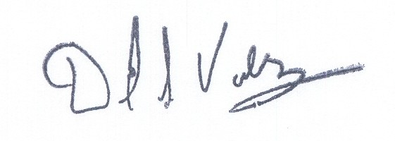

David S. Valdez
Vice President - Public Affairs, Policy and Communications

DSV:kad
Enclosures
(WAIGLU-17-0208)

c: Service List
Attachment A

General and Local Exchange Tariff, WN U-17

Section 2

4th Revised Sheet 20

Section 5

1st Revised Sheet 5.1
4th Revised Sheet 6

VERIZON NORTHWEST INC.
EVERETT, WASHINGTON

N O T I C E

Verizon Northwest Inc. submits for filing Advice No. 3144 containing the attached tariff sheets to become part of the General and Local Exchange Tariff, WN U-17. An original and fifteen (15) copies are being provided pursuant to Paragraph 15 of Order No. 3.

The company submits this Advice filing in compliance with the Commission’s Order No. 17 in Docket No. UT-040788 dated May 5, 2005. The purpose of the filing is to remove the provision for the expiration of the late payment charge for business customers. This advice filing complies with the terms of the order and should be accepted by letter from the Commission’s Executive Secretary per Paragraph 22 of Order No. 17. The requested effective date for this filing is May 13, 2005.
A copy of this tariff is available for public inspection at the following Verizon Plus store locations:

189 Cascade Mall Drive 1402 SE Everett Mall Way
Burlington Everett
Burlington Verizon Plus Everett Verizon Plus

511 Valley Mall Parkway 18700 - 33rd Ave. West, Suite D
East Wenatchee Lynnwood
East Wenatchee Verizon Plus Alderwood Verizon Plus

Posted at ___________________
___________________
by ___________________

Post in above business offices.

