BEFORE THE WASHINGTON STATE
UTILITIES AND TRANSPORTATION COMMISSION

In the Matter of the Joint Application of  QWEST COMMUNICATIONS INTERNATIONAL INC. AND CENTURYTEL, INC.  For Approval of Indirect Transfer of Control of Qwest Corporation, Qwest Communications Company LLC, and Qwest LD Corp.  . . . . . . . . . . . . . . . . . . . . . . . . . . . . . . . . | )  )  )  )  )  )  )  )  )  )  )  ) | DOCKET UT-100820  JOINT MEMORANDUM IN SUPPORT OF SETTLEMENT AGREEMENT AND MOTION FOR WITHDRAWAL OF 360NETWORKS

COMES NOW, Qwest Communications International Inc. and CenturyTel, Inc. (the “Joint Applicants”) and 360networks (USA) inc. (360networks), pursuant to WAC 480-07-730 and 480-07-740, to file their Letter Agreement and request that it be approved and adopted by the Washington Utilities and Transportation Commission (the “Commission”). In support thereof, the parties state as follows:

- The parties to the Letter Agreement (attached hereto as Attachment 1) are the Joint Applicants and intervenor 360networks.

- The parties believe that the Letter Agreement and the conditions agreed to therein are consistent with the law and the public interest and thus, approval and adoption of the agreement by the Commission is appropriate.

- On May 13, 2010, the Joint Applicants filed an application with this Commission for approval of the indirect transfer of control of Qwest Corporation (“QC”), Qwest LD Corp (“QLDC”) and Qwest Communications Company LLC (“QCC”) (collectively “Qwest”) to CenturyLink (the “Transaction”).

- On May 26, 2010, 360networks moved to intervene in this proceeding on the basis that it had a substantial interest in the Transaction as a wholesale supplier of communications services, a registered competitive local exchange carrier with an interconnection agreement with QC and a wholesale customer of Qwest’s products, both through its interconnection agreements and through tariffs. 360networks sought to participate to ensure that the Transaction would not adversely impact competition in Washington or 360networks’ rights and ability to obtain the interconnection and related services and facilities it needs to provide its communications services. 360networks’ intervention was granted at the initial Prehearing Conference.

- The initial term of 360networks’ interconnection agreement with QC in Washington expired on March 31, 2009 yet, it continues in effect on a month to month basis. Both QC and 360networks are familiar with the agreement and have developed and become accustomed to a course of dealing and conduct with each other that in large measure satisfies the business needs of the parties, consistent with the terms of the agreement. In addition, when needed, the agreement has been amended to reflect the evolving nature of the relationship between the parties.

- 360networks was concerned that, with the introduction of new management, the agreement and its amendments would be terminated by the new entity, which would seriously disrupt 360networks’ business and that of its customers. 360networks was also concerned that new management would implement an interconnection “template agreement” for successor agreement negotiations that would differ substantially in form and content from the QC agreement, with which it is familiar and upon which it has come to rely.

- The attached Letter Agreement provides (1) for an extension of the term of 360networks’ interconnection agreements with QC for a period of three years from the Closing Date of the Transaction and (2) that the parties will begin negotiations of an initial replacement interconnection agreement with their existing interconnection agreement, as amended (with the option of incorporating the amendments into the body of the proposed agreement). In addition, 360networks will get the benefit of any additional conditions placed on the Transaction by the Federal Communications Commission (“FCC”). In exchange for these items, 360networks agrees to withdraw from participation in regulatory proceedings relating to this Transaction at both the state and the federal levels.

- The terms of the Agreement satisfy 360networks’ interests as they provide three years of stability for the part of its business that relies on the services that it purchases from QC out of its interconnection agreement. In addition, starting successor agreement negotiations with the existing agreement provides a framework for negotiations that reflects the business relationship established during the term of the initial interconnection agreement. These terms are consistent with the public interest as they enable 360networks to continue to provide competitive local exchange services in QC territory under the conditions it provides services today and minimize the significant transaction costs associated with negotiating and arbitrating interconnection agreements. 360networks additionally saves costs and resources involved in litigating this Transaction in several state jurisdictions as well as at the FCC. 360networks believes it is not disadvantaged by reaching a settlement with the Joint Applicants without the resolution of all wholesale issues in this Transaction since (1) it received a 14-state agreement with regard to these issues when several states have no authority to review and place conditions on the Transaction and (2) it will benefit from any additional conditions placed on the Transaction by the FCC.

- The Joint Applicants’ interests are satisfied in that the Letter Agreement will aid in the timely and orderly regulatory review and approval of the Transaction in multiple jurisdictions. The Letter Agreement assures that QC’s commitments and obligations in the wholesale area can be fulfilled in a manner that minimizes uncertainty and disputes, while at the same time allowing those wholesale relationships to properly evolve with changes in law and market forces. Minimizing uncertainty and contention in the wholesale area will allow the merged company to better focus its efforts on other aspects of the Transaction that will bring benefits to consumers as a whole. Therefore the Letter Agreement is consistent with the public interest.

- The Letter Agreement also supports the public interest as it does not disadvantage other competitive local exchange carriers in Washington since the Joint Applicants will make its terms available to all other similarly situated competitive local exchange carriers operating in the State of Washington. The Letter Agreement covers interconnection agreements not expired as of the closing date of the Transaction as well as interconnection agreements that have been expired less than three years as of the closing date. The terms of the Letter Agreement will be available to other competitive local exchange carriers with regard to such agreements.

- The parties offer, if requested by the Commission, to present one or more witnesses to testify in support of the Letter Agreement and answer questions concerning the agreement’s details and its costs and benefits. Counsel for the parties will also make themselves available as necessary to address any legal matters associated with the Letter Agreement and to respond to any questions from the bench. The parties also commit that they will submit any necessary conforming amendments to the covered interconnection agreements within thirty days of the Transaction closing.

BASED ON THE FOREGOING, the parties request that the Commission issue an order approving and adopting the attached Letter Agreement and allowing 360networks to withdraw from this proceeding.

RESPECTFULLY SUBMITTED this ____day of October 2010.

CENTURYLINK QWEST

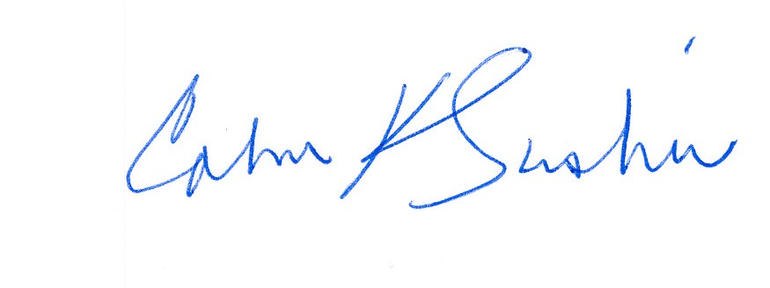
__________________ ____________________________
Calvin K. Simshaw Lisa A. Anderl (WSBA # 13236)
CenturyLink Qwest Law Department
805 Broadway 1600 – 7th Ave., room 1506
Vancouver, WA 98660 Seattle, WA 98191
calvin.simshaw@centurylink.com lisa.anderl@qwest.com

360networks (USA) inc.

By: __________________________
Michel Singer-Nelson
Associate General Counsel
mnelson@360.net

