Report Reviewing CC Technologies’

Summary of Field Inspection of Seventy-five (75) and Metallurgical Analysis of Six (6) Service Risers – Spirit Ridge Subdivision
(F4434-01G)

(Dated June 15, 2005)

Prepared by:

M.J. Schiff & Associates, Inc.
Consulting Corrosion Engineers
431 West Baseline Road
Claremont, CA 91711
(July 18, 2005)

This report is prepared on behalf of the Staff of the Washington Utilities and Transportation Commission. This report constitutes our review of the study conducted by Puget Sound Energy’s (PSE’s) consultant CC Technologies Laboratories entitled: “Summary of Field Inspection of Seventy-five (75) and Metallurgical Analysis of Six (6) Service Risers – Spirit Ridge Subdivision (F4434-01G),” dated June 15, 2005. In this report, we refer to this document as the “Riser Study.”

Overview of the Riser Study

The CC Technologies Laboratories, Inc. (CCTL) Riser Study is part of PSE’s response to the requirement of the Washington State Utilities and Transportation Commission (the Commission) set forth on page 8, item d of Docket No. PG-041624, Order No. 01 that directs PSE to “Conduct a metallurgical analysis of the service line that served the house to determine what caused it to leak, and provide the results to the Commission upon request.” CCTL was retained by Gordon Murray Tilden LLP on behalf of PSE to conduct testing, research and offer opinions regarding the explosion at 16445 SE 26 Place in Bellevue, WA that occurred on September 2, 2004.

CCTL performed an inspection of seventy-five (75) natural gas service risers that were randomly selected and removed from the Spiritridge area during PSE’s distribution pipe replacement project that took place from February 7 to April 1, 2005. Each riser sample was labeled, wrapped in polyethylene, sealed at the excavation site and stored in a secure, dry storage site in Bellevue, WA. The Riser Study details, documents and provides the data from the physical, metallurgical and chemical results of the field inspections and metallurgical analysis.

Overview and Methodologies of the Field Inspection and Testing

On April 26 and 27, 2005, CCTL personnel, along with Mr. Raleigh Purtzer, EIT of our firm, plus WUTC Staff participated in the field inspection and testing of the seventy-five randomly selected riser samples according to the following protocol:

CCTL Service Riser Field Testing Protocol

- Identify and inventory riser by street address.
- Photograph as found condition.
- Remove polyethylene wrapping.
- Measure and record dimensions and determine (if possible) installed orientation.
- Photograph risers in “as found” condition from both sides.
- Visually inspect coating condition and identify possible corrosion features.
- Photograph possible corrosion features or deposits.
- Perform qualitative analysis of deposits for Calcium, Carbonate, Sulfide, Iron and pH.
- Perform holiday detection test (“wet sponge”) and document holiday locations.
- Select risers exhibiting more than superficial corrosion for more detailed metallurgical laboratory analyses.
- Rewrap and store risers.

An identification number was assigned to each riser and the relevant data for each riser was recorded on a data form. The data recorded included date inspected, date removed, service address, coating type, pipe inside diameter and observed holiday or corrosion locations. Coating holidays that were obviously caused by removal (shovel damage) were not recorded. The results of the holiday test, pipe orientation and the results of any quantitative analysis (if completed), along with a photograph, were also recorded for each riser inspected.

Six (6) of the risers that appeared to have the most significant corrosion were selected for further laboratory analysis. These six samples were carefully packed and shipped to CCTL’s Dublin, Ohio laboratory on May 29, 2005, for metallurgical analysis.

CCTL performed the metallurgical investigation in accordance with the Puget Sound Energy laboratory investigation protocol, revised on December 15, 2004, including the following steps: Visual inspection, sectioning, metallographic examination using light and scanning electron techniques, and energy-dispersive spectroscopy (EDS) when appropriate.

The methodologies used by CCTL were appropriate for these types of field and metallurgical investigations.

Overview of the Results and Discussion of the Findings from Field Inspection and Testing

CCTL summarized the results of the field inspection and testing on page 2 of the Riser Study (Item 1 below).

CCTL Table from Page 2- Spirit Ridge Service Riser Inspection Summary
43 (57.3%) were 3/4" Coal Tar Coated pipe | 17 of the 45 (39.5%) of the Coal Tar services were field wrapped at the bend
31 (41.3%) were 1/2" X-Tru Coat® pipe | 27 of the 31 (87.1%) of the Coal Tar X-Tru Coat® (Shown as Coal Tar in Report, but should be X-Tru Coat based on accompanying table) services were field wrapped at the bend
1 was ½" FBE coated pipe with field wrapped tape
A total of 45 holidays (judged not to be made during removal -i.e. new) were recorded on 20 risers
A total of 12 corrosion defects (all minor) were identified on 10 risers
Item 1: CCTL’s summary of results of field inspection of seventy-five (75) service risers from Spiritridge subdivision

Most of the risers tested had complete coating coverage with some holidays. CCTL in many instances assumed that the holidays found were due to “rough” handling during excavation. Mr. Purtzer of MJS&A agreed that many “holidays” or defects were the result of removal excavation. The cuts seem to have been made by a sharp object such as a shovel. At places (“holidays”) where the coating was sliced there was no dirt or corrosion product on the pipe surface as shown on Photo 1 below. This photo was taken by Mr. Purtzer of our firm (it is not contained in the Riser Study).

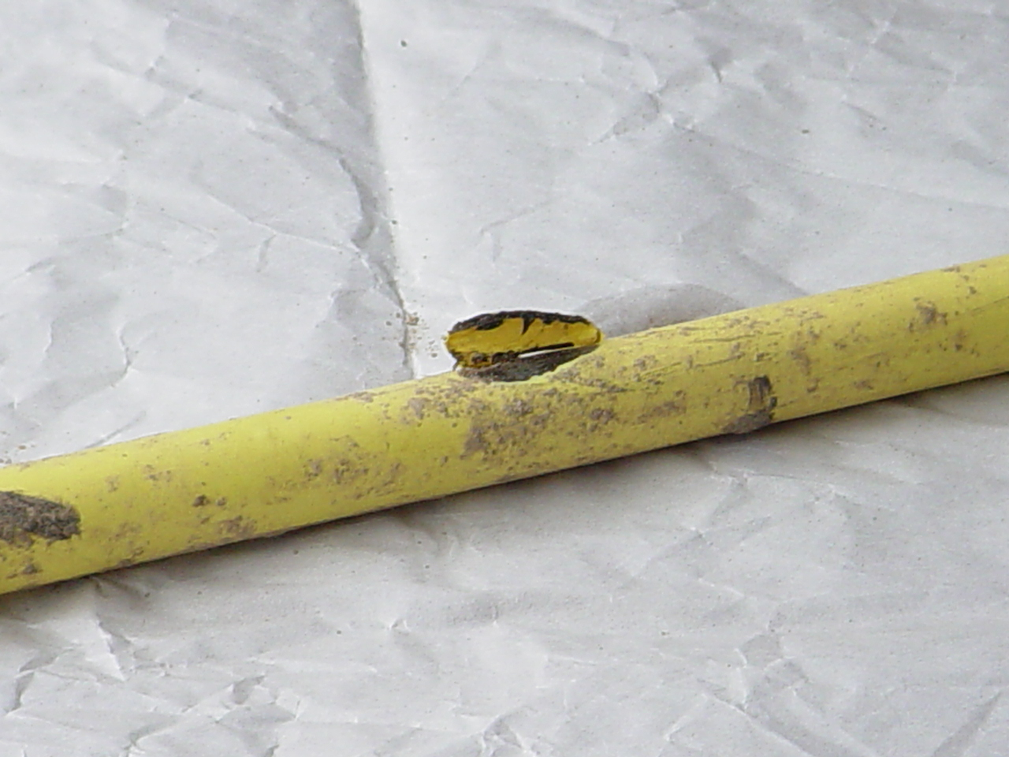
Photo 1: Photo of typical coating holiday attributed to "damaged during removal"

Our primary concern was coating damage due to field bending of the previously coal tar coated pipe. There were possibly six (6) pipes that displayed the tell-tale marks of being bent in the field. In some the cases, the coating integrity was not compromised near the bends. The following three photographs were taken by Mr. Purtzer of our firm. They are not contained in the Riser Study. Photos 2 and 3 below show coating damage at the riser bend. Photo 4 is an example of a riser with no damage at the riser bend.

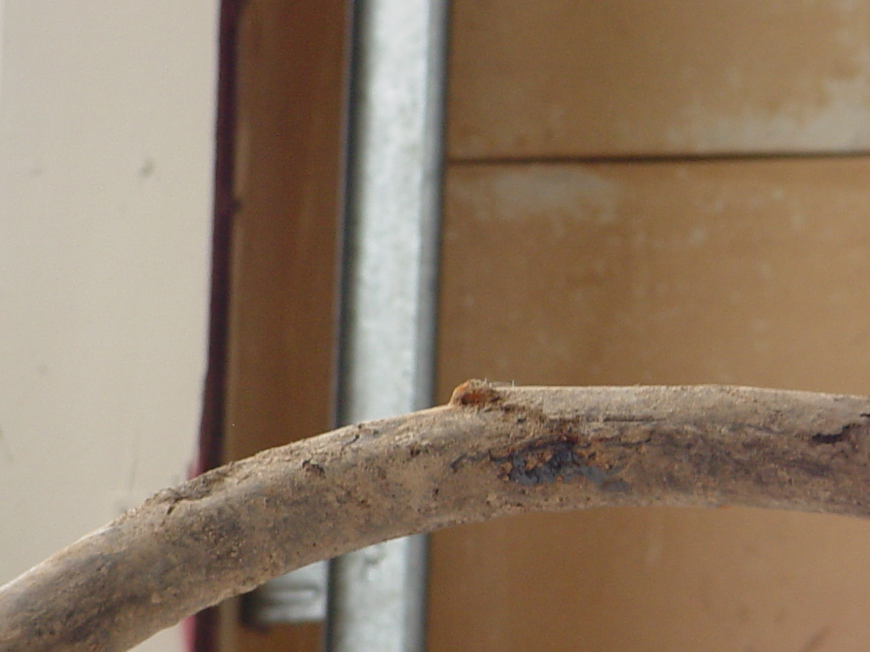
Photo 3: Examples of coal tar coated and bent service risers from Spiritridge subdivision with visible coating holidays

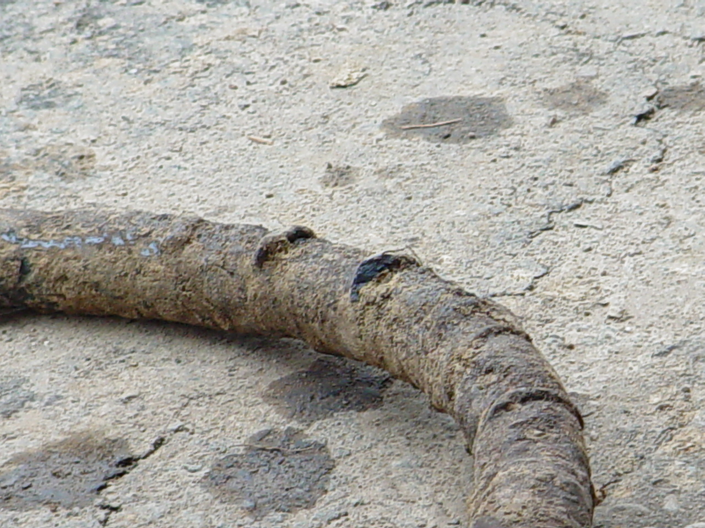
Photo 3: Examples of coal tar coated and bent service risers from Spiritridge subdivision with visible coating holidays
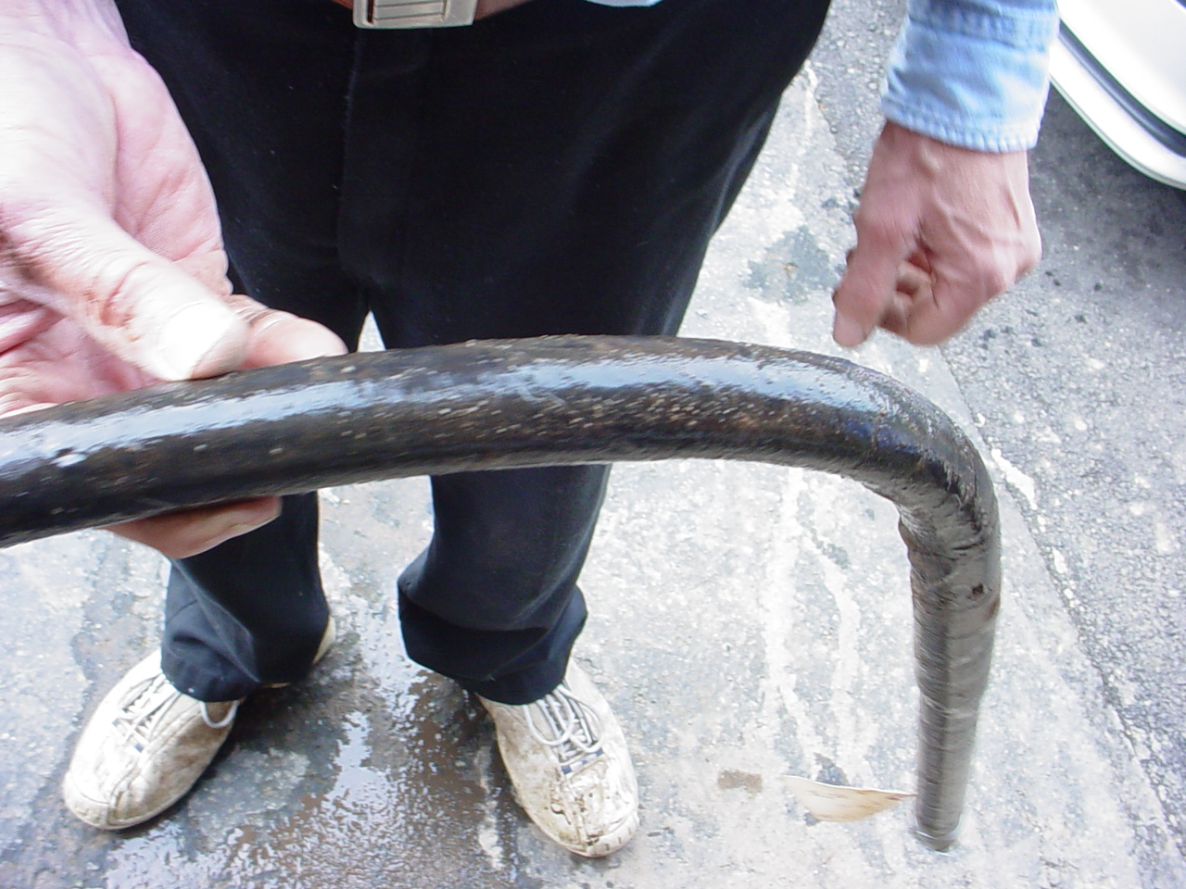
Photo 4: Example of bent coal tar service riser from Spiritridge with no visible coating holidays

Overview and Methodologies of the Metallurgical Analysis and Testing

CCTL performed metallurgical investigations on six (6) Spiritridge gas service risers. The risers were selected from seventy-five risers randomly sampled during the distribution pipe replacement project from February 7 to April 1, 2005. Risers CT-4, -10, -18, -49, -66 and -71 were received at CC Technologies on May 3, 2005. The service risers were either 0.5-inches or 0.75-inches in diameter. Four had a coal tar coating (CT-18,
-49, -66 and – 71) and two (CT-4 and -10) had an extruded polyethylene coating.

The metallurgical investigation was performed in accordance with the Puget Sound Energy laboratory investigation protocol revised on December 15, 2004, including the following steps: Visual inspection, sectioning, metallographic examination using light and scanning electron techniques, and energy-dispersive spectroscopy (EDS) when appropriate.

Overview of the Results and Discussion of the Findings from Metallurgical Analysis and Testing

Significant corrosion damage was identified on five of the six risers. Through wall penetrations of 39% (CT-4) and 81% (CT-10) were identified on the extruded polyethylene risers. Only superficial corrosion damage was reported on coal tar coated CT-71, with through wall penetrations of between 26% to 47% reported on the other coal tar risers tested.

Critique and Review of Conclusions of the CCTL Service Riser Report

The conclusions of the Riser Study are provided in a paragraph on page 8 of the document. In order to critique and respond to these conclusions, we have recast the paragraph below as a bulleted list of italicized quotations from page 8 of the Riser Study, followed by our responses in bold:

- “The metallurgical analysis of the service risers revealed that pipe anomalies were confined to areas of faults in the coating.”

We concur and take no exception to this conclusion.
- “Only two of the observed pits were related to areas of cracks along the extrados of the coating. In general, it appears that there is no greater propensity for corrosion pitting to occur at the bends than away from the bends.”

We concur and take no exception to this conclusion.
- “The major determining factor on whether there was a pipe anomaly or not was faults in the coating. All observed pipe anomalies occurred beneath coating faults.

We concur and take no exception to this conclusion.
- “The representative sample of the service risers indicates that they were installed in a manner that is consistent with industry practice and that there were no shortcomings in the manner that the risers were installed or wrapped in the field.”

We concur and take no exception to this conclusion.
- “The representative sample did not identify any systemic integrity threats.

We take exception to this conclusion. The amount of external coating damage and external corrosion that led to a leak and ultimately an explosion is prima facie evidence that the coating is not in good condition. This is particularly true when taking into account the amount of third party damage identified in the PSE Integrity Assessment, dated June 21, 2005. The fact that these inspections identify numerous defects and associated corrosion damage both for coal tar coated and extruded polyethylene coated pipes should be a concern for PSE’s systems of similar design, installation and operation. Extruded polyethylene came into use as a pipe coating material well after coal tar was in common use. If follows that the extruded polyethylene services were likely installed long after the coal tar coated services were installed. The fact that the polyethylene coated services showed the largest through wall penetration indicates that this is not simply a 1950’s vintage coal tar service issue.

- The risers were performing in accordance with industry and regulatory standards in effect.”

We assume this statement means the standards in effect at the time of installation. If this assumption is correct, this conclusion may be valid, but significant corrosion damage has occurred since the installation of both the coal tar and extruded polyethylene coated services. Again, since the extruded polyethylene services were presumably installed long after the coal tar coated services, the fact that they showed the largest through wall penetration indicates that it is not simply a 1950’s vintage coal tar service issue. It is simply an issue with corrosion of services.

- “The reversal of the Vasa Park Rectifier polarity did not appear to contribute to accelerated attack of the risers for the period that the rectifier was cross-wired.”

We concur and take no exception to this conclusion.

M.J. SCHIFF & ASSOCIATES, INC.
Graham E.C. Bell, Ph.D., P.E.
President and Principal Engineer
July 19, 2005

CC Technologies, “Laboratory-based Evaluation of Failed Service Line, Final Report, F4434-01G,” dated February 18, 2005
CC Technologies, “Laboratory-based Evaluation of Failed Service Line, Final Report, F4434-01G,” dated February 18, 2005

