June 21, 2016

VIA WEB PORTAL AND OVERNIGHT MAIL

Mr. Steven King
Executive Director and Secretary
Washington Utilities and Transportation Commission
1300 S. Evergreen Park Drive, SW
Olympia, WA 98504
Re: Petition of Puget Sound Energy, Inc. for (i) Approval of a Special Contract for Liquefied Natural Gas Fuel Service with Totem Ocean Trailer Express, Inc. and
(ii) a Declaratory Order Approving the Methodology for Allocating Costs Between Regulated and Non-regulated Liquefied Natural Gas Services
Docket No. UG-151663
Dear Mr. King:
Enclosed for filing please find an original and one (1) copy of the following documents:
(1) Confidentiality Agreement for Donald T. Trotter as Mediator on behalf of the parties; and
(2) Certificate of Service.
If you have any questions, please contact the undersigned, or Pam Anderson at (425) 635-1417.

Very truly yours,
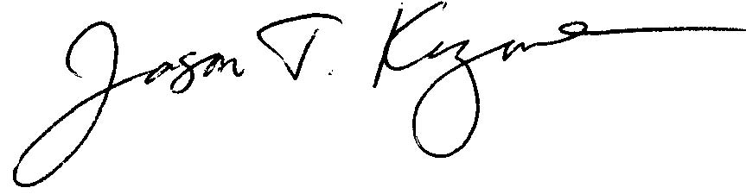
Jason Kuzma
JK:cgm
Enclosures
cc: Service List (First Class Mail & E-mail)

