WN U-16  VERIZON NORTHWEST INC.  14th Revised Sheet 346  Canceling  13th Revised Sheet 346  FACILITIES FOR INTRASTATE ACCESS  4. SWITCHED ACCESS (Cont'd)  4.6 Rate and Charges (Cont'd)  4.6.4 Information Surcharge Rate  Per Access Minute  Premium: Terminating $0.00  Originating 0.00  Nonpremium: Terminating 0.00  Originating 0.00  4.6.5 IntraLATA Equal Access Recovery Charge  Per Originating Access Minute 0.00  4.6.6 Interim Terminating Access Charge  Per End Office Switching Terminating Minute 0.0161897 (R)  Advice No. 3142 By Authority of the Washington Utilities and Transportation  Commission, Order No. 15 in Docket No. UT-040788, dated 4/12/05  Issued: April 25, 2005 Effective: May 1, 2005  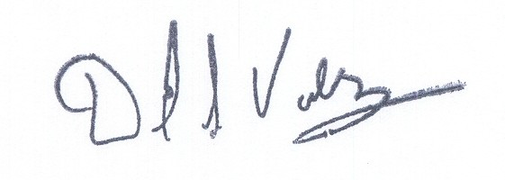  Issued by Verizon Northwest Inc.  By David S. Valdez, Vice President-Public Affairs, Policy and Communications | (D)  (D)

