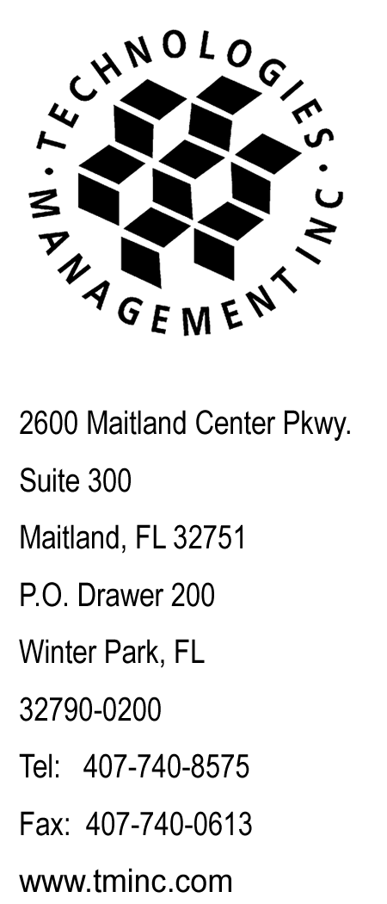
May 9, 2013
Webfile

Utilities and Transportation Commission (Webfile)
Washington Utilities and Transportation Commission

RE: Budget PrePay, Inc. d/b/a Budget Mobile
WA Quarterly Lifeline Compliance Filing
For the quarter of January 1, 2013 to March 31, 2013

Dear Sir or Madam:

Enclosed please find the confidential and redacted copies of the Revised WA Quarterly Lifeline Compliance Filing for the quarter of January 1, 2013 to March 31, 2013, filed on behalf of Budget PrePay, Inc. d/b/a Budget Mobile.

Questions regarding this filing should be directed to my attention at 407-740-8575. Thank you for your assistance in this matter.

Sincerely,

Craig Neeld
Compliance Reporting Specialist

