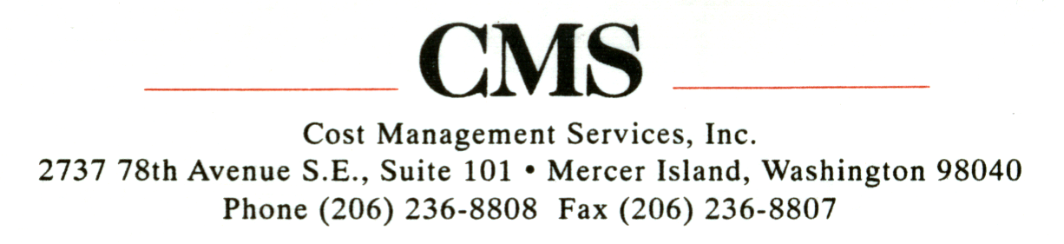

June 10, 2005

VIA ELECTRONIC FILING TO: records@wutc.wa.gov

Ms. Carole J. Washburn, Executive Secretary
Washington Utilities and Transportation Commission
P.O. Box 47250
Olympia, Washington 98504-7250

Re: Rulemaking to Review Natural Gas Decoupling
Docket No. UG-050369

Dear Ms. Washburn,

Cost Management Services, Inc. (“CMS”) is an independent marketer that sells natural gas to 80 retail industrial and commercial customers in the State of Washington, including customers served by Cascade Natural Gas and Puget Sound Energy. CMS also serves customers in the State of Oregon through its affiliate, Direxx Energy, Inc. While this rulemaking may not directly apply to CMS’ current customers, it may have implications for future customers and will likely have rate implications that affect all customer segments. Therefore, CMS appreciates the opportunity to participate in the proceeding by responding to the Commission’s May 16, 2005 Notice of Opportunity to File Written Comments.

The primary objectives in decoupling a utility’s revenue from throughput are to (i) stabilize the utility’s revenue stream, insulating it from uncontrollable variables such as weather; and (ii) eliminate the disincentive utilities have to support and promote energy efficiency. By decoupling margin from throughput, a utility’s relative economic health will not be adversely affected by the weather, the economy, or energy efficiency advancements.

Decoupling fundamentally changes the way in which a utility recovers its costs, and can be very complex and difficult to implement; therefore, it is imperative that consideration of any such program take into account the impact it will have on all stakeholders and the market. In order to garner support for such a program, and successfully and equitably implement it, the following basic objectives must be met:

- Eliminate subsidies between customer classes;
- Price services to fully (and solely) recover costs;
- Benefits must be measurable and appropriately shared with customers;
- Changes must effectively lead to the desired results (i.e., revenue stability and energy efficiency);
- Create a mechanism with meaningful price signals – to effectively modify behavior, all customers must have access to and be affected by changing prices in both the short- and long-term horizon; and
- Rate changes must not be unduly discriminatory.

Accordingly, the following should be considered to ensure an effective and equitable decoupling program.

Proper Cost Allocation

Cost-of-Service Study – The first step in fundamentally changing the way in which a utility recovers costs is a comprehensive cost-of-service study. The cost-of-service study should be used to appropriately allocate costs to each rate schedule. Each customer class should bear responsibility for the fixed costs attributable to its service and each rate schedule should appropriately recover the costs associated with serving that particular set of customers (i.e., services that don’t fully recover costs should be adjusted accordingly or not offered); one segment of customers should not subsidize another. Appropriate cost allocation is also an essential step in sending the appropriate pricing signals to consumers and ensures that energy efficiency measures can be reasonably assessed.

General Rate Case – The comprehensive cost-of-service study can only be effectively undertaken if actual revenue requirements are known. Cascade’s last rate case was ten years ago – it is difficult to understand how rates can be modified so dramatically without a general rate case. In the May 12th meeting, Cascade indicated that it did not plan to file a general rate case, but use a restatement of operations cost-of-service study to capture all unrecovered costs going back to the last rate case. That undertaking should be accomplished via a general rate case. Furthermore, decoupling essentially shifts volume risk from the utility to the ratepayer and that shift in risk must be reflected in rate design; without a general rate case, it is not clear how those benefits could be allocated.

Program Designed to Adequately Meet Objectives

Decoupling Should Target Only Residential Service – Substantive progress toward the stated objectives, revenue stabilization and energy efficiency, will primarily be made in the residential service sector. Industrial and commercial markets are much less weather sensitive and already have the means and incentives to undertake cost effective efficiency initiatives. Significantly modifying rate design for the industrial and commercial segments will have little or no impact on meeting either stated objective.

Meaningful and Timely Price Signals – In order to successfully modify consumer behavior, it is essential that consumers see and feel the impact of their actions on a near-term basis. Historically, core energy consumers have not been exposed to market conditions until well after-the-fact. Purchased gas cost adjustments or other deferral mechanisms delay the impact, good or bad, until subsequent periods. Decoupling mechanisms have generally employed deferral mechanisms, so consumers don’t really know how much the service actually costs for months. It is difficult, if not impossible, to effectively modify behavior with deferral mechanisms. Unfortunately, exposure to real-time pricing may be contrary to what’s important to consumers – many utilities have asserted that their core customers are very much interested in rate stability, not simply lowest possible costs. This issue is likely the hardest problem to overcome in developing an effective decoupling program.

Cascade’s proposed decoupling program should, in fact, stabilize monthly bills, and certainly, it will stabilize utility revenues as core customers pay more of their allocated costs on a fixed basis. And it clearly removes the barrier utilities have to promote and encourage energy efficiency. So it may partially meet the stated objectives. However, it is unclear how effective Cascade’s proposed program will be in actually encouraging energy efficiency.

Under Cascade’s fixed-variable proposal, energy efficiency may be beneficial to the consumer given a long-term perspective; however, development of such a long-term perspective would take a tremendous consumer education effort. Practically, however, the marginal cost of consuming the next therm of gas will actually decrease, which could result in increased consumption, especially in colder months (home owners will be able to turn up the thermostat with less impact on that month’s heating bill). So unless consumers will take that longer-term perspective, the program might be relatively ineffective.

There will certainly be legitimate concerns that a fixed-variable rate design will place an undue burden on low-income households. Rather than invalidate the whole structure, this concern should be addressed with a special program for qualified low-income households.

Conclusion

Cascade’s proposed program could have merit by partially meeting the stated objectives; however, it will only be effective in the residential sector, and only if accompanied by an aggressive educational campaign regarding energy efficiency. A comprehensive cost-of-service study will allow costs to be appropriately allocated to each respective customer class, and the financial responsibility allocated accordingly. Appropriate allocations will send the appropriate price signals with respect to energy costs. The fixed-variable rate design should stabilize Cascade’s revenue stream, resulting in lower capital and administrative costs, which should be appropriately reflected in a general rate case. The primary question is whether the program will, in fact, encourage energy efficiency.

Very Truly Yours,

/s/Doug Betzold
CEO

