Report Reviewing CC Technologies

Laboratory-based Evaluation of Failed Service Line
Final Report, F4434-01G
(Dated February 18, 2005)

Prepared by:

M.J. Schiff & Associates, Inc.
Consulting Corrosion Engineers
431 West Baseline Road
Claremont, CA 91711
(July 18, 2005)

This report is prepared on behalf of the Staff of the Washington Utilities and Transportation Commission. This report constitutes our review of the document prepared by Puget Sound Energy’s (PSE’s) consultant CC Technologies Laboratories, Inc., entitled: “Laboratory-based Evaluation of Failed Service Line, Final Report, F4434-01G,” dated February 18, 2005. Below we refer to this document as the “CCTL Report.”

Overview of the CCTL Report

The CCTL Report is PSE’s response to the requirement of the Washington State Utilities and Transportation Commission (the Commission) set forth on page 8, item d of Docket No. PG-041624, Order No. 01 that directs PSE to “Conduct a metallurgical analysis of the service line that served the house to determine what caused it to leak, and provide the results to the Commission upon request.” CCTL was retained by Gordon Murray Tilden LLP on behalf of PSE to conduct testing, research and offer opinions regarding the explosion at 16445 SE 26th Place in Bellevue, WA that occurred on September 2, 2004.

The CCTL Report details, documents and provides the data from the physical, metallurgical and chemical results of the inspection.

Overview and Methodologies of the CCTL Report

The ¾-inch, 62-foot long service pipe was removed on September 3, 2004 in six pieces. To facilitate shipping, four of the six segments were further cut to facilitate packaging in the shipping crate, thus producing a total of 10 segments, identified 1 through 10.

CCTL analyzed each segment using the following primary and supplemental methods of analysis:

Primary methods of analysis:

- Visual evaluation and photo documentation of the pipe segments in as-received condition.
- Visual evaluation, identification of areas of interest and photo documentation of the pipe segments with the external coating and documentation of the extent of corrosion attack to the pipe.
- Removal of the coating and cross-sectioning of selected areas of interest and corroded areas.
- Sectioning, mounting, polishing and metallographic evaluation of the transverse surfaces in as-polished and etched conditions using light microscopy.
- Scanning electron microscope examination and documentation of polished cross-sections.
- Elemental analysis of the surface products from corrosion sites by means of energy dispersive spectroscopy (EDS)

Supplemental methods of analysis:

- Chemical analysis of the steel.
- Ultrasonic measurements of remaining wall thickness at selected samples at locations exhibiting corrosion damage.
- Analysis of the surface products in the vicinity of the leak for the presence of microbiological organisms which may have contributed to corrosion.

CCTL conducted the testing during mid-December 2004 and February 2005. I was present for the unpacking, documentation and some of the testing on December 13-14, 2004.

The methodologies used by CCTL were appropriate for this type of investigation with two exceptions. First, there was no photo documentation (macro photos or light microscopy) of the internal corrosion identified on segment 10 at the leak location. The corrosion damage is documented by scanning electron micrographs and EDS spectra taken on cross-sections through the leak site, but these do not give a general sense of the amount of degradation due to internal corrosion over the entire length of the leak site. The only other criticism is that dry storage of the pipe samples reduce the chances of identifying microbiological factors by the serial dilution method used.

Overview of the Results and Discussion of the Findings

The CCTL Report presents the results of the analysis in different Report sections by external coating assessment, corrosion assessment, metallographic, scanning electron microscopy (SEM) and energy dispersive spectroscopy (EDS) and microbiological testing of surfaces near the leak location.

External Coating Assessment:

The condition of each of the segments was assessed visually to establish the presence of coating defects (i.e., holidays). The external coating damage for each segment is documented in Appendix D of the CCTL Report. Multiple locations were observed to contain holidays with products at the bottom of some holidays indicating a penetration of the coating to the pipe substrate. The results of the external coating assessment are summarized in Table 2 of the CCTL Report, which is reproduced in Item 1.

Some of damage reported in Item 1 probably occurred during removal of the service on September 3, 2004. No attempt was made to distinguish between damage that occurred during removal and pre-existing coating damage. We have assumed that indications of scrapes and scratches are damage from removal unless corrosion damage was observed on the metal surface.

Based on the data in Item 1, twenty-two coating holidays and coating deformations were reported on the 10 pipe segments. No definition of this terminology is given. We have interpreted it to mean that coating “holidays” are defects which penetrate to the metal and show signs of corrosion, coating “deformation” does not penetrate to the metal, and “scrapes” and “crimps” appear to be damage upon removal. Coating wrap is a previous repair of the coating, probably during installation.

In analyzing the table, we find at least six coating holidays, including coating holidays which must have been present for the corrosion damage on segments 1 and 10 (leak location) to have occurred. In addition, we note that the cracks in the coating on the extrados of segment 10 are not documented in Table 2 of the CCTL Report, although clearly present in Figures 34 (page 46) and 35 (page 47) of Appendix D of the Report. Figure 34 is reproduced here in Item 2.

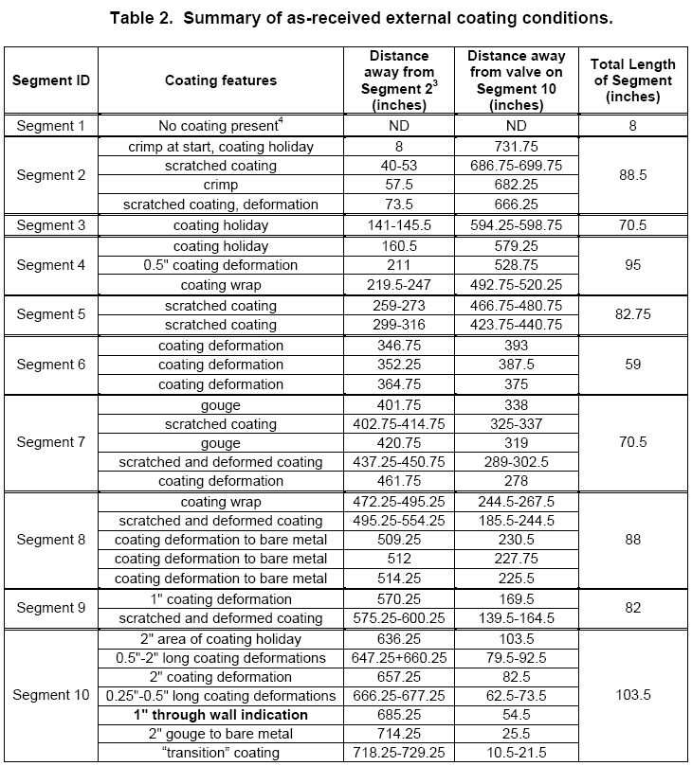
Item 1: Table 2 from page 10 of CCTL Report, Summarizing External Coating Assessment by Segment

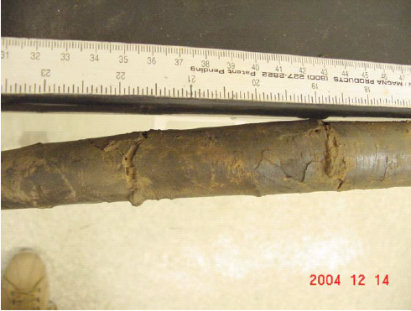
Item 2: Photograph from page 47 (Figure 34)of the CCTL Report, showing cracks in coating on extrados of pipe segment 10 not reported in Table 2 of the CCTL Report.

Corrosion Assessment:

From the areas identified during the visual examination by CC Technologies (contained in the CCTL Report, Appendix D), areas of interest and possible corrosion damage were identified. CCTL removed the external coating from the areas where the coating exhibited more than a superficial damage. CCTL then cleaned the steel surface by hand-held nonabrasive tools and a more thorough metallographic sectioning and examination was conducted (CCTL Report, Appendices H, I, and K). In addition, selected samples were identified for ultrasonic testing/evaluation (CCTL Report, Appendix L).

The results of the Corrosion Assessment are summarized by segment in Table 3 of the CCTL Report, which is reproduced here in Item 3. Corrosion features identified on segments 1, 2 (2 locations), 4, 9 (2 locations) and 10 had ultrasonic testing (UT) conducted to circumferentially map the corrosion damage in the vicinity of the identified corrosion feature.

Of particular interest was the relatively large corrosion feature (1”x2”) on segment 1. We have reproduced here in our Item 4. Note that the ultrasonic evaluation shows a virtual 100% through wall penetration (0 mils wall thickness near circumferential distance of 300 mils). No coating was present on segment 1 after removal so coating damage could not be determined based on visual inspection after removal. Subsequent metallographic examination revealed a thin ligament of metal remaining at the thinnest location (Item 5).
.
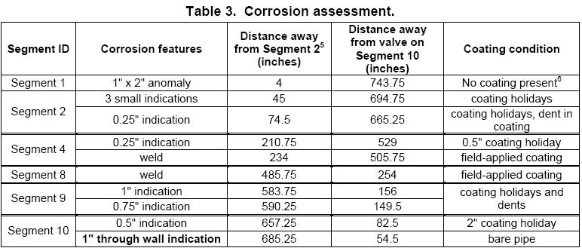
Item 3: Table 3 from page 17 of CCTL Report, summarizing corrosion assessment by pipe segment

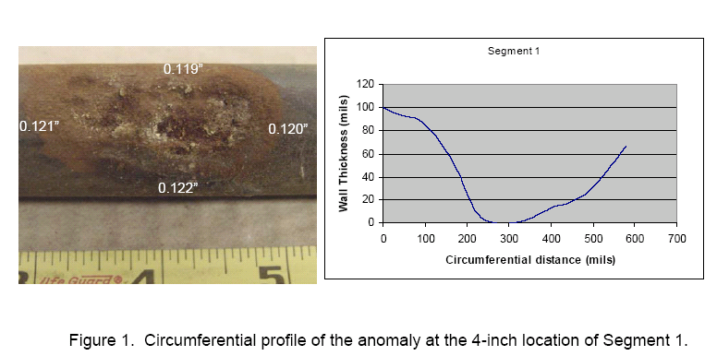
Item 4: Figure 1 from Appendix L of CCTL Report, page 124 showing corrosion feature on segment 1 with circumferential ultrasonic testing results
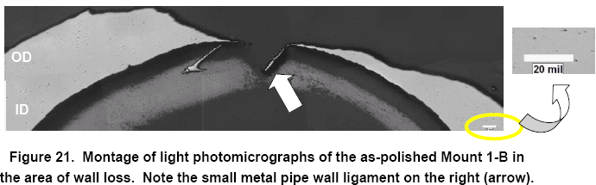
Item 5: Figure 21 from CCTL Report, page 21. White arrow shows remaining ligament of metal from virtual through wall corrosion feature on segment 1.

Corrosion features on segment 2 were 5% and 62% through wall. The corrosion features on segment 4 was 75% through wall. Corrosion features on segment 9 were 35% and 45% through wall. Finally, the corrosion feature on segment 10, the leak location that was the root cause of the explosion, also showed 100% through wall penetration (Item 6 and Item 7). This indicates that the leak at segment 10 was not the only area of significant corrosion damage on the service line from the Schmitz residence.

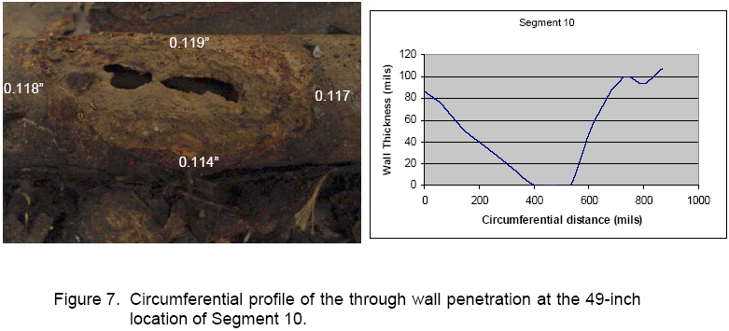
Item 6: Figure 7 from Appendix L of CCTL Report, page 127, showing corrosion feature on segment 10 with circumferential ultrasonic testing results
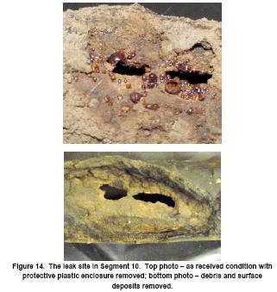
Item 7: Figure 14 from CCTL Report, page 16, showing corrosion feature on segment 10 at leak location before and after removal of surface debris and deposits

Metallographic, scanning electron microscopy (SEM) and energy dispersive spectroscopic (EDS) Testing

Metallographic evaluation focused on the areas containing corrosion features on Segments 1, 4, 9, and 10. The pipe segments were sectioned to produce smaller-sized samples for analysis. The samples were then used by CCTL to make metallographic mounts which were polished and prepared for examination using light and scanning electron microscopy with EDS analysis for chemical compositional analysis.

Chemical compositional analyses from three locations were consistent with American Petroleum Institute 5L specification for Grade B steel.

The leak location on segment 10 is of greatest interest and concern because it was the cause of the incident. Segment 10 was further sectioned into six samples (Numbered Sample 10-1 through 10-6, with Sample 10-1 being the left-most upstream sample (closest to the gas main) and Sample 10-6 being the right-most downstream sample (closest to the customer’s meter). The leak location was in Sample 10-4, which was further sectioned to 10-4B and 10-4C (Item 8)

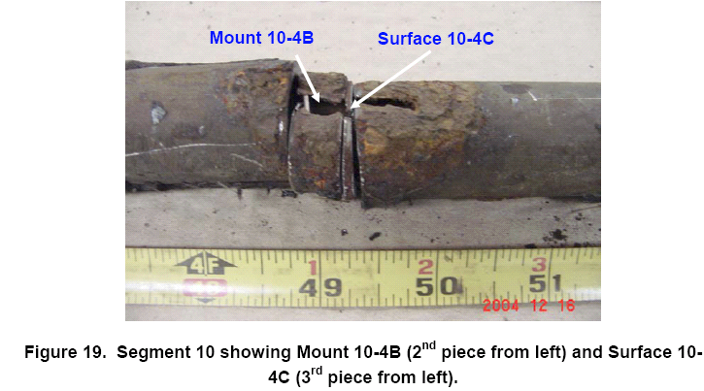
Item 8: Figure 19 from CCT Report, page 20, showing subsequent sectioning and metallographic mounting of leak location for additional analysis and testing.

SEM examination of mount 10-4B at the leak location identified corrosion deposits on both the exterior and interior surfaces of the pipe. Despite the presence of interior deposit, no documentation of the damage other than the SEM and EDS spectrum were presented in the CCTL Report.

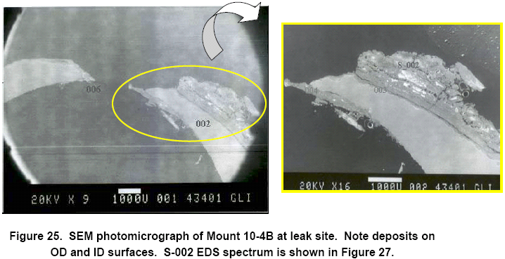
Item 9: Figure 25 from CCTL Report, page 23, showing interior and exterior corrosion deposits at the leak location of segment 10, mount 10-4B

CCTL states on page 26 of the Report that, “The most plausible explanation for the ID corrosion is condensation near the leak location caused by local cooling of the steel wall due to the Joule-Thompson [sic] effect.” The Joule-Thomson refers to the change in temperature of a non-ideal gas that occurs when the non-ideal gas suddenly expands from a high pressure to a low pressure. The amount of corrosion observed on the interior of the pipe would require significant time to occur given this mechanism (i.e. condensation on the interior of the pipe wall). This indicates that leak had been present for some time, most likely prior to the reversal of the Vasa Park rectifier, which has been estimated by Kuang Chu of the Commission to have been mis-wired for at most sixty-four and not less than five days.

There was no photo documentation (macro photos or light microscopy) of the internal corrosion identified on segment 10 at the leak location. The corrosion damage is documented by scanning electron micrographs and EDS spectra taken on cross-sections through the leak site, but these do not give a general sense of the amount of degradation due to internal corrosion over the entire length of the leak site.

Microbiological Testing:

Bacterial culture analyses were conducted on surface deposit samples collected from three locations on Segment 10. The liquid bacteria cultures were inoculated with the slurry prepared using the surface deposits in accordance with the serial dilution method per American Petroleum Institute RP38. The cultures were monitored for 30 days. The results were summarized in Table 5 of the CCTL Report, and are presented here as Item 10. Basically, the results from the deposits on Segment 10 were negative for microbiological activity.

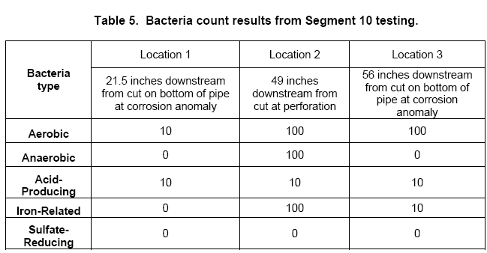
Item 10: Table 5 from CCTL Report, page 28, with results of bacterial testing from three deposits from segment 10

It is important to note that at the time of the sampling of the deposits for bacterial testing from the leak location, the service had been out of the ground and dry, aerated storage for more than 3 months. Since bacteria need moisture and the proper environment to survive, it should not be surprising that the results of the testing were negative for such samples.

However, fresh soil samples from near the meter location at 16645 SE 26th Place, collected by WUTC staff on December 8, 2004 and immediately analyzed using similar methods by MJS&A, gave positive indications of the presence of Anaerobic, Acid Producing, Iron-related and Low Nutrient bacteria after 30 days. Tests by MJS&A were reproducible and reported in our letter of March 17, 2005. Subsequent re-testing of fresh soil samples in the vicinity of 16645 SE 26th Place, Bellevue, WA by CC Technologies main showed higher bacterial results after just 7 days of testing (Table 1)

Table 1: Interim Bacteria culture results for soil samples (after 7 days) from July 6, 2005 Progress Report. Samples shown were fresh and taken at 16645 SE 26th Place, Bellevue, WA.
Sample ID | Bacteria counts/g
Sample ID | Aerobic | APB | IRB | SRB | Anaerobic
050405 meter | 1-10 | Negative | Negative | Negative | Negative
050405 gas main | 10-100 | 100-1K | 1-10 | 1-10 | 100-1K
050405 remote | 1-10 | 1-10 | Negative | Negative | 10-100
050405 SW foundation | 10-100 | 10-100 | Negative | 1-10 | 10-100

The presence of bacteria does not necessarily dictate that corrosion which has occurred was due to microbiologically influenced corrosion (MIC); results from MJS&A’s testing and the follow-on results in Table 1 indicate that MIC can not be ruled out as a possible causal factor in the corrosion damage and ultimately the fugitive emission of gas which caused the explosion.

Critique of the Conclusions of the CCTL Report

Page 29 of the CCTL Report lists seven conclusions based on the analysis that CCTL conducted. These conclusions, along with our responses of the CC Technology laboratory-based assessment, were as follows:

- The leak on the gas service (Segment 10) occurred as a result of external corrosion that may have initiated at a coating holiday at the outside diameter (OD) surface.

We concur and take no exception to this conclusion.
- Internal corrosion at the inside diameter (ID) side at the leak site suggests that the leak may have existed for a period of time prior to the incident.

We concur and take no exception to this conclusion.
- There is no evidence to suggest that the ID corrosion contributed to the cause of the leak.

We would agree that the ID corrosion was not the initiation of the leak, but that internal corrosion of the remaining ligament of the metal wall (see Item 9) may have increase the size of the hole and the gas leak rate as a function of time at a higher rate when taken in combination with external corrosion contributing factors.
- The wall thickness of the pipe in the areas unaffected by corrosion was measured to be 0.113-inch.

We concur and take no exception to this conclusion.
- The external coating was found to be in good overall condition with some isolated holidays.

We take exception to this conclusion. The amount of external coating damage and external corrosion that led to a leak is prima facie evidence that the coating is not in good condition. While it is true that from a percentage bare standpoint, not much metal was exposed to the soil, the number of defects recorded on this service and the fact that there was one through wall pit, another near through wall pit and the accumulation of significant damage at other locations indicates that the coating is nearing the end of its useful life. This is particularly true when taking into account the amount of third party damage identified in the PSE Integrity Assessment, dated June 21, 2005. To be fair, CC Technologies did not have the benefit of these data for their analysis at the time of this report preparation (February 18, 2005).
- Bacteria concentration in the analyzed deposits was low and suggests that microbially influenced corrosion was not a contributing factor.

We take exception to this conclusion. The storage of the sample and the length of time between collection and analysis were not conducive to determining microbially (or microbiologically) influenced corrosion. Subsequent testing by both WUTC and CC Technologies indicates that bacteria are present in the soils in the vicinity of the incident. MIC may have been a factor.
- The composition and microstructure of the steel is typical for low strength (X52 grade and lower) carbon steel line pipe.

We concur and take no exception to this conclusion.

M.J. SCHIFF & ASSOCIATES, INC.
Graham E.C. Bell, Ph.D., P.E.
President and Principal Engineer
July 18, 2005

