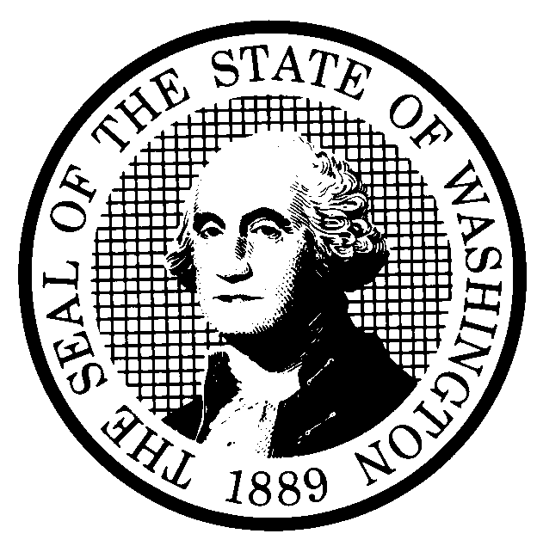 | PROPOSED RULE MAKING  (RCW 34.05.320) |  |  |  |  |  |  |  |  | CR-102 (7/22/01)  Do NOT use for expedited  rule making
Agency: Utilities and Transportation Commission |  |  |  |  |  |  |  |  |  | X Original Notice
Preproposal Statement of Inquiry was filed as WSR 99-09-027 ; or  Expedited Rule Making -- Proposed notice was filed as WSR ; or  Proposal is exempt under RCW 34.05.310(4). |  |  |  |  |  |  |  |  |  | Supplemental Notice  to WSR  Continuance of WSR
- Title of rule: (Describe Subject)
Chapter 480-120 WAC Telephone Companies. The subject of these rules is telecommunications. Chapter 480-120 is the Commission’s primary chapter for rules concerning telecommunications. This proposed chapter reflects revisions to the existing chapter after consideration of new, changed, or deleted statutory requirements and concomitant changes to policy.

Purpose: The purpose of the proposed rules is to update current rules, codify current procedures and best-practice options, use clear language, organize the chapter by subject area, and match the rule requirements to the legislature’s substantive requirements, consistent with the Governor’s Executive Order 97-02.
Other identifying information: Docket UT-990146, Telecommunications operations rules. This is the third CR-102 proposal in this docket. The first covered general rules and was adopted at WSR 01-15-022. The second concerned customer information rules and was filed on April 3, 2002 at WSR 02-08-081, the Commission will hold a joint adoption hearing on the rules under WSR 02-08-081 and the rules filed with this CR-102.

(b) Statutory authority for adoption: RCW 80.01.040; RCW 80.04.160; 80.36.080; 80.36.090; 80.36.100; 80.36.300; 80.36.320; 80.36.390; 80.36.400; 80.36.410; 80.36.500; 80.36.510, 80.36.520; 80.36.524; 80.36.555; 80.36.560; and 80.36.610 RCW. |  |  |  |  |  |  |  |  | Statute being implemented:  Chapter 80.36 RCW Telecommunications; Title 80 RCW Public Utilities.
(c) Summary: The proposed rules cover nine topic areas: (1) General rules including definitions; (2) establishing service and credit; (3) payments and disputes; (4) discontinuing and restoring service; (5) posting and publication notice; (6) telecommunications services; (7) financial records and reporting; (8) safety and standards rules; and (9) adoption by reference.

See section (j) below

Reasons supporting proposal:

(d) Name of Agency Personnel Responsible for: |  |  |  |  |  | Office Location |  |  |  |  | Telephone
1. Drafting............... Robert Shirley |  |  |  |  |  | 1300 S. Evergreen Park Dr. S.W., Olympia, WA 98504-7250 |  |  |  |  | 360-664-1292
2. Implementation.... Carole J. Washburn, Secretary |  |  |  |  |  | 1300 S. Evergreen Park Dr. S.W., Olympia, WA 98504-7250 |  |  |  |  | 360-664-1174
3. Enforcement.......... Carole J. Washburn, Secretary |  |  |  |  |  | 1300 S. Evergreen Park Dr. S.W., Olympia, WA 98504-7250 |  |  |  |  | 360-664-1174
(e) Name of proponent (person or organization): Washington Utilities and Transportation Commission |  |  |  |  |  |  |  |  |  |  | Private  Public  X Governmental
(f) Agency comments or recommendations, if any, as to statutory language, implementation, enforcement and fiscal matters:
None

(g) Is rule necessary because of:  Federal Law?  Federal Court Decision?  State Court Decision? |  | Yes  Yes  Yes |  |  | X No  X No  X No |  | If yes, ATTACH COPY OF TEXT  Citation:
(h) HEARING LOCATION: |  |  |  |  |  |  |  | Submit written comments to:
Washington Utilities and Transportation Commission  Headquarters, Room 206  1300 S. Evergreen Park Dr. S.W.  Olympia, Washington 98502-7250 |  |  |  |  |  |  |  | Secretary, Docket No. UT-990146  Washington Utilities and Transportation Commission  1300 S. Evergreen Park Dr. S.W.  P.O. Box 47250  Olympia, Washington 98504-7250  FAX (360) 586-1150 By June 27, 2002
Date: July 26, 2002 Time:. 9:30 A.M. |  |  |  |  |  |  |  | DATE OF INTENDED ADOPTION: July 26, 2002
Assistance for persons with disabilities: Contact  Mary De Young by Friday, July 19, 2002 |  |  |  |  |  |  |  | CODE REVISER USE ONLY
TDD (360) 586-8203 or (360) 664-1133
NAME (TYPE OR PRINT)

CAROLE J. WASHBURN
SIGNATURE

TITLE  SECRETARY |  |  | DATE  May 30, 2002
(COMPLETE REVERSE SIDE)
(j) Short explanation of rule, its purpose, and anticipated effects:
The rules concern telecommunications service generally. The purpose is to revise existing rules consistent with statutory changes and policy goals expressed in statute. Additionally, an effort has been made to increase clarity and to that effect they are re-ordered to group like-topic subjects together.

The anticipated effect is to alter practices of companies that affect customers in an effort to insure that practices are consistent with law and in the public interest.

Does proposal change existing rules? | XYES NO | If yes, describe changes:
The proposal would change practices as they relate to establishing service and credit; payments and disputes; discontinuing and restoring service; posting and publication notice; telecommunications services; financial records and reporting; safety and standards rules; and adoption by reference. In addition, definitions are added, changed, and deleted.

(k) Has a small business economic impact statement been prepared under chapter 19.85 RCW?
X Yes. Attach copy of small business economic impact statement.
A copy of the statement may be obtained by writing to:
Washington Utilities and Transportation Commission
P.O. Box 47250
1300 S. Evergreen Park Dr. S.W.
Olympia, Washington 98504-7250

telephoning: (360) 664-1234
faxing: (360) 586-1150

The SBEIS addresses this proposal and the remaining rules that will be filed under a subsequent proposal.
No. Explain why no statement was prepared

(l) Does RCW 34.05.328 apply to this rule adoption? Yes X No
Please explain:
The Commission is not an agency to which RCW 34.05.328 applies. The proposed rules are not significant legislative rules as referenced in RCW 34.05.328(5).

