BEFORE THE WASHINGTON UTILITIES & TRANSPORTATION COMMISSION
WUTC V. AVISTA
DOCKETS UE-120436, et. al.
ERRATA SHEET FOR

Exhibit No. SC-1CT

At p. 25, l. 18: The number of approximately 150 minutes should be replaced with approximately 110 minutes.

At p. 26, Table 5, l. 2: Table 5 should be modified as follows:

Table 5 - REVISED: CAIDI Factor Used In Incentive Pay

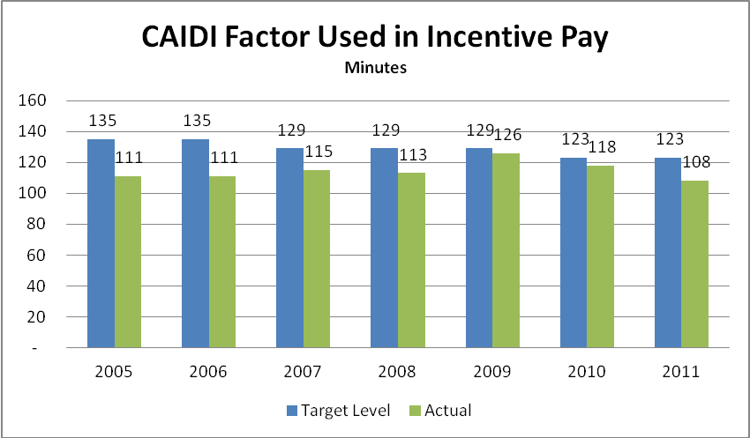
At p. 26, Immediately following Table 5 –REVISED: CAIDI Factor Used in Incentive Pay, insert the following question and answer:

Q: Does the revision to Table 5 change your overall conclusion or recommendation?

A: No, the revision does not change my conclusion that customers have experienced deterioration in service reliability over the 2005 to 2011 period. With the exception of 2011, which is a slight improvement over 2005, the CAIDI factor, which measures average customer service interruption time, has escalated from 2005 to 2010. Furthermore, the SAIFI (System Average Interruption Frequency Index) factor, the other service reliability factor used by the Company to trigger short-term incentive pay is still worse off in 2011 at 1.08 outages than it was in 2005 at 0.92 outages. Overall, these two factors affect about 5% of the target short-term incentive pay.

