
David S. Valdez
Vice President
Public Affairs, Policy & Communications
WA0101RA
1800 41st Street
P.O. Box 1003
Everett, WA 98201
Phone 425 261-5691
Fax 425 261-5262
April 15, 2005

Advice No. 3140

Ms. Carole Washburn, Executive Secretary
Washington Utilities and
Transportation Commission
1300 S. Evergreen Park Drive S.W.
Olympia, Washington 98504-7250

Dear Ms. Washburn:

Verizon Northwest Inc. submits for filing Advice No. 3140 containing the attached tariff sheets to become part of the General and Local Exchange Tariff, WN U-17. An original and fifteen (15) copies are being provided pursuant to Paragraph 15 of Order No. 3.

The company submits this Advice filing in compliance with the Commission’s Order No. 15 in Docket No. UT-040788 dated April 12, 2005. The proposed rates included with this filing are as follows:

 | Current Rate | 05/01/05  Proposed Rate
Residential Late Payment Charge | n/a | $2.50 or 1.5%, whichever is greater
Business Late Payment Charge | n/a | $2.50 or 1.5%, whichever is greater

The overall net revenue effect for Advice No. 3140 is $8,007,020. The requested effective date for this filing is May 1, 2005.
A copy of the Public Notice is attached.

If there are questions, please contact Lin Fogg at (425) 261.6380.

Very truly yours,

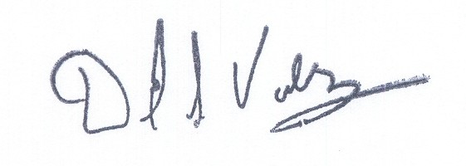

David S. Valdez
Vice President - Public Affairs, Policy and Communications

DSV:kad
Enclosures

c: Service List
Attachment A

General and Local Exchange Tariff, WN U-17

Section 1

13th Revised Sheet 4

Section 2

Table of Contents 6th Revised Sheet 1
3rd Revised Sheet 19
3rd Revised Sheet 20

Section 5

Original Sheet 5.1
3rd Revised Sheet 6

VERIZON NORTHWEST INC.
EVERETT, WASHINGTON

N O T I C E

Verizon Northwest Inc. filed Advice No. 3140 today with the Washington Utilities and Transportation Commission at Olympia to become part of the General and Local Exchange Tariff, WN U-17.

The company submits this Advice filing in compliance with the Commission’s Order No. 15 in Docket No. UT-040788 dated April 12, 2005. The proposed rates included with this filing are as follows:

 | Current Rate | 05/01/05  Proposed Rate
Residential Late Payment Charge | n/a | $2.50 or 1.5%, whichever is greater
Business Late Payment Charge | n/a | $2.50 or 1.5%, whichever is greater

The overall net revenue effect for Advice No. 3140 is $8,007,020. The requested effective date for this filing is May 1, 2005.
A copy of this tariff is available for public inspection at the following Verizon Plus store locations:

189 Cascade Mall Drive 1402 SE Everett Mall Way
Burlington Everett
Burlington Verizon Plus Everett Verizon Plus

511 Valley Mall Parkway 18700 - 33rd Ave. West, Suite D
East Wenatchee Lynnwood
East Wenatchee Verizon Plus Alderwood Verizon Plus

Posted at ___________________
___________________
by ___________________

Post in above business offices.

