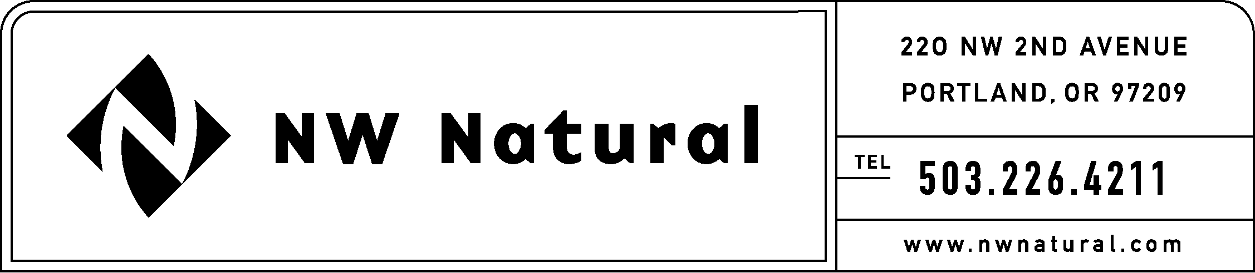

Rates and Regulatory Affairs
Facsimile: 503.721.2532

March 28, 2008 NWN Advice No. WUTC 08-2
Docket No. UG-080546
Do Not Redocket

VIA ELECTRONIC FILING
Carole Washburn, Executive Secretary
Washington Utilities and Transportation Commission
1300 S. Evergreen Park Drive S.W.
P.O. Box 47250
Olympia, WA 98504-7250

Re: Substitute Sheets: Application for General Rate Increase

Dear Ms. Washburn:

Northwest Natural Gas Company (NW Natural or the Company) files herewith replacement sheets in NWN Advice No. WUTC 08-2 filed on March 28, 2008.

Attached is a replacement of the Table of Replacement Tariff Sheet Revisions deleting proposed revision to Sheets 201.1, 201.2 and 203.1.

Please do not hesitate to contact me if you have any questions.

Sincerely,

/s/ Onita King

Onita R. King
Rates & Regulatory Affairs

