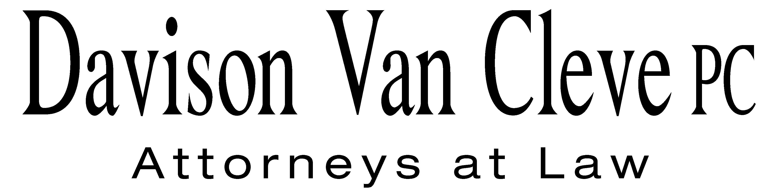
TEL (503) 241-7242 ● FAX (503) 241-8160 ● mail@dvclaw.com
Suite 400
333 SW Taylor
Portland, OR 97204

November 17, 2009

Via Email and Federal Express

Carole J. Washburn
Secretary
Washington Utilities and Transportation Commission
PO Box 47250
1300 S Evergreen Park Drive SW
Olympia, WA 98504-7250

Re: In the Matter of the Petition of Puget Sound Energy for an Accounting
Order.

Docket No. UE-090704/UG-090705

Dear Ms. Washburn:

Enclosed please find an original and seventeen (17) copies each of the following Direct Testimony of Donald W. Schoenbeck on behalf of the Industrial Customers of Northwest Utilities in the above referenced docket.

Thank you for your assistance.

Sincerely yours,

/s/ Brendan E. Levenick
Brendan E. Levenick
Enclosures

cc: Service List

CERTIFICATE OF SERVICE

I hereby certify that I have this day served the foregoing documents upon all parties of record in this proceeding by mailing a copy thereof in a sealed, first-class postage prepaid envelope to each individual’s last-known address, as listed below.
DATED this 17th day of November, 2009.
Davison Van Cleve, P.C.

/s/ Brendan E. Levenick
Brendan E. Levenick

PUGET SOUND ENERGY  TOM DEBOER  PO BOX 97034 PSE-08N  BELLEVUE WA 98009-9734  tom.deboer@pse.com | PERKINS COIE  SHEREE CARSON  Donna Barnett  10885 N.E. FOURTH STREET STE 700 BELLEVUE WA 98004-5579  scarson@perkinscoie.com  dbarnett@perkinscoie.com
PUBLIC COUNSEL  SARAH A SHIFLEY  800 5TH AVE STE 2000  SEATTLE WA 98104-3188  E-mail: Sarah.Shifley@atg.wa.gov | PUGET SOUND ENERGY  KARL KARZMAR  PO BOX 97034 PSE-08N  BELLEVUE WA 98009-9734  E-mail: karl.karzmar@pse.com
Chad M. Stokes  Cable Huston Benedict  Haagensen & Lloyd LLP  1001 SW Fifth Avenue  Suite 2000  Portland, OR 97204-1136  cstokes@cablehuston.com | PUBLIC COUNSEL  SIMON FFITCH  Representing Public Counsel  800 FIFTH AVENUE STE 2000  SEATTLE WA 98104-3188  E-mail: simonf@atg.wa.gov
Robert D. Cedarbaum, AAG  Michael Fassio, AAG  Attorney General Office  State Mail Stop 40128  Olympia, WA 87504-0128  bcedarba@wutc.wa.gov  MFassio@utc.wa.gov | Danielle Dixon  David Johnson  NW Energy Coalition  811 1st Avenue, Ste 305  Seattle, WA 98104  danielle@nwenergy.org  david@nwenergy.org
John Cameron  Davis Wright Tremaine  1300 SW Fifth Ave STE 2300  Portland, OR 97201  johncameron@dwt.com | Norman Furuta  Department of the Navy  1455 Market Street, Ste 1744  San Francisco, CA 94103-1399  norman.furuta@navy.mil
Charles Eberdt  The Energy Project  1322 N. State Street  Bellingham, WA 98225  CHUCK_EBERDT@oppco.org | Ronald Roseman  Attorney At Law  2011 – 14th Avenue East  Seattle, WA 98112  ronaldroseman@comcast.net
Elaine Spencer  Graham & Dunn  Pier 70, Ste 300  2801 Alaskan Way  Seattle, WA 98121-1128  espencer@grahamdunn.com | Robert Sheppard  Seattle Steam Company  30 Glacier Key  Bellevue, WA 98006  rbsheppard@comcast.net
P. DOUGLAS BETZOLD  COST MANAGEMENT SERVICES, INC.  2737 78TH AVE. SE STE 101  MERCER ISLAND WA 98040  cms@cmsnaturalgas.com | PAULA E PYRON  NORTHWEST INDUSTRIAL GAS USERS  4113 WOLF BERRY COURT  LAKE OSWEGO OR 97035-1827  ppyron@nwigu.org
KURT J BOEHM  BOEHM, KURTZ & LOWRY  Representing The Kroger Co.  36 E. SEVENTH ST. STE 1510  CINCINNATI OH 45202 | PETER G HALLER  BRICKFIELD, BURCHETTE, RITTS & STONE  Representing Nucor Steel Seattle, Inc.  1025 THOMAS JEFFERSON ST. NW  EIGHTH FLOOR-WEST TOWER  WASHINGTON DC 20007  peter.haller@bbrslaw.com

