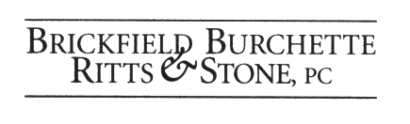

May 30, 2008
Carole J. Washburn, Secretary
Washington Utilities and Transportation Commission
1300 S. Evergreen Park Dr. SW
P.O. Box 47250
Olympia, Washington 98504-7250
Re: WUTC v. Puget Sound Energy (General Rate Case)
Dockets UE-072300 and UG-072301 (Consolidated)
Dear Ms. Washburn:
Enclosed for filing in the above-referenced docket please find the original and 12 copies of the Prefiled Response Testimony of Kevin C. Higgins on Behalf of Nucor Steel Seattle, Inc., including exhibits, an attachment and a certificate of service.

Sincerely,

Damon E. Xenopoulos
Brickfield, Burchette, Ritts & Stone, P.C.
1025 Thomas Jefferson St., NW
8th Floor, West Tower
Washington, DC 20007-5201
(202) 342-0800
(202) 342-0807 (fax)

Enclosures
cc: Hon. Dennis J. Moss
Hon. Adam Torem
Parties

