WN U-2

Original Sheet No. 1134

PUGET SOUND ENERGY
NATURAL GAS SCHEDULE NO. 134
Pipeline Integrity Program

Section 1: Applicability and Purpose

- This Pipeline Integrity Program (“PIP”) is applicable to all firm and interruptible gas sales and transportation Customers as well as Special Contract Customers.
- The purpose of this schedule is to provide for the recovery of eligible program costs incurred by the Company through an adjustment of certain natural gas rates.

Section 2: Method of Calculation and Eligible Investments

1. The rate adjustment will be based on forecasted expense and investment activity through October 31 of the upcoming program period, adjusted to reflect the difference between the previous program period’s actual versus forecasted costs and loads. The costs included in the rate adjustment will be based on actual and forecasted incremental: 1) return on incremental plant, net of accumulated depreciation and applicable deferred federal income tax and 2) depreciation expense on the associated incremental plant. Additionally, the rate adjustment will include a true-up of estimates used in any previous filing to actual costs and loads. The rate adjustment will be updated each year with a November 1 effective date. The first program period will be August 1, 2011 to October 31, 2011. All subsequent program periods will be November 1 through October 31.

2. An investment included in the PIP must be expected to be completed during the upcoming program period and is not currently included in the Company’s rate base in its most recently completed general tariffs’ update. Eligible investments will be determined on an annual basis in consultation with interested stakeholders and shall initially consist of the following programs:
- Wrapped Steel Service Assessment
- Wrapped Steel Main Assessment
- Older Polyethylene Pipe Replacement

(N)
|
|
|
|
|
|
|
|
|
|
|
|
|
|
|
|
|
|
|
|
|
|
|
|
|
|
|
|
|
|
|
|
|
(N)

Issued: April 26, 2011 Effective: August 1, 2011
Advice No.: 2011-12
Issued By Puget Sound Energy
By: | 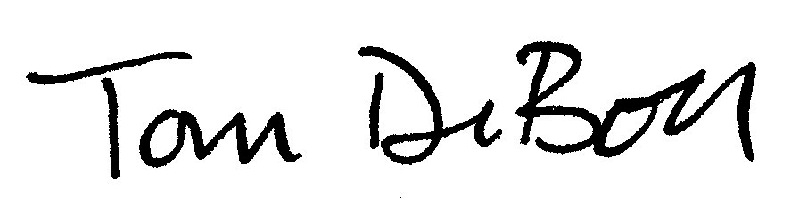 | Tom DeBoer Title: Director, Federal & State Regulatory Affairs

WN U-2

Original Sheet No. 1134-A

PUGET SOUND ENERGY
NATURAL GAS SCHEDULE NO. 134
Pipeline Integrity Program
(Continued)

Section 3: Program Cap

Total capital expenditures during a program year will not exceed $25 million without prior
Commission approval. Capital expenditures which exceed the total approved program year amount by greater than 10% will not be allowed recovery under the program without separate
Commission approval.

Section 4: Adjustment Rates

MONTHLY RATE:
Schedule 16 $ 0.05 per mantle
Schedules 23 0.00239 ¢ per therm
Schedules 31 and 31T 0.00211 ¢ per therm
Schedules 41 and 41T 0.00104 ¢ per therm
Schedules 85 and 85T 0.00033 ¢ per therm
Schedules 86 and 86T 0.00053 ¢ per therm
Schedules 87 and 87T 0.00023 ¢ per therm
Special Contracts 0.00023 ¢ per therm

Section 5: Termination

The program will remain in effect through October 31, 2016, or until such other time as the
Commission may approve.

Section 6: Adjustments

Rates in this schedule are subject to conditions and adjustment as set forth in Schedule No. 1 and to adjustment by other adjusting or supplemental schedules, when applicable.

Section 7: General Rules and Regulations

Service under this schedule is subject to the rules and regulations contained in Company's tariff.

(N)
|
|
|
|
|
|
|
|
|
|
|
|
|
|
|
|
|
|
|
|
|
|
|
|
|
|
|
|
|
|
|
|
|
|
|
|
(N)

Issued: April 26, 2011 Effective: August 1, 2011
Advice No.: 2011-12

Issued By Puget Sound Energy
By: |  | Tom DeBoer Title: Director, Federal & State Regulatory Affairs

