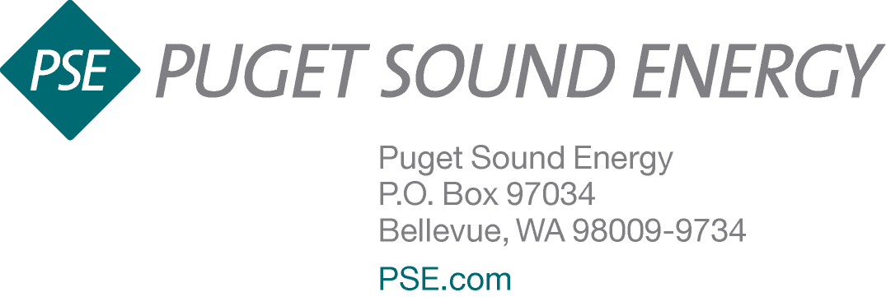

June 25, 2015

Filed via Web Portal and Overnight Courier

Mr. Steven V. King, Executive Director and Secretary
Washington Utilities and Transportation Commission
1300 South Evergreen Park Drive S.W.
P.O. Box 47250
Olympia, WA 98504-7250

Re: Docket No. UE-132043
Updated Conservation Program Details
Dear Mr. King:

Enclosed are an original and three copies of Puget Sound Energy, Inc.’s (“PSE”) Q1 and Q2 revisions of its 2015 Exhibit 4: Energy Efficiency List of Measures, Incentives and Eligibility, originally filed as a part of PSE’s 2015 Annual Conservation Plan (ACP) in Docket No. UE-132043 on November 26, 2014.

The revisions are consistent with Condition (5) in Appendix A of Order 01 in Docket No. UE-132043 which indicates that Exhibit 4 revisions must be filed as updates to the BCP with the Commission. Similarly, Condition (7)(a) indicates that program modifications must be filed with the Commission as revisions to tariffs or as revisions to PSE’s ACP, as appropriate. The enclosed Exhibit 4 reflects “Version: Fourteenth” in the footers throughout the document to reflect that it replaces the thirteenth version of Exhibit 4.

In addition to implementing formatting improvements throughout the document, PSE clarified its refrigerator replacement qualifications language and changed “direct install” to “directly installed” in the Water Heater measure grouping of the Multifamily Existing program. In another modification, it is important to note that PSE separated the Multifamily Air Sealing measures table in the Low Income Weatherization program for clarity only; no measure incentive values changed. PSE also modified protocols for HVAC control upgrades in the Commercial/Industrial Retrofit program.

Consistent with WAC 480-109-110(3), PSE provided advance copies of Exhibit 4, including draft and final versions, reflecting revisions, retirements, and additions that were implemented since January 1, 2015, to the Conservation Resource Advisory Group on May 29, 2015.

Please contact Lynn Logen at (425) 462-3872 or Andy Hemstreet at (425) 456-2633 for additional information about this filing. If you have any other questions, please contact me at (425) 462-3495.

Sincerely,

Ken Johnson
Director, State Regulatory Affairs

Enclosure

cc: Simon ffitch, Public Counsel
Sheree Carson, Perkins Coie

