For Information:
Stanley Davis
914/745-4191
stanley.davis@towers.com

TOWERS PERRIN PROJECTS FIFTH CONSECUTIVE YEAR OF DOUBLE-DIGIT
HEALTH CARE COST INCREASES IN 2004

Employers Are Facing a 12% Increase in 2004,
Which Amounts to a $742 Increase per Employee From 2003

NEW YORK, NY, September 29, 2003 ⎯ “Employers are facing yet another grim year of double-digit increases in health care costs, and their employees are facing the harsh prospect of paying even higher out-of-pocket costs,” said Jim Foreman, managing director of Health and Welfare for Towers Perrin. Foreman made the statement after viewing preliminary results based on an analysis of the first 200 responses to Towers Perrin’s 2004 Health Care Cost Survey.

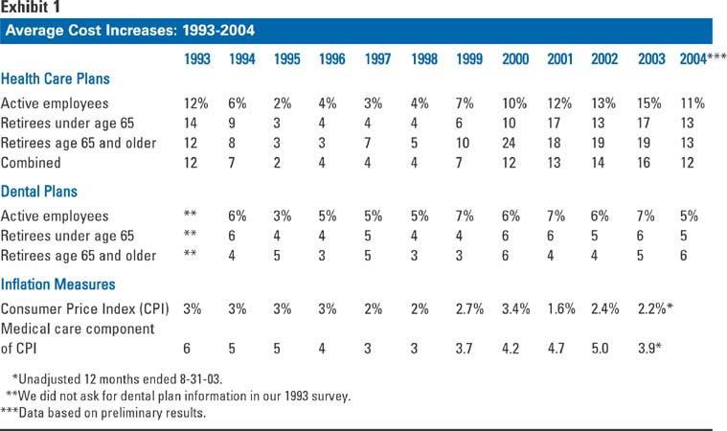Foreman pointed out that, while the size of the cost increase in 2004 is expected to be lower than it was in 2003 (12% versus 16%), the cumulative effect of five years of double-digit increases will have a dramatic toll on employers. “I cannot recall a longer sustained period of double-digit increases in the health care industry,” said Foreman. “Companies are paying twice as much in health care costs today as they paid six years ago.” (See Exhibit 1.)

Active and retiree medical costs
The survey found that the average reported 2004 cost of medical coverage for all types of health plans combined is $314 per month ($3,768 on an annual basis) for employee-only coverage; $627 per month ($7,524 annually) for employee-plus-one dependent coverage and $888 per month ($10,656 annually) for family coverage.

The percentage increase for employer-sponsored medical plans is higher for retirees than for active employees ⎯ a trend that has persisted since 1999. This is of particular concern to employers who have large post-retirement medical obligations. (See Exhibit 2.)

Exhibit 2
Average 2004 Monthly Health Care Costs and Cost Increases by Covered Group
 | Employee/ Retiree Only | Employee/ Retiree Plus Spouse | Family | Average Increase From 2003
Active employees | $314 | $627 | $888 | 11%
Retirees under age 65 | $453 | $915 | $1,169 | 13%
Medicare-eligible retirees | $259 | $530 | N/A | 13%

Overall, the 2004 increase in health care costs amounts to $742 per active employee, on average. The survey also found that, while employees will be asked to pay more out-of-pocket for their health care in 2004, employers are still shouldering the lion’s share of the costs. According to the survey, employees will contribute 19% of the total cost for employee-only coverage and 22% for family coverage, nearly the same percentages that they paid in 2003.
In dollar terms, employees will contribute an average of $59 a month in 2004 for employee-only coverage (compared to $48 a month in 2003 and $38 a month in 2002). Employee contributions for family coverage will average $196 a month in 2004 (compared to $160 a month in 2003 and $134 a month in 2002).

Retirees will contribute nearly half of the total cost of their coverage. Retirees under 65 will pay an average of $180 a month ($2,160 annually) for retiree-only coverage. Contributions for family coverage for retirees under 65 contributions will average $483 a month ($5,796 annually).

Retirees 65 and older will pay an average of $111 a month for retiree-only coverage. Their contribution for family coverage will average $232 monthly ($2,784 annually). (See Exhibit 3.)

Exhibit 3 – Average Employee/Retiree Share of 2004 Coverage Costs
“The irony is that employers are paying more, but their employees feel as if they are getting less,” said Rich Ostuw, a Towers Perrin Principal and senior health care consultant. “Health care is an emotional issue for employees. Companies are reluctant to make dramatic changes to their health plans because they recognize that their employees are already feeling squeezed in this environment of modest wage increases. However, employers are at their limit. They simply cannot continue to absorb double-digit increases.”

Several factors lead to rising costs
According to the survey, there are several factors driving higher costs, including:
- higher HMO rates
- high core medical and pharmacy fees and usage
- sharp increases in the price of hospital services
- greater demand for more expensive diagnostic tests such as MRIs and CT scans
- higher utilization of certain physician specialists.

“The causes are pretty much the same as last year,” notes Ostuw. “It’s the solutions that require a fresh approach.”

Costs vary significantly among employers
“While all companies are feeling the pain of rising health care costs, some are feeling it more than others,” states Ron Fontanetta, a Towers Perrin Principal and senior health care consultant. “According to the survey, the spread for active employees and retirees older than 65 is more than $3,000 for those in the 10th percentile of companies versus those in the 90th percentile. And the spread for retirees younger than 65 is nearly double for those in the 90th percentile than those in the 10th percentile.” (See Exhibit 4.)

Exhibit 4 – Range of 2004 Employer Health Care Costs

“Companies in the 90th percentile might consider taking lessons from companies in the 10th percentile,” added Fontanetta, who also noted that health care costs vary significantly by industry and by state.

Employers are beginning to take action
“One of the trends that is evident in our survey is that most employers are taking steps to minimize the pain,” said Foreman. “Companies are changing their plan designs, stepping up their employee communications, targeting clinical programs, implementing care management programs, reviewing and updating their vendor management selections and adopting consumerism strategies that encourage their employees to be more effective purchasers of health care.”

“However, many employers are taking baby steps when bold steps are needed,” added Foreman. “If companies are serious about lowering their health care cost increases into the single digits, they must review their plans from top to bottom and commit themselves to take the necessary steps to align their health care strategy with their overall business strategy. Employers must also find a way to enlist their employees as partners in this effort.”

Dental costs
According to the survey, dental costs for 2004 will increase by 5%. “Although increases in dental premiums are not as dramatic as health care premium increases, they continue to outpace the rate of inflation,” notes Fontanetta. Dental costs commonly represent 8% to 10% of a company’s active employee health care costs.

About the survey
The Towers Perrin 2004 Health Care Cost Survey was conducted during August/September 2003. Participants were asked to report their 2004 per capita premium costs for insured health and dental plans, and premium equivalents (i.e., estimated benefit and administrative costs) for self-insured plans. These findings were culled from the first 200 responses to the survey.
The full survey report is expected to be available in December 2003. Survey respondents represent primarily Fortune 1000 companies with operations in numerous locations nationwide. Collectively, the participating companies provide medical benefits to more than two million employees and retirees across the country. The average participating company has 7,200 employees.

About Towers Perrin
Towers Perrin is one of the world’s largest management, human resource consulting and administration firms. It helps organizations manage their investments in people to achieve measurable performance improvements, focusing on human resource strategy and service delivery, benefit and compensation design and implementation, employee and organizational communication, HR technology and outsourced administration. Towers Perrin is part of a broader family of businesses that also includes Tillinghast − Towers Perrin, a management consultancy for financial services companies worldwide, and Towers Perrin Reinsurance, a reinsurance intermediary and consultancy. Together, these businesses have over 9,000 employees and 79 offices in 77 cities and 24 countries. More information about Towers Perrin is available at www.towersperrin.com.

EDITOR’S NOTE: Jim Foreman, Rich Ostuw, Ron Fontanetta and other Towers Perrin consultants are available for interviews on this topic. Please contact Stanley Davis (914-745-4191) or Joe Conway (914-745-4175) in the Press Relations office or via fax at (914-745-4180) to arrange for an interview.

