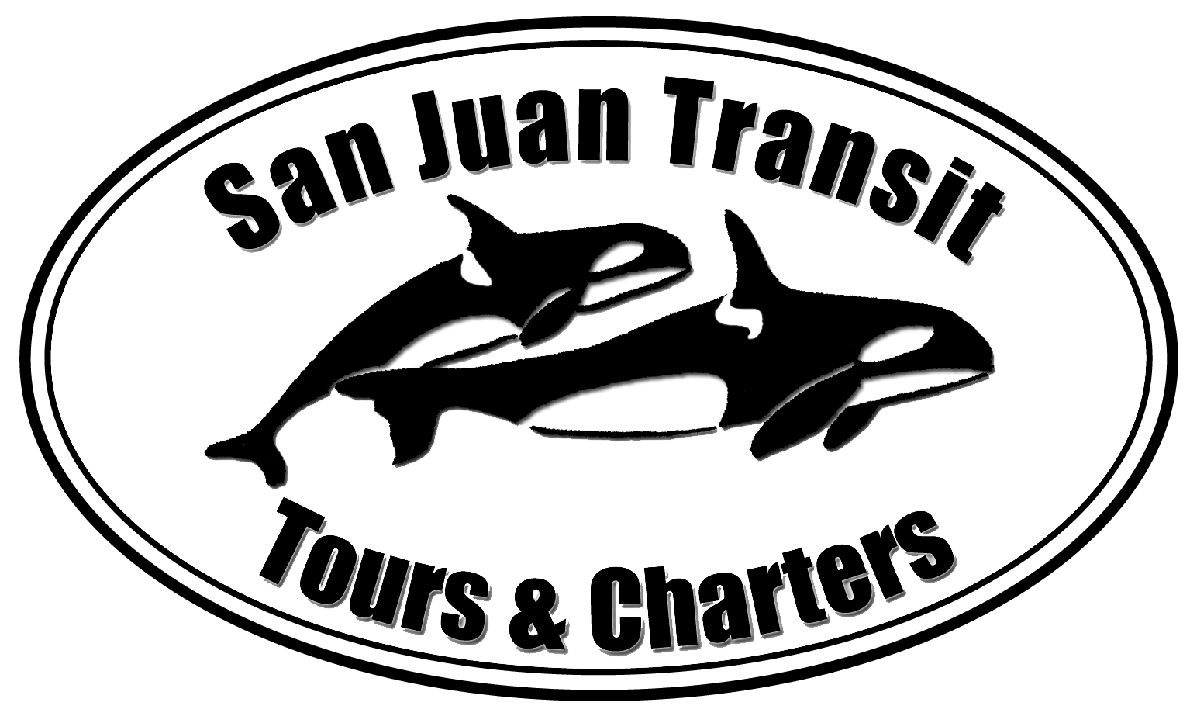

San Juan Transit

Tours and Charters, LLC

San Juan Transit

is
Resuming Transit Service on

SAN JUAN ISLAND

May 17 through September 28, 2014

Friday Harbor, Roche Harbor Village, Alpaca Ranch, English Camp, Sculpture Park, Lakedale Resort, San Juan Vineyards, Golf Course, American Camp, Lavender Farm, Whale Watch Park, Snug Harbor, S J County Park

For Transit Information: www.sanjuantransit.com

Call or visit our office located upstairs at Cannery Landing Next to the Ferry Landing in Friday Harbor. 360-378-8887

You may contact the Washington Utilities and Transportation Commission to comment, or to oppose the company’s proposal at
(888) 333-WUTC (9882) comments@utc.wa.gov

Posted Date: April 17, 2014 Effective Date(s): June (May) c 17, 2014
SERVING THE TRANSPORTATION NEEDS OF THE SAN JUAN ISLANDS
P.O. Box 2809  Friday Harbor, Washington 98250  360-378-8887
Email: sjtransit@rockisland.com Web Site: sanjuantransit.com

