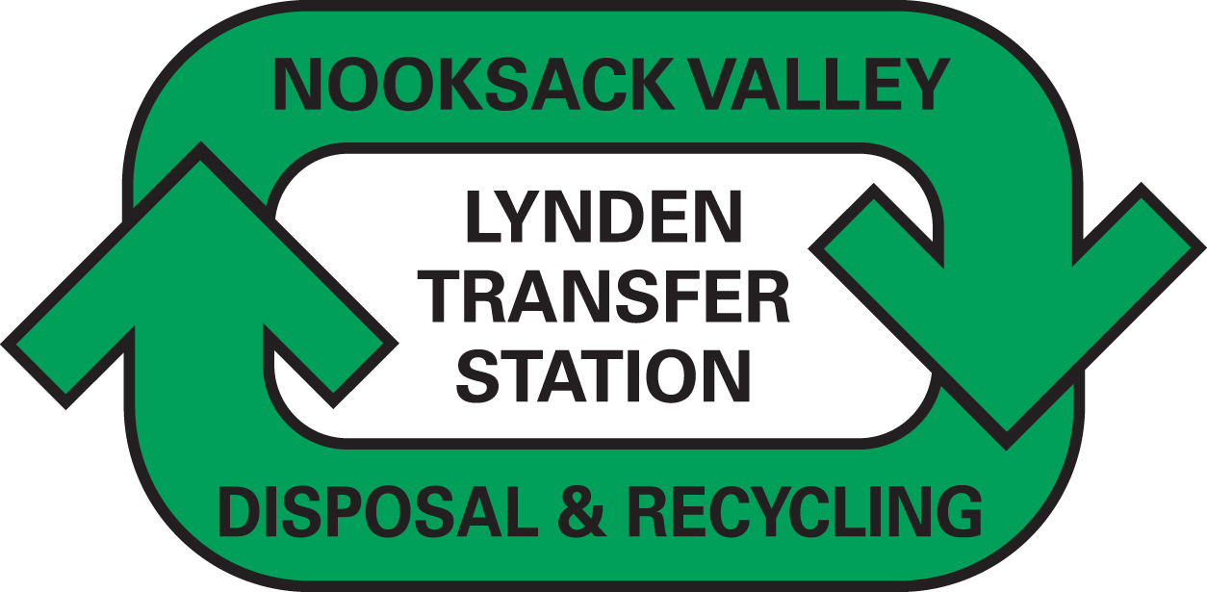
Steven King, Executive Secretary
Washington Utilities and Transportation Commission
1300 South Evergreen Park Drive SW
P.O. Box 47250
Olympia, WA 98504-7250 October 3, 2013

FOR DOCKET #TG-131704 DO NOT RE-DOCKET

Dear Secretary King,

Attached please find replacement page as directed by staff for the above docket.

The contact person for this submittal is: Calvin Den Hartog
P.O. Box 267, Lynden, WA 98264
Phone: (360) 354-3400 Fax: (360) 354-3288
Email: Calvin_NVD@msn.com

Sincerely,

Calvin Den Hartog
General Manager

CC: Whatcom County Council

