CenturyLink

1600 7th Avenue, Room 1506

Seattle, Washington 98191

(206) 345-1568

Facsimile (206) 343-4040

Mark S. Reynolds

VP Regulatory & Legislative Affairs

Western Region

June 21, 2013

Advice No. WA 13-01A, Replacement No. 1
Docket No. UT-131015 – DO NOT REDOCKET

Steven King
Acting Executive Director and Secretary
1300 S. Evergreen Park Dr. S.W.
P.O. Box 47250
Olympia, Washington 98504-7250

Dear Mr. King:

United Telephone of the Northwest Access Service d/b/a CenturyLink is forwarding for filing the replacement sheets listed on Attachment A. The original filing is the second step in implementing the “Transitional Intrastate Access Service” reductions mandated by the Federal Communications Commission's November 18, 2011 Report and Order and Further Notice of Proposed Rulemaking in WC Docket Nos. 10-90, etc. (FCC 11-161) and was originally submitted May 28, 2013.

Replacement No. 1 corrects the following:

1) Adds a (T) symbol to Sheet 6-168 in the right margin of the rate description for
(7) OptiPoint -3, 12 & 48 Service Upgrade
2) Adds 2nd Revised Sheet 6-171 to the original filing correcting (F) and (G)
to (E) and (F)
3) Adds a (D) symbol to Sheet 6-172 in the right margin to indicate the
removal of note **

If you have questions concerning these replacement sheets please contact me.

Sincerely,

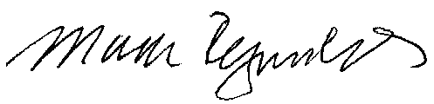

Mark Reynolds
Attachments
Attachment A
WA 13-01A, Replacement No.
Docket No. UT-131015

ACCESS SERVICE
Tariff WN U-10

SECTION | SHEET | REVISION
6 | 6-168 | 1st
6 | 6-170 | 3rd
6 | 6-171 | 2nd
6 | 6-172 | 2nd

