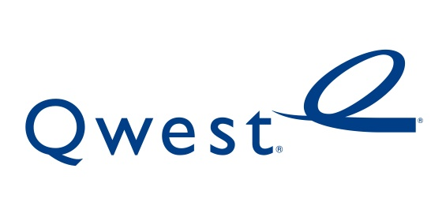

July 29, 2011

David Danner
Executive Director and Secretary
1300 S. Evergreen Park Dr. S.W.
P.O. Box 47250
Olympia, Washington 98504-7250

Re: Advice No. 3681T, Docket No UT-111278, Replacement No. 1
Do Not Redocket

Dear Mr. Danner:

On July 8, 2011 Qwest Corporation filed Advice 3681T, a tariff filing to propose the approval of the Company’s fictitious name d/b/a CenturyLink QC. Pursuant to Docket No UT-111278, Order 01, Qwest submits this substitute filing to add language to the adoption notice, and an asterisk (*) after the d/b/a with an explanation for the asterisk at the bottom of the Title page . Qwest shall continue to include the language required by this Order until CenturyLink’s challenge to the conditions of Order 14 in Docket UT-100820 has been resolved.

If you have any questions concerning this filing please contact Sharon Alvarado on (303) 992 5836.

Sincerely,

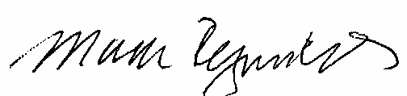

Mark Reynolds

Attachments

Attachment A
Advice No. 3681T Replacement No. 1

EXCHANGE AND NETWORK SERVICE
WN U-40

SECTION | SHEET | REVISION
Adoption Notice | 1 | Original
Title | 1 | 3rd
1 | 1 | 2nd

