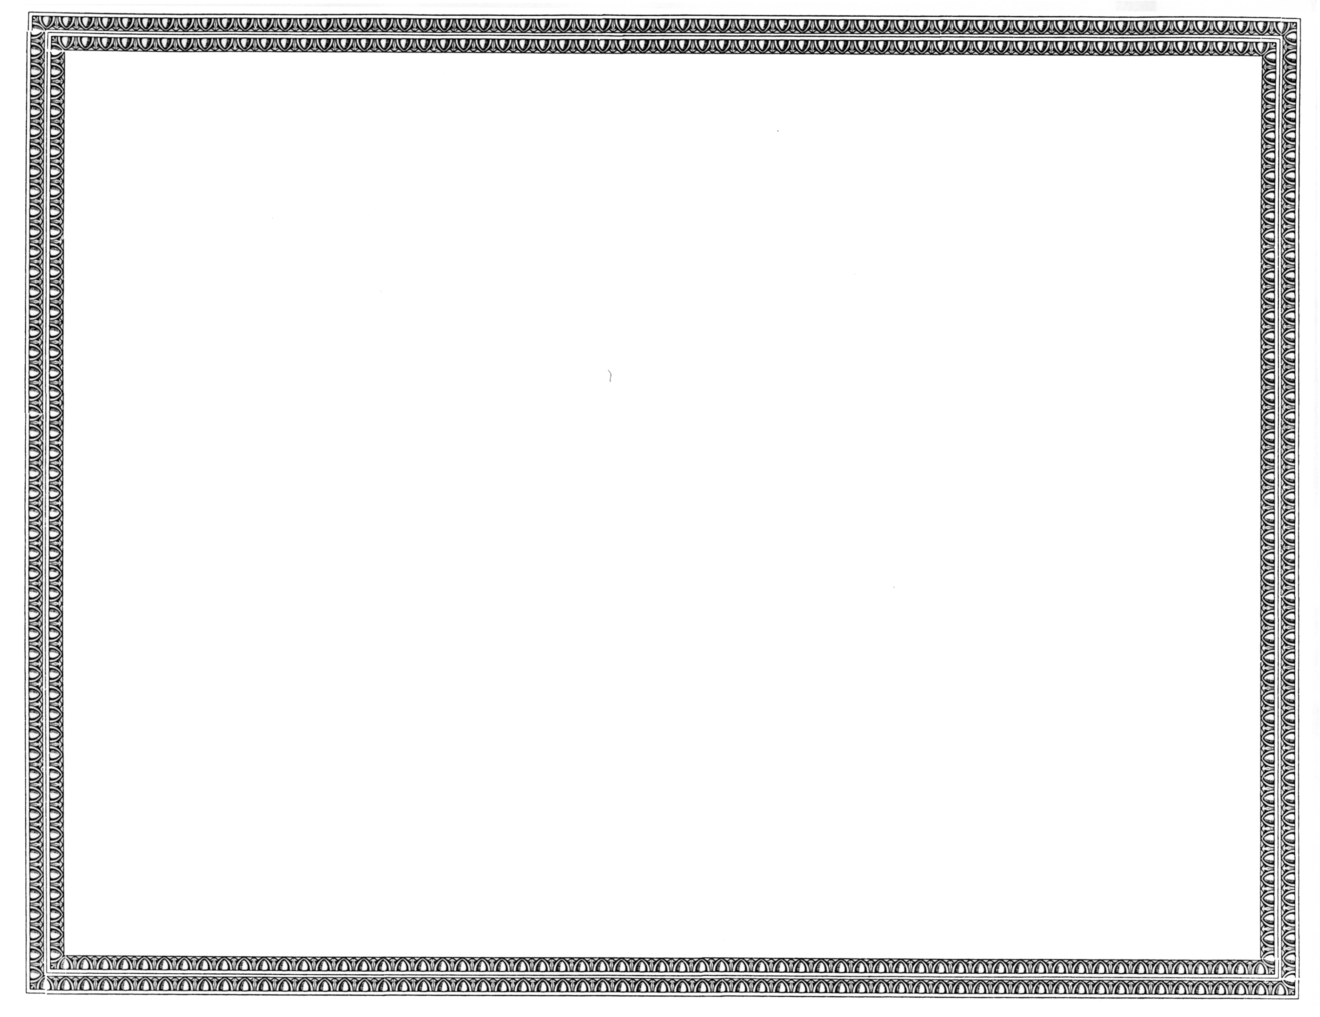



REGISTRATION
OF

CoSpeed, LLC

AS A COMPETITIVE
TELECOMMUNICATIONS COMPANY

Docket Number UT-091326 September 19, 2009
Effective Date

DAVID W. DANNER

Executive Director and Secretary

CERTIFICATE IS NOT TRANSFERABLE

