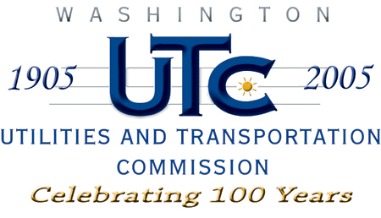

Memorandum
August 19, 2008

To: TR-080634 - File

From: Kathy Hunter, Transportation Safety Compliance Manager

Subject: TR-080634 Tacoma Rail
Grade Crossing Protective Fund (GCPF) Project at 104th Street East

On April 28, 2008, the Washington Utilities and Transportation Commission (Commission) awarded a GCPF grant totaling $20,000 for upgrades to a crossing located at 104th Street East in Pierce County. Total project costs are estimated $43,000, with Tacoma Rail paying the amount over $20,000. The USDOT number assigned to this crossing is 396677J.

On August 19, 2008, the applicant, Tacoma Rail submitted a request for reimbursement in the amount of $20,000 pursuant to commission order. Actual project costs were $39,623.90. On August 13, 2008, commission staff conducted a site visit and verified that the project is completed according to the specifications outlined in the order approving the grant.

Please close this docket.

