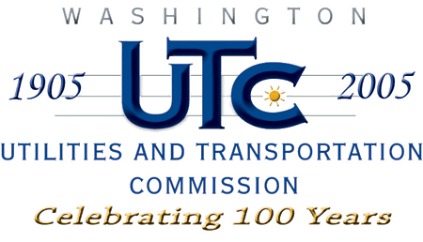

Memorandum
March 6, 2008

To: TR-080116 - File

From: Kathy Hunter, Transportation Safety Compliance Manager

Subject: TR-080116 Washington and Idaho Railway
Grade Crossing Protective Fund (GCPF) Project at SR-27

On January 24, 2008, the Washington Utilities and Transportation Commission (Commission) awarded a GCPF grant totaling $4,873.85 for upgrades to a crossing located at SR-27 in Whitman County. The USDOT number assigned to this crossing is 066183E.

On March 4, 2008, the applicant, Washington and Idaho Railway submitted a request for reimbursement in the amount of $4,542.90 pursuant to commission order. On
February 27, 2008, commission staff conducted a site visit and verified that the project is completed according to the specifications outlined in the order approving the grant.

Please close this docket.

