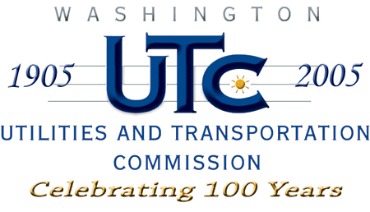

Memorandum
June 20, 2008

To: TR-072335 - File

From: Kathy Hunter, Transportation Safety Compliance Manager

Subject: TR-072335 Washington and Idaho Railway
Grade Crossing Protective Fund (GCPF) Project at Kimiaken Street

On December 17, 2007, the Washington Utilities and Transportation Commission (Commission) awarded a GCPF grant totaling $17,836.64 for upgrades to a crossing located at Kimiaken Street in Pullman. The USDOT number assigned to this crossing is 066266T.

On June 17, 2008, the applicant, Washington and Idaho Railway submitted a request for reimbursement in the amount o f $17, 836.64 pursuant to commission order. On June 12, 2008, commission staff conducted a site visit and verified that the project is completed according to the specifications outlined in the order approving the grant.

Please close this docket.

