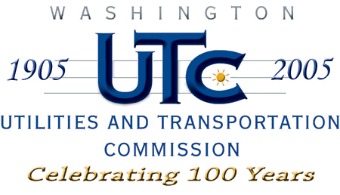

Memorandum
July 25, 2008

To: TR-072332 - File

From: Kathy Hunter, Transportation Safety Compliance Manager

Subject: TR-072332 Eastern Washington Gateway Railroad
Grade Crossing Protective Fund (GCPF) Project at Range Street

On December 17, 2007, the Washington Utilities and Transportation Commission (Commission) awarded a GCPF grant totaling $17,786 for upgrades to a crossing located at Range Street in the city of Hartline. The USDOT number assigned to this crossing is 066099W.

On July 25, 2008, the applicant, Eastern Washington Gateway Railroad submitted a request for reimbursement in the amount of $17,782.14 pursuant to commission order. On July 17, 2008, commission staff conducted a site visit and verified that the project is completed according to the specifications outlined in the order approving the grant.

Please close this docket.

